CAPE WINELANDS DISTRICT MUNICIPALITY

MINUTES OF THE COUNCIL MEETING OF THE CAPE WINELANDS DISTRICT MUNICIPALITY HELD ON THURSDAY, 23 MARCH 2023 AT 10:00 IN THE COUNCIL CHAMBER, CAPE WINELANDS DISTRICT MUNICIPALITY, TRAPPES STREET, WORCESTER

PRESENT (3/2/1/2)

COUNCILLORS

Ald. D.D. Joubert (Speaker)
Ald. (Dr.) H. von Schlicht (Executive Mayor)
Ald. M. Sampson (Executive Deputy Mayor)
Cllr. W.M. Blom
Cllr. M.N. Bushwana
Cllr. G.J. Carinus
Cllr. P. Daniels
Cllr. P.T. de Villiers
Cllr. A.J. du Plessis
Ald. R. Farao
Cllr. G.J. Fredericks
Ald. S. Goedeman
Cllr. E. Groenewald
Cllr. F. Jacobs
Cllr. D.B. Janse
Cllr. C.O. Klaaste
Cllr. J. Kriel
Cllr. J. Maliti
Cllr. C. Manuel
Cllr. X.L. Mdemka
Ald. C. Meyer
Cllr. T.R. Mpulanyana
Cllr. R.S. Nalumango
Cllr. D.W. Nel
Cllr. L. Ngwane
Cllr. A.J. Pedro
Cllr. W.C. Petersen
Cllr. N. Phatsoane
Cllr. A.M. Richards
Cllr. N.D. Sauerman
Cllr. J. Smit
Cllr. M. Smit
Cllr. D. Swart
Cllr. M. van Stade
Cllr. J.H.P. Steyn
Cllr. M.H. Yabo
ABSENT

Cllr. C.F. Wilskut

OFFICIALS

Mr. H.F. Prins (Municipal Manager)
Mr. F. van Eck
Mr. P.A. Williams
Ms. K. Smit
Ms. S.S. Sanders
Ms. B.T. Daries
Mr. M.J. Lesch
Ms. E.J. Otto
Ms. G.C.N. Julie
Mr. C.J.M. Arangie
Mr. R.W.B. van Wyk
Ms. R.A. Leo
Mr. R.J. Humphreys
Mr. R. Hollenbach
Ms. N.J. Fortuin
Mr. C. Swart
Mr. W. Josias
Mr. S.P. Minnies
Ms. J. Swanepoel
Mr. D.A. Heath
Ms. I. Willemse

C.1 OPENING (3/2/1/2)
_______________________________________________________________

The Speaker welcomed all present and requested a moment of reflection.

Councillor A.J. Pedro opened the meeting with prayer.

C.2 ELECTION OF ACTING SPEAKER, IF NECESSARY (3/2/1/2)
_______________________________________________________________

Not applicable.

C.3 DISCLOSURE OF ANY DIRECT OR INDIRECT INTERESTS BY COUNCILLORS AND/OR OFFICIALS (3/4/1 & 4/8/4)
_______________________________________________________________

Councillor M. van Stade declared his indirect interest pertaining to projects contained in Item C.15.4 of the agenda in terms of Item 6(1) of the Code of Conduct for Councillors as contained in Schedule 7 of the Local Government: Municipal Structures Act, 1998 (Act No. 117 of 1998), as amended, with specific reference to his wife being a possible recipient of grant funding.

C.4 APPLICATION FOR LEAVE OF ABSENCE (3/2/1/2)
_______________________________________________________________

COUNCILLORS

Cllr. J.J.S. Januarie (subject to submission and approval of prescribed leave form)
Cllr. V. Hani (subject to submission and approval of prescribed leave form)
Cllr. M.S. Liebenberg (subject to submission and approval of prescribed leave form)

OFFICIALS

None.

C.5 STATEMENTS AND COMMUNICATIONS BY THE SPEAKER (Verbatim)
(3/2/1/3)
_______________________________________________________________

Councillor Birthdays: March 2023

I would like to congratulate the following Councillors who have celebrated their birthdays during March 2023:

02 March : Cllr. G.J. Carinus
14 March : Cllr. A.J. du Plessis
15 March : Cllr. M. Smit
15 March : Cllr. M. van Stade

General Comments

Ramadan will commence on 24 March 2023.

I want to extend our condolences to the colleagues and family of former Alderman A. Crombie who passed away and request all present to stand for a moment of silence.

A workshop on the following policies approved by Council will take place after the meeting of the Mayoral Committee in April 2023:

- Burial or Cremation of Pauper Bodies at Forensic Pathology Services Mortuaries Policy; and
- Preferential Procurement Policy, 2022.

C.6 STATEMENTS AND COMMUNICATIONS BY THE EXECUTIVE MAYOR (Verbatim) (3/2/1/3)
_______________________________________________________________

Thank you, Speaker, allow me to share a few statements and information with Council, but first of all I want to wish all Muslim Councillors, their families and citizens of our district a peaceful Ramadan.

- Love and loss

Speaker, I have noted that colleagues have lost family members during this month and others are recovering in the hospital. I am aware of Mr. Josias who lost his brother and former colleague, Alderman Ansaaf Crombie who passed on.

To our colleagues, on behalf of the Office of the Executive Mayor, Councillors, and employees of the Cape Winelands District Municipality, we send our heartfelt condolences to you and your family.

Then, Speaker, to our colleagues who achieved extraordinary milestones, whether personally or within your family, since our last Council Meeting; may you cherish and appreciate these special moments together.

- Load-Shedding Relief

On 28 February 2023, at the Premier’s Coordinating Forum, Cape Winelands District Municipality received an emergency loads shedding relief grant to mitigate the energy crisis.

The Western Cape Government has allocated nearly R89 billion to keep municipal services running amid load shedding. The Western Cape Government has urged municipalities to put our citizens first as we work through the energy crisis. We received R950,000 which will go towards procuring generators to capacitate ourselves and the local municipalities in a crisis.

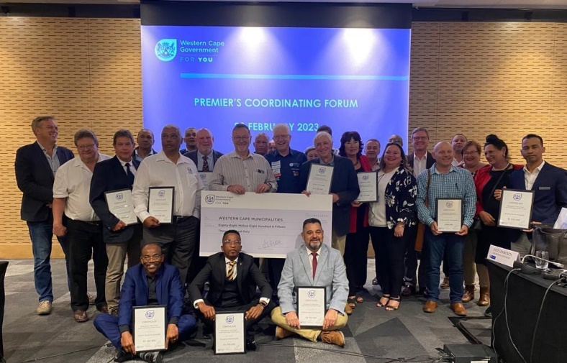

- Health and Wellness in Cape Winelands District

On 21 February 2023, Cape Winelands District Health Plan went through a consultation with the District Health Council. As the Chairperson of the District Health Council, I would like to share with Council the following statistics on leading underlying natural cause of death:

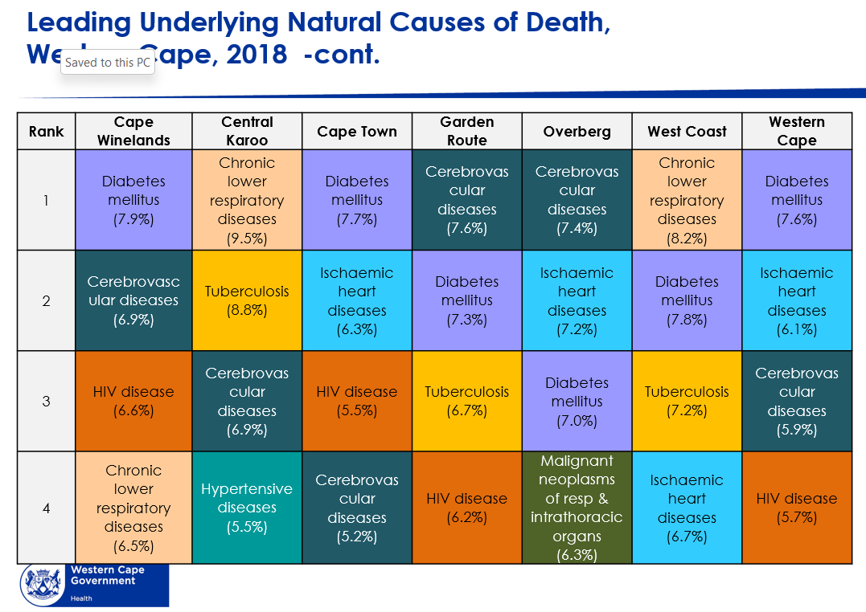

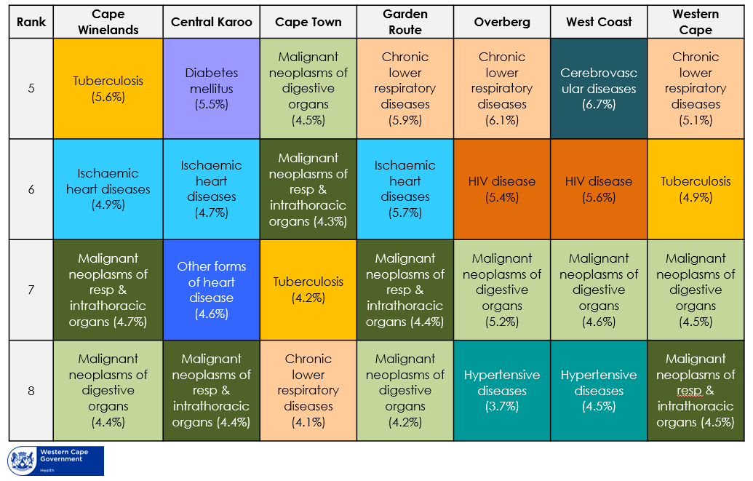

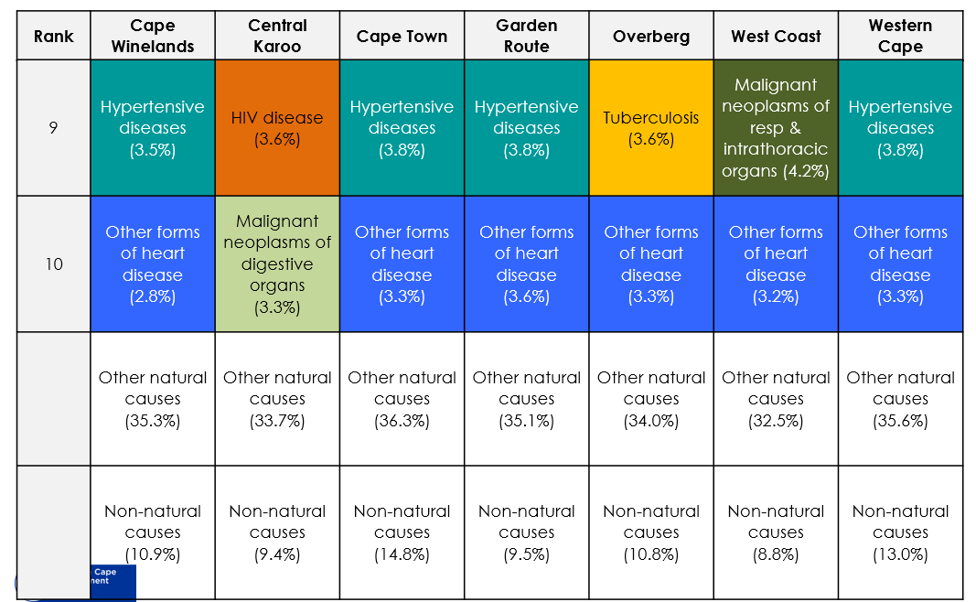

The leading causes of natural deaths are diabetes and heart diseases, HIV and Tuberculosis. Other notable challenges that the DHC highlighted was the increase in suicide, especially scholars/teenagers.

Cape Winelands District Municipality is actively busy to investigate possible action plans and partners to address suicide and mental wellness in our district.

The Western Cape, Department of Health has developed a hotspot model to focus on HIV and Tuberculosis in the area of the Cape Winelands District Municipality.

- Public Service Week

The Cape Winelands District Municipality and Witzenberg Municipality formed part of the dialogue in Tulbagh, between the Office Public Services Commission, Department of Local Government, and other Departments.

Various services, like ID smart cards and access to information were available for the community of Witzenberg.

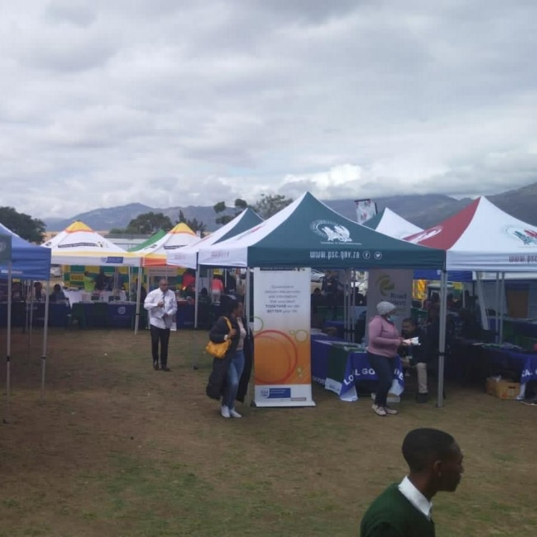

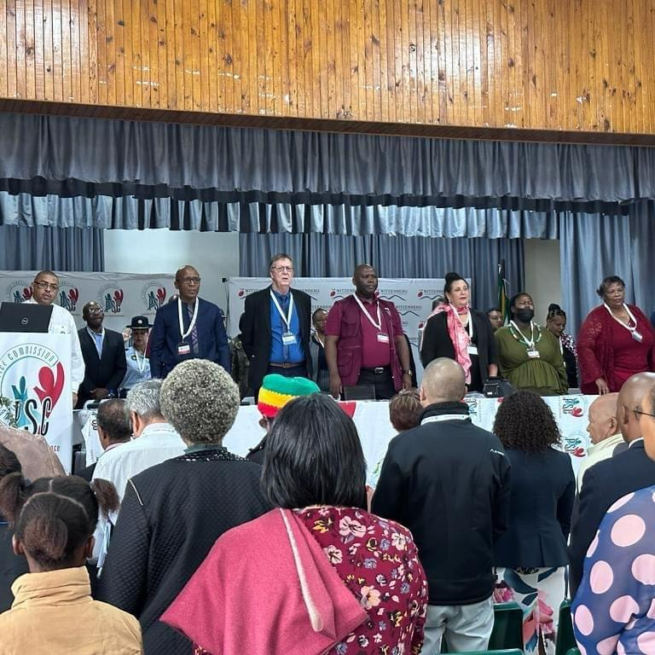

- Mayoral Monday

The Executive Mayor, together with the Mayoral Committee members and officials commenced with the Mayoral Mondays in September 2022 and they have now finally visited all five municipal areas in the district.

The final Mayoral Monday was held in Stellenbosch on Monday, 27 February 2023.

All registered businesses, stakeholders, and community organisations in the Stellenbosch municipal area, had the opportunity to meet with the Executive Mayor and representatives of the various departments.

This form of engagement enabled organisations to address issues that were specific to their challenges on a one-on-one basis, and we have included the priorities in our Integrated Development Plan which informed the 2023/2024 – 2024/2025 Medium Term Revenue and Expenditure Framework (MTREF).

We know that to remain a municipality of excellence, we must take government to the citizen. Public participation is a vital part of the CWDM’s IDP and budgetary processes, and through continuous engagement we can ensure that the challenges and needs are being addressed in our budget.

Speaker, more on what emanated from the Mayoral Mondays will be addressed in the tabling of the draft budget.

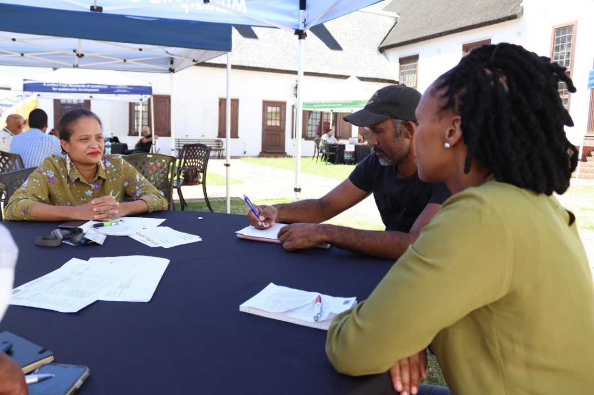

I thank you.

C.7 CONSIDERATION OF NOTICES OF MOTION
_______________________________________________________________

None.

C.8 CONSIDERATION OF NOTICES OF QUESTIONS (3/2/1/5)
_______________________________________________________________

COUNCIL MEETING: 23 MARCH 2023: ITEM C.8

RESOLVED Unanimously:

That cognisance be taken of the confirmation by the Municipal Manger that Councillor M.H. Yabo submitted a question, but due to constricted timeframes the matter will be dealt with in terms of the Rules of Order of Council with specific reference to Item 34.

C.9 CONSIDERATION OF MOTIONS OF EXIGENCY (3/2/1/4)
_______________________________________________________________

None.

C.10 MINUTES

C.10.1 CONFIRMATION OF THE MINUTES OF THE COUNCIL MEETING HELD ON THURSDAY, 23 FEBRUARY 2023 (3/2/1/6)
_______________________________________________________________

COUNCIL MEETING: 23 MARCH 2023: ITEM C.10.1

RESOLVED Unanimously:

That the minutes of the Council meeting held on Thursday, 23 February 2023 be taken as read and duly confirmed.

C.10.2 REPORT BY THE MUNICIPAL MANAGER: ACTION MINUTES OF THE COUNCIL MEETING HELD ON THURSDAY, 23 FEBRUARY 2023
______________________________________________________________

RESOLVED:

That cognisance be taken of the communication by the Municipal Manager that all matters pertaining to the action minutes of the Council meeting held on Thursday, 23 February 2023 had been attended to.
C.11 INTERVIEWS WITH OR PRESENTATIONS BY DEPUTATIONS
_______________________________________________________________

C.11.1 PRESENTATION: EPWP – MS. R.F. PETERSEN AND MR. J. CLOETE
_______________________________________________________________

Ms. F.R. Petersen and Mr. J. Cloete were welcomed to the meeting.

Mr. J. Cloete proceeded with a presentation regarding EPWP.

COUNCIL MEETING: 23 MARCH 2023: ITEM .11.1

RESOLVED: That –

*** (a) Cognisance be taken of the presentation by Mr. J. Cloete of the Department of Transport and Public Works, Western Cape Government, regarding the EPWP, attached as Annexure “A” to the minutes;

(b) A presentation pertaining to the EPWP programme of the Cape Winelands District Municipality be made at the next Council meeting.

C.12 URGENT MATTERS SUBMITTED BY THE MUNICIPAL MANAGER
_______________________________________________________________

None.

C.13 REPORT BY THE EXECUTIVE MAYOR: MAYORAL COMMITTEE MEETING HELD ON MONDAY, 6 FEBRUARY 2023 (3/2/2/1)
_______________________________________________________________

The following report outline the issues and decisions taken by the Mayoral Committee.

The relevant minutes of matters that served before the Executive Mayor and Mayoral Committee on the dates indicated have been distributed to all Councillors -

1 MEETING HELD ON 6 FEBRUARY 2023

MATTERS OF WHICH COGNISANCE WERE TAKEN:

MC.7.2 NOTIFICATION TO THE MAYORAL COMMITTEE: RESOLUTIONS BY THE EXECUTIVE MAYOR TOGETHER WITH THE MAYORAL COMMITTEE AND THE SPEAKER IN TERMS OF THE SYSTEM OF DELEGATIONS RECONFIRMED BY COUNCIL AT ITEM C.4.8 ON 2 DECEMBER 2021 (2/4/2)
______________________________________________________

RESOLVED:

That cognisance be taken of the item that served before the Mayoral Committee.

MC.7.3 NOTICE TO MAYORAL COMMITTEE: MINUTES OF THE MEETINGS OF THE TRAINING COMMITTEE HELD ON TUESDAY, 30 AUGUST 2022 AND TUESDAY, 25 OCTOBER 2022 (3/2/5/1)
______________________________________________________

RESOLVED:

That cognisance be taken of the item that served before the Mayoral Committee.

MC.7.4 ATTENDANCE REPORT OF THE NAMIBIA TOURISM EXPO IN WINDHOEK HELD FROM THURSDAY, 3 NOVEMBER 2022 TO SATURDAY, 5 NOVEMBER 2022 (17/15/5 & 6/23/1)
______________________________________________________

RESOLVED:

That cognisance be taken of the item that served before the Mayoral Committee.

MC.7.5 DEPARTMENT: TECHNICAL SERVICES: QUARTERLY REPORT: OCTOBER 2022 TO DECEMBER 2022 (2/10/1/5)
______________________________________________________

RESOLVED:

That cognisance be taken of the item that served before the Mayoral Committee.

MC.7.6 DEPARTMENT: TECHNICAL SERVICES: INFORMATION AND COMMUNICATION TECHNOLOGY REPORT FOR THE PERIOD OCTOBER 2022 TO DECEMBER 2022 (6/2/1/5)
______________________________________________________

RESOLVED:

That cognisance be taken of the item that served before the Mayoral Committee.

MATTERS OF WHICH RESOLUTIONS WERE TAKEN:

MC.7.7 OFFICE OF THE MUNICIPAL MANAGER: QUARTERLY REPORT FOR THE PERIOD FROM 1 OCTOBER 2022 TO 31 DECEMBER 2022 (2/10/1/1)
______________________________________________________

RESOLVED:

That cognisance be taken of the decision taken by the Executive Mayor together with the Mayoral Committee.

MC.8.2.1 MONTHLY PROGRESS REPORT ON MUNICIPAL MINIMUM COMPETENCY LEVELS: DECEMBER 2022
(4/12/5, 1/1/1 & 3/2/5/13)
______________________________________________________

RESOLVED:

That cognisance be taken of the decision taken by the Executive Mayor together with the Mayoral Committee.

MC.8.2.2 MONTHLY PROGRESS REPORT ON MUNICIPAL MINIMUM COMPETENCY LEVELS: JANUARY 2023
(4/12/5, 1/1/1 & 3/2/5/13)
______________________________________________________

RESOLVED:

That cognisance be taken of the decision taken by the Executive Mayor together with the Mayoral Committee.

MC.8.2.3 REVISION OF BUDGET ESTIMATES: MUNICIPAL ADJUSTMENTS BUDGET FOR THE 2022/2023 FINANCIAL YEAR
(5/1/1/9)
______________________________________________________

RESOLVED:

That cognisance be taken of the decision taken by the Executive Mayor together with the Mayoral Committee.

C.14 MATTERS FOR NOTIFICATION
_______________________________________________________________

C.14.1 NOTICE TO COUNCIL: MINUTES OF THE MEETING OF THE RULES COMMITTEE HELD ON MONDAY, 28 NOVEMBER 2022 (3/2/3/1)
_______________________________________________________________

PURPOSE OF SUBMISSION

That Council take cognisance of the minutes of the meeting of the Rules Committee held on Monday, 28 November 2022.

BACKGROUND

In terms of section 79 of the Local Government: Municipal Structures Act, 1998 (Act No. 117 of 1998), as amended:

- A municipal council may –

- establish one or more committees necessary for the effective and efficient performance of any of its functions or the exercise of any of its powers;

- appoint the members of such a committee from among its members; and

- dissolve a committee at any time.
(2) The municipal council –

- must determine the functions of a committee;

(b) may delegate duties and powers to it in terms of section 32;

(c) must appoint the chairperson;

(d) may authorise a committee to co-opt advisory members who are not members of the council within the limits determined by the council;

(e) may remove a member of a committee at any time; and

(f) may determine a committee’s procedure.

At Item C.15.3 of 27 January 2022 Council resolved that:

(a) The Rules Committee be re-established in terms of section 79 of the Local Government: Municipal Structures Act, 1998 (Act No. 117 of 1998);

- The following Whips of political parties represented in Council be appointed as members of the Rules Committee:

Cllr. W.M. Blom (DA)
Cllr. A.J. du Plessis (VF Plus)
Cllr. M.S. Liebenberg (PA)
Cllr. L. Ngwane (EFF)
Cllr. A.J. Pedro (GOOD)
Cllr. C.F. Wilskut (BO)
Cllr. M.H. Yabo (ANC)

- Members of the Rules Committee be appointed in terms of section 79(1)(b) of the Act, of which the Executive Mayor will be appointed ex officio, taking into account that section 160(8) of the Constitution of the Republic of South Africa, 1996 entitles members of committees of municipal councils to participate in the proceedings of a council and its committees in a manner that allows parties and interests reflected within the Council, to be fairly represented;

(d) The Speaker be appointed as Chairperson of the Rules Committee in terms of section 79(2)(c) of the Act;

(e) The function/terms of reference of the Rules Committee shall be to make recommendations to Council regarding matters affecting the procedures and policies of the municipal Council and its Councillors in terms of section 79(2) of the Act;

(f) Cognisance be taken of the fact that the Rules of Order adopted by Council stipulates in Clause 2(1) thereof that the relevant Rules of Order will also be applicable to all committees of Council (i.e. section 79 committees).

COMMENT

*** Attached as Annexure “A” is a copy of the minutes of the meeting of the Rules Committee held on Monday, 28 November 2022.

RECOMMENDATION BY MUNICIPAL MANAGER:

That Council take cognisance of the minutes of the meeting of the Rules Committee held on Monday, 28 November 2022.

COUNCIL MEETING: 23 MARCH 2023: ITEM C.14.1

RESOLVED:

That cognisance be taken of the minutes of the meeting of the Rules Committee held on Monday, 28 November 2022, attached as Annexure “A” to the agenda item.

C.14.2 SOUTH AFRICAN LOCAL GOVERNMENT ASSOCIATION WESTERN CAPE (SALGA WESTERN CAPE): PROVINCIAL WORKING GROUPS ATTENDANCE AND MINUTES FOR THE PERIOD FROM 13 FEBRUARY 2023 TO 17 FEBRUARY 2023 (1/R & 12/1/1/10)

_______________________________________________________________

PURPOSE OF SUBMISSION

That Council take note of the South African Local Government Association Western Cape (SALGA Western Cape): Provincial Working Groups attendance and minutes for the period from 13 February 2023 to 17 February 2023.

BACKGROUND

*** Attached as Annexure “A” is a copy of the minutes of the South African Local Government Association Western Cape (SALGA Western Cape): Human Settlement and Urban held on Monday, 13 February 2023.

*** Attached as Annexure “B” is a copy of the minutes of the South African Local Government Association Western Cape (SALGA Western Cape): Joint Provincial Working Group on Electricity and Energy Provision and Public Works, Water and Sanitation held on Monday, 13 February 2023.

*** Attached as Annexure “C” is a copy of the minutes of the South African Local Government Association Western Cape (SALGA Western Cape): Joint Economic Development and Job Creation and Development Planning and Rural Development Working Groups, Monday, 13 February 2023.

*** Attached as Annexure “D” is a copy of the minutes of the South African Local Government Association Western Cape (SALGA Western Cape): Provincial Working Group on Community Development and Security, Tuesday, 14 February 2023.

*** Attached as Annexure “E” is a copy of the minutes of the South African Local Government Association Western Cape (SALGA Western Cape): Joint Provincial Working Group on Public Transport and Roads and Environmental Management and Climate Resilience, Tuesday, 14 February 2023.

*** Attached as Annexure “F” is a copy of the minutes of the South African Local Government Association Western Cape (SALGA Western Cape): Provincial Working Group on Health, Wednesday, 15 February 2023.

*** Attached as Annexure “G” is a copy of the minutes of the South African Local Government Association Western Cape (SALGA Western Cape): Provincial Working Group Meeting on Emergency Services and Disaster Management, Thursday, 16 February 2023.

*** Attached as Annexure “H” is a copy of the minutes of the South African Local Government Association Western Cape (SALGA Western Cape): Provincial Working Group on Municipal Finance and Fiscal Policy, Thursday, 16 February 2023.

*** Attached as Annexure “I” is a copy of the minutes of the South African Local Government Association Western Cape (SALGA Western Cape): Provincial Working Group on Governance and Intergovernmental Relations, Friday, 17 February 2023.

*** Attached as Annexure “J” is a copy of the minutes of the South African Local Government Association Western Cape (SALGA Western Cape): Provincial Working Group on Municipal Capabilities and Institutional Resilience, Friday, 17 February 2023.

*** Attached as Annexure “K” is a copy of the minutes of the South African Local Government Association Western Cape (SALGA Western Cape): Provincial Working Group on Municipal Digital Solutions, Friday, 17 February 2023.

COUNCIL MEETING: 23 MARCH 2023: ITEM C.14.2

RESOLVED:

That cognisance be taken of the South African Local Government Association Western Cape (SALGA Western Cape): Provincial Working Groups attendance and minutes for the period from 13 February 2023 to 17 February 2023.

C.14.3 QUARTERLY REPORT OF THE CAPE WINELANDS DISTRICT MUNICIPALITY AUDIT AND PERFORMANCE COMMITTEE FOR THE SECOND QUARTER OF THE 2022/2023 FINANCIAL YEAR (3/2/5/3)

_______________________________________________________________

PURPOSE OF SUBMISSION

That Council take cognisance of the quarterly report of the Audit and Performance Committee of the Cape Winelands District Municipality for the second quarter of the 2022/2023 financial year.

BACKGROUND

*** Attached as Annexure “A” is a copy of the Audit and Performance Committee Report.

*** Attached as Annexure “B” is a copy of the minutes of the Audit and Performance Committee meeting held on 02 November 2022.

*** Attached as Annexure “C” is a copy of the minutes of the special Audit and Performance Committee meeting held on 12 December 2022.

*** Attached as Annexure “D” is a copy of the draft minutes of the Audit and Performance Committee meeting held on 01 February 2023, which will be approved at the next quarterly meeting which is scheduled to take place on 03 May 2023.

In terms of section 166(2)(a) of the Local Government: Municipal Finance Management Act, 2003 (Act No. 56 of 2003) (MFMA), the Audit and Performance Committee must provide advice on matters relating to:

- Internal financial control and internal audit;
- Risk management;
- Accounting policies;
- The adequacy, reliability and accuracy of financial reporting and information;
- Performance management;

- Effective governance;
- Performance evaluation;
- Compliance with the MFMA; and
- Any issues referred to it by the Council.

The Audit and Performance Committee must also review the annual financial statements in order to advise Council whether its finances are being managed efficiently and effectively.

Furthermore, the Audit and Performance Committee may respond to Council on issues raised by the Auditor–General in the audit report and carry out investigations into the financial affairs of the District Municipality if requested to do so by Council.

In order to execute its responsibilities effectively, the Audit and Performance Committee must have access to the financial records and all other relevant information of the District Municipality.

COMMENT

The Audit Committee is constituted in terms of section 166 of the Local Government: Municipal Finance Management Act, 2003 (Act No. 56 of 2003), the Local Government: Municipal Systems Act, 2000 (Act No. 32 of 2000), the National Treasury Framework for Managing Programme Performance Information, 2007 (as amended) and other applicable legislation or regulations and the requirements for good public governance practices.

The Audit and Performance Committee is an independent oversight and advisory body, advising amongst others the Municipal Council, the Mayoral Committee, the Accounting Officer, management and the staff of the District Municipality with regard to; internal financial controls and internal audit, risk management, accounting policies, compliance with applicable laws and regulations, issues raised by the Auditor-General of South Africa (AGSA) and Internal Audit (IA) in their reports and the effectiveness of the performance management system.

The first Audit and Performance Committee meeting for quarter two was held on 02 November 2022 to review the progress of the first quarter of the 2022/2023 financial year. A special Audit and Performance Committee meeting was held on 12 December 2022 to review and discuss the Auditor-General final management report 2021/2022 financial year.

The Audit and Performance Committee meets quarterly and the progress meeting pertaining to the second quarter was held on 01 February 2023.

IMPLICATIONS

PERSONNEL

None.

Comment prepared by: Ms. G.C.N. Julie

FINANCIAL

None.

Comment prepared by: Ms. F.A. du Raan-Groenewald

LEGAL

In accordance with clause 4.1 of the Cape Winelands District Municipality Audit and Performance Management Charter 2022/2023 the Audit and Performance Committee shall submit quarterly reports to be considered by the Council through the offices of the Accounting Officer, which summarizes its recommendations and decisions. The minutes of the Audit and Performance Committee meeting(s) must be attached to these reports.

Comment prepared by: Ms. S.S. Sanders

RECOMMENDATION BY MUNICIPAL MANAGER:

That Council take cognisance of the quarterly report of the Audit and Performance Committee of the Cape Winelands District Municipality for the second quarter of the 2022/2023 financial year.

COUNCIL MEETING: 23 MARCH 2023: ITEM C.14.3

The Municipal Manager submitted and apology on behalf of the Chairperson of the Audit and Performance Committee for not attending the Council meeting due to prior commitments.

RESOLVED:

That cognisance be taken of the quarterly report of the Audit and Performance Committee of the Cape Winelands District Municipality for the second quarter of the 2022/2023 financial year.

C.15 MATTERS FOR CONSIDERATION
_______________________________________________________________

C.15.1 MONTHLY PROGRESS REPORT ON MUNICIPAL MINIMUM COMPETENCY LEVELS: FEBRUARY 2023 (4/12/5, 1/1/1 & 3/2/5/13)
_______________________________________________________________

PURPOSE OF SUBMISSION

That Council consider to approve the monthly Municipal Minimum Competency Levels Progress Report for February 2023.

MUNICIPAL MINIMUM COMPETENCE COMPLIANCE LEVEL

Number of Municipal Officials that must comply with the MMCL 84
Number of Municipal Officials that comply with MMCL 76
Number of Municipal Officials that are currently in the process 8
to obtain the necessary qualifications

BACKGROUND

The Municipal Regulations on Minimum Competency Levels were first issued on 15 June 2007. This required municipalities and municipal entities to achieve full compliance by 1 January 2013. The Regulations required officials holding key positions and those that are responsible for financial management to comply with the prescribed minimum competencies relevant to their positions.

In April 2012, National Treasury issued MFMA Circular 60 aimed at assisting municipalities who were experiencing difficulties in complying with the legislation for officials already in the employ of the municipality. In accordance with the Circular, municipalities could apply to the National Treasury to consider a delay in enforcement of certain provisions of the regulations as a “Special Merit Case”.

On 14 March 2014, National Treasury issued a MFMA Exemption Notice to delay the enforceability of the Regulations. This Exemption Notice lapsed on 30 September 2015.

After consultation with key stakeholders and correspondence received from municipalities regarding the challenges faced in attracting and retaining key skills as a result of the prescribed minimum competency level requirements, a decision was taken to further exempt municipalities and municipal entities from the application of Regulations 15 and 18 of the Municipal Regulations on Minimum Competency Levels for a period of 18 months from 3 February 2017.

In order to effectively address the above situation, the Cape Winelands District Municipality embarked on a formal tender process to ensure the procurement of an accredited Municipal Finance Management Programme (MFMP) service provider. In March 2016 Kgolo Institute was appointed on a three-year contract
as the preferred service provider for the CWDM’s Municipal Finance Management Programme. The Municipal Finance Management Programme were implemented via three intakes over a three-year contract period.

Intake 1 consisted of a combination of CWDM officials, those affected by the MFMA Regulations on Minimum Competency Levels, as well as those middle and junior management officials not affected by the MFMA Regulations on Minimum Competency Levels. Intake 1 concluded in January 2017.

Intake 2 commenced on 19 June 2017 and consisted of officials affected by the MFMA Regulations on Minimum Competency Levels, who have not participated in the previous Municipal Finance Management Programmes (MFMP). Intake 2 concluded in April 2018 and ensured that these officials were in full compliance with the prescribed competency levels on 02 August 2018, as stipulated in the MFMA Exemption Notice 40593.

Intake 3 commenced in July 2018 and consisted of outstanding middle and junior managers within the Cape Winelands District Municipality who are not affected by the Minimum Competency Levels. New appointees (Management Officials appointed after 3 February 2018 in terms of the MFMA Exemption Notice 40593) affected by the MMCL also formed part of Intake 3. Intake 3 concluded in April 2019.

Receipts of Statement of Results are administered by the LGSETA. Currently, the LGSETA has huge backlogs in terms of providing municipalities with these results. A number of affected CWDM officials have completed several Unit Standards and are currently awaiting their LGSETA certification. However, until such time that the CWDM receive these certificates to be issued by the LGSETA, it cannot be reflected in this report.

New Appointees - As from January 2019 (Not part of Intake 3) - All employees appointed after 1 January 2019 affected by the MFMA Exemption Notice 40593 embarked on the Municipal Finance Management Programme in order to ensure full compliance to the MMCL regulations. On 25 October 2019, the CWDM appointed Stellenbosch University (School of Public Leadership) as the new MFMP service provider. Affected officials commenced with the MFMP on 19 March 2020, however, the Covid-19 Lockdown negatively influenced the course schedules resulting in the postponement of the course, meaning that these affected learners completed their modules in September 2021.

COMMENT

*** On 3 February 2017, MFMA Exemption Notice 40593 was issued in terms of section 177(1) (b) of the MFMA relating to exemption from compliance with Regulations 15 and 18 of the Municipal Regulations on Minimum Competency levels (attached as Annexure “A”).

Paragraphs 2.5 and 2.6 of the MFMA Exemption Notice stipulate as follows:

  - A municipality must –

- Submit a report to the National Treasury on the implementation of the conditions referred to in paragraph 2.1(a), in respect of the municipality and each of its entities in such format and on such dates as the National Treasury determines; and

(b) On a monthly basis, submit to the National Treasury and the relevant Provincial Treasury a report with details of –

- Employment contracts of officials appointed by virtue of this Notice;
(ii) Registration with accredited training providers; and
(iii) Progress made in attaining the minimum competency levels.

2.6 The report envisaged in paragraph 2.5(b) must be tabled at each municipal council meeting to enable the council to –

- Enforce the Regulations and this Notice; and

- Institute corrective action as may be required.

Chapter 2 of the Municipal Minimum Competency Level Regulations stipulates as follows:

(3) An accounting officer and officials involved in supply chain management must note that failure to comply with supply chain management responsibilities, functions and powers may constitute financial misconduct in terms of the Act.

In addition, Chapter 7 of the Municipal Minimum Competency Level Regulations stipulates as follows:

14. Reporting on and monitoring competency levels

(1) The municipal manager of a municipality and the chief executive officer of a municipal entity must monitor, and take any necessary steps to ensure, compliance with the prescribed minimum competency levels for financial officials and supply chain management officials within the timeframes set out in regulation 15.

(2) A municipality must report the consolidated information in respect of the municipality and each of its entities set out in sub-regulation (4) —

- to the National Treasury and to the relevant provincial treasury by 30 January and 30 July of each year, until 30 July 2015; and

- in its annual report, reflecting the information as at the end of the financial year to which the report relates.

(3) A municipal entity must report to its parent municipality by 20 January and 20 July of each year, and in its annual report, the information set out in sub regulation (4). The annual report of the municipal entity must reflect the information as at the end of the financial year to which the report relates.

(4) A report on the compliance with prescribed competency levels must be in the format set out in the Annexure hereto and include the following minimum information as at 30 June and 31 December of each year, as may be appropriate –

- the total number of financial officials employed;
- the total number of financial officials whose competency assessments have been completed;
- the total number of supply chain management officials employed;
- the total number of supply chain management officials whose competency assessments have been completed;
- the total number of financial officials and supply chain management officials that meet the prescribed competency levels; and
- the total number of financial officials and supply chain management officials whose performance agreements comply with regulation 16.

16. Attainment of competency levels within prescribed timeframes to be included in performance agreements

(1) If a financial official or supply chain management official is employed by a municipality or municipal entity subject to a performance agreement and that official does not meet the minimum competency levels, attainment of such competency levels within the timeframes set out in regulation 15 must be included as a performance target in that official’s performance agreement.

The CWDM, fully complies with all of the above regulatory requirements, by submitting the required bi-annual reports to National Treasury and the inclusion of Municipal Minimum Competency Levels Progress Report as part of the CWDM Annual Report.

In terms of compliance with the Municipal Regulations on Minimum Competency Levels of officials at the Cape Winelands District Municipality, they are grouped as follows:

Category | Number of officials who comply
Municipal Manager | 1
Chief Financial Officer | 1
Senior Managers | 2
Supply Chain Management Head | 1
Supply Chain Management Manager | 1
Financial Officials at Middle Management Level | 22
Officials involved in Implementation of Supply Chain Management Policy: Officials with Financial Delegations | 29
Officials involved in Implementation of Supply Chain Management Policy: Officials serving on Supply Chain Management Bid Committees | 18

OUTSTANDING: OFFICIALS CURRENTLY ON MFMP TRAINING
Job Title | Date of appointment | Category
Director: Roads | 01/04/2022 | Financial Officials at Middle Management Level - "middle management level" means a management level associated with persons in middle management positions for supervising staff and includes- (a) an official directly accountable to a manager in the senior management level; or (b) a person that occupied a position in a management level, outside the local government sphere.
Deputy Director: Roads | 01/11/2021 | Officials involved in Implementation of Supply Chain Management Policy: Officials with Financial Delegations
Deputy Director: Resealing & Maintenance | 01/07/2021 | Officials involved in Implementation of Supply Chain Management Policy: Officials with Financial Delegations
Deputy Director: Construction & Maintenance | 01/05/2020 | Officials involved in Implementation of Supply Chain Management Policy: Officials with Financial Delegations
Manager: Office of Executive Mayor | 10/02/2022 | Officials involved in Implementation of Supply Chain Management Policy: Officials with Financial Delegations
Occupational Health & Safety Officer | 01/04/2022 | Officials involved in Implementation of Supply Chain Management Policy: Officials with Financial Delegations
Chief Audit Executive | 01/05/2022 | Officials involved in Implementation of Supply Chain Management Policy: Officials with Financial Delegations
Deputy Director:  Legal Services | 01/12/2023 | Officials involved in Implementation of Supply Chain Management Policy: Officials with Financial Delegations

This graph illustrates the CWDM officials that were required to comply with the Municipal Minimum Competency Levels (as stipulated in the MFMA Exemption Notice 40593), by 02 August 2018. As evident on this graph, all affected sixty-seven (67) x officials complied by 02 August 2018.

This graph illustrates the newly appointed CWDM officials, appointed after 02 August 2018 (as stipulated in the MFMA Exemption Notice 40593), that should comply within the required 18-month period. Within the CWDM a total of fifteen (15) x officials (affected by the MMCL) were appointed after 02 August 2018, of which eight (8) x officials complied within the prescribed period. Currently, eight (8) x officials are registered on the Municipal Finance Management Programme (MFMP), for completion by October 2023.

Eight (8) new appointments were made respectively in 2020 and 2021, all falling under the category: Officials involved in the implementation of Supply Chain Management policy: officials with financial delegations. The latter together with three (3) new appointed Financial Interns, embarked on the Municipal Finance Management Programme with Next Step Academy (Pty) Ltd, who was appointed as the accredited service provider, for the implementation of the Municipal Finance Management Programme. This MFMP commenced on 19 April 2022 and will run until 30 October 2023.

IMPLICATIONS

PERSONNEL

Officials who were already in the employment of municipalities prior to 3 February 2017 were given until 2 August 2018 to complete all outstanding prescribed Unit Standards, in order to ensure full compliance with the Regulation.

To give effect to Exemption Notice 40593, all affected officials (already in the employ of the Cape Winelands District Municipality), who are involved in the implementation of the Supply Chain Management policy of the Municipality, must meet the prescribed financial management competency levels. In addition, it is required of them to sign a Memorandum of Agreement which, inter alia, stipulated the consequences to officials should they refuse to either complete their outstanding Unit Standards and/or refuse to participate in the Municipal Finance Management Programme (MFMP).

REMEDIAL ACTIONS TAKEN:

None – All participants are progressing as per training schedule.

Comment prepared by: Ms. G.C.N. Julie

FINANCIAL

Sufficient provision has been made in the 2022/2023 financial year for MMCL training of newly appointed employees.

Comment prepared by: Ms. F.A. du Raan-Groenewald

LEGAL

Section 119(1) of the Local Government: Municipal Finance Management Act, 2003 (Act No. 56 of 2003) (MFMA) stipulates that the accounting officer and all other officials of a municipality or a municipal entity involved in the implementation of the supply chain management policy of the municipality must meet the prescribed financial management competency levels, whilst section 119(2) stipulates that a municipality and a municipal entity must for the purposes of subsection 119(1) provide resources or opportunities for the training of officials referred to in that subsection to meet the prescribed competency levels.

In terms of regulation 13 of the Municipal Regulations on Minimum Competency Levels, 2007 the municipal manager of a municipality and the chief executive officer of a municipal entity must ensure that competencies of all financial officials and supply chain management officials are assessed in order to identify and address gaps in competency levels of those officials.

In terms of regulation 14(1) of the Municipal Regulations on Minimum Competency Levels, 2007 the municipal manager of a municipality and the chief executive officer of a municipal entity must monitor and take any necessary steps to ensure compliance with the prescribed minimum competency levels for financial officials and supply chain management officials within the time frames set out in regulation 15.

Comment prepared by: Ms. S.S. Sanders

RECOMMENDATION BY MUNICIPAL MANAGER: That –

- The Executive Mayor and Mayoral Committee take cognisance of the monthly Municipal Minimum Competency Levels Progress Report for February 2023;

- The Executive Mayor together with the Mayoral Committee consider to recommend to Council to consider the monthly Municipal Minimum Competency Levels Progress Report for February 2023.

MAYORAL COMMITTEE: 7 MARCH 2023: ITEM MC.8.2.1

RESOLVED: That –

- Cognisance be taken of the monthly Municipal Minimum Competency Levels Progress Report for February 2023;

- It be recommended to Council to consider the monthly Municipal Minimum Competency Levels Progress Report for February 2023;

- In future, a copy of the latest bi-annual report submitted to National Treasury, as well as the compliance notice received from National Treasury, be included in the agenda item submitted to Council.

RECOMMENDATION BY MAYORAL COMMITTEE: That –

- Council consider the monthly Municipal Minimum Competency Levels Progress Report for February 2023;

- In future, a copy of the latest bi-annual report submitted to National Treasury, as well as the compliance notice received from National Treasury, be included in the agenda item submitted to Council.

COUNCIL MEETING: 23 MARCH 2023: ITEM C.15.1

RESOLVED : (35 Councillors) That –

- The monthly Municipal Minimum Competency Levels Progress Report for February 2023 be approved;

- In future, a copy of the latest bi-annual report submitted to National Treasury, as well as the compliance notice received from National Treasury, be included in the agenda item submitted to Council.

C.15.2 DRAFT ANNUAL REPORT AND DRAFT OVERSIGHT REPORT FOR THE 2021/2022 FINANCIAL YEAR (3/2/5/5, 5/1/1/13 & 9/1/1)
_______________________________________________________________

PURPOSE OF SUBMISSION

That Council considers to approve the draft Annual Report as well as the draft Oversight Report for the 2021/2022 financial year without reservations.

BACKGROUND

The draft 2021/2022 Annual Report is tabled in terms of sections 121 and 127 of the Local Government: Municipal Finance Management Act, 2003 (Act No. 56 of 2003).

The Local Government: Municipal Finance Management Act, 2003 (Act No. 56 of 2003), section 121(2), states that the purpose of the draft Annual Report is to provide a record of activities of Council during the financial year, and to provide a report on the performance against the budget for the financial year and to promote accountability to the local community for the decisions made throughout the year.

At Item C.15.9 of 26 January 2023 Council resolved that approval be granted for the draft 2021/2022 Annual Report to be made public for comment.

COMMENT

*** Included under separate cover in the agenda as Annexure “A” is a copy of the draft 2021/2022 Annual Report.

IMPLICATIONS

PERSONNEL

None.

Comment prepared by: Ms. G.C.N. Julie

FINANCIAL

The approval of the 2021/2022 Draft Annual Report and concomitant oversight report holds no financial implication.

Comment prepared by: Ms. F.A. du Raan-Groenewald

LEGAL

In terms of section 121(2) of the Local Government: Municipal Finance Management Act, 2003 (Act No. 56 of 2003) the purpose of the annual report is –

- to provide a record of the activities of the municipality or municipal entity during the financial year to which the report relates;

- to provide a report on performance against the budget of the municipality or municipal entity for that financial year; and

- to promote accountability to the local community for the decisions made throughout the year by the municipality or municipal entity.

Annual reports must be aligned with the planning documents and municipal budget for the year reported on. This means that the IDP, Budget, SDBIP, In-year reports, annual performance report and annual report should have similar and consistent information to facilitate understanding and to enable the linkage between plans and actual performance.

Annual reports are the key reporting instruments for municipalities to report against the performance targets and budgets outlined in their strategic plans. Annual reports are therefore required to contain information on service delivery and outcomes, in addition to financial statements. It is a backward-looking document, focusing on performance in the financial year that has just ended, and it must demonstrate how the budget was implemented and the results of service delivery operations for that financial year.

The annual report of municipalities is governed by Chapter 12 of the Local Government: Municipal Finance Management Act, 2003 (Act No. 56 of 2003). In terms of section 127(2) of the said Act, the mayor of a municipality must, within seven (7) months after the end of the financial year, table the annual report of the municipality in the municipal council.

Section 127(3)(a) and (b) of the Local Government: Municipal Finance Management Act, 2003 (Act No. 56 of 2003) stipulates that if the mayor, for whatever reason is unable to table in the council the annual report of the municipality, the mayor must promptly submit to the council a written explanation setting out the reasons for the delay, together with any components of the report that are ready and submit to council the outstanding report or the outstanding components of the annual report as soon as possible.

The table below is a short summary of the Chapter 12 process:

ACTION | DEADLINE
The Mayor must within 7 months after the end of the financial year table the draft Annual Report in Council. | 31 January 2023
The Accounting Officer must publish the draft Annual Report. | Immediately after tabling
The Accounting Officer must invite submissions. | Immediately after tabling
The Accounting Officer must submit the draft Annual Report to the Auditor General, Provincial Treasury and the Provincial Department of Local Government. | Immediately after tabling
Council must deal with the draft Annual Report within 9 months after the end of the financial year. Part of this process includes the drafting of an oversight report. | 31 March 2023

In terms of section 121(3) of the Local Government: Municipal Finance Management Act, 2003 (Act No. 56 of 2003) the Annual Report must include-

- the annual financial statements of the municipality, and in addition, if section 122(2) applies, consolidated annual financial statements, as submitted to the Auditor-General for audit in terms of section 126(1);

- the Auditor-General’s audit report in terms of section 126(3) on those financial statements;

- the annual performance report of the Municipality prepared in terms of section 46 of the Municipal Systems Act;

- the Auditor-General’s audit report in terms of section 45(b) of the Municipal Systems Act;

- an assessment by the municipality’s accounting officer of any arrears on municipal taxes and service charges;

- an assessment by the municipality’s accounting officer of the municipality’s performance against the measurable performance objectives referred to in section 17(3)(b) for revenue collection from each revenue source and for each vote in the approved budget for the year;

- particulars of any corrective action taken or to be taken in response to issues raised in the audit reports referred to in paragraphs (b) and (d);

- any explanations that may be necessary to clarify issues in connection with the financial statements;

- any information as determined by the municipality;

- any recommendations of the municipality’s Audit Committee; and

- any other information as may be prescribed.

In terms of section 130(1) of the Local Government: Municipal Finance Management Act, 2003 (Act No. 56 of 2003) the meetings of a municipal council at which an annual report is to be discussed or at which decisions concerning an annual report are to be taken, must be open to the public and any organs of state.

According to MFMA Circular 32 dated 15 March 2006, the Annual Report is submitted to Council by the Accounting Officer and the Mayor and is part of the process for discharging accountability by the executive and administration for their performance in achieving the goals set by Council.

Comment prepared by: Ms. S.S. Sanders

RECOMMENDATION BY MUNICIPAL MANAGER:

That the members of the Municipal Public Accounts Committee (MPAC) consider to recommend to Council to –

- Take cognisance of –

- The report on the draft 2021/2022 Annual Report by the Chairperson of the Audit and Performance Committee as contained in the draft Annual Report;

(ii) The report of the Auditor-General on the financial statements of the Cape Winelands District Municipality for the year ended 30 June 2022 as contained in the draft Annual Report;

- Approve –

- The draft 2021/2022 Annual Report of the Cape Winelands District Municipality, attached as Annexure “A” to the agenda item;

- The draft 2021/2022 Oversight Report, without reservations.

MUNICIPAL PUBLIC ACCOUNTS COMMITTEE (MPAC): 14 MARCH 2023: ITEM MPAC.5.1

RESOLVED:

That it be recommended to Council to –

- Take cognisance of the –

(i) Report on the draft 2021/2022 Annual Report by the Chairperson of the Audit & Performance Committee as contained in the draft Annual Report;

(ii) Report of the Auditor-General on the financial statements of the Cape Winelands District Municipality for the year ended 30 June 2022 as contained in the draft Annual Report;

- Approve –

(i) The draft 2021/2022 Annual Report of the Cape Winelands District Municipality included under separate cover as Annexure “A” to the agenda item;

(ii) The draft 2021/2022 Oversight Report, without reservations.

RECOMMENDATION BY THE MUNICIPAL PUBLIC ACCOUNTS COMMITTEE (MPAC)

That Council consider to –

- Take cognisance of the –

(i) Report on the draft 2021/2022 Annual Report by the Chairperson of the Audit & Performance Committee as contained in the draft Annual Report;

(ii) Report of the Auditor-General on the financial statements of the Cape Winelands District Municipality for the year ended 30 June 2022 as contained in the draft Annual Report;

- Approve –

(i) The draft 2021/2022 Annual Report of the Cape Winelands District Municipality included under separate cover as Annexure “A” to the agenda item;

(ii) The draft 2021/2022 Oversight Report, without reservations.

COUNCIL MEETING: 23 MARCH 2023: ITEM C.15.2

RESOLVED : (33 Councillors) That –

- Cognisance be taken of the –

(i) Report on the draft 2021/2022 Annual Report by the Chairperson of the Audit & Performance Committee as contained in the draft Annual Report;

(ii) Report of the Auditor-General on the financial statements of the Cape Winelands District Municipality for the year ended 30 June 2022 as contained in the draft Annual Report;

- The following be approved:

(i) The draft 2021/2022 Annual Report of the Cape Winelands District Municipality included under separate cover as Annexure “A” to the agenda item;

(ii) The draft 2021/2022 Oversight Report, without reservations.

C.15.3 INVESTIGATION OF ALLEGED BREACHES OF THE CODE OF CONDUCT BY COUNCILLORS OF THE CAPE WINELANDS DISTRICT MUNICIPALITY
(3/2/1/2)
_______________________________________________________________

PURPOSE OF SUBMISSION

That Council consider the following recommendations from the Ad Hoc Special Committee –

- Council take cognisance of the:

(i) Legal opinion provided to the Ad Hoc Special Committee;

(ii) Ad Hoc Special Committee’s findings that there is no prima facie case to proceed with an investigation into the alleged breaches of the Code of Conduct by Councillors R.S. Nalumango and N. Phatsoane;

- Council consider to approve that the:

(i) Speaker informs the MEC for local government in the province of the findings of the Ad Hoc Special Committee within 14 days, in terms of Item 16(3) of the Code of Conduct for Councillors;

(ii) Cape Winelands District Municipality’s Rules of Order be reviewed and amended to reflect the outcome of the legal opinion, whereafter it be submitted to Council for approval via the Rules Committee.

BACKGROUND

In terms of Item 16 of the Code of Conduct for Councillors (‘the Code’) contained in Schedule 7 of the Local Government: Municipal Structures Act, 1998 (Act No. 117 of 1998), a municipal council may investigate and make a finding on any alleged breach of a provision of the Code or, alternatively, establish a special committee for this purpose.

On 27 October 2022, under Item C.15.9, Council considered the establishment of an Ad Hoc Special Committee to investigate and make findings on the alleged breaches of the Code by Councillors R.S. Nalumango and N. Phatsoane, following allegations that they failed to attend three (3) consecutive meetings of the Council of the Cape Winelands District Municipality on the following dates, and that they further failed to apply for leave of absence:

- Confidential Council meeting of 24 March 2022
- Ordinary Council meeting of 28 April 2022
- Confidential Council meeting of 28 April 2022.

Council resolved as follows:

That –

(a) The establishment of an ad hoc special committee to investigate and make findings on the alleged breaches of the Code of Conduct by Councillors R.S. Nalumango and N. Phatsoane be approved;

(b) The following Councillors be appointed to serve on the ad hoc special committee in (a) above:

Cllr. A.J. Pedro
Cllr. M.H. Yabo
Cllr. W.M. Blom
Cllr. X.L. Mdemka
Cllr. P. Daniels

(c) Councillor W.M. Blom be appointed as chairperson for the ad hoc special committee in (a) above;

(d) The ad hoc Special Committee on conclusion of their investigations and findings make appropriate recommendations to Council.

The Ad Hoc Special Committee met on 28 November 2022 where it was requested that the Legal Advisor of the District Municipality be part of the next meeting and that a legal opinion be obtained that will clarify whether an Ordinary Council meeting and a Confidential Council meeting held on the same day, are regarded as two different meetings or one meeting. Furthermore, it was inter alia resolved that ‘The newly appointed Legal Advisor of the Cape Winelands District Municipality determines whether there is a prima facie case against the Councillors who allegedly breached the Code of Conduct.’

Allegation pertaining to the failure to attend three (3) consecutive meetings

*** At the next meeting of the Ad Hoc Special Committee, held on 16 January 2023, the Legal Advisor provided the requested legal opinion, attached herewith as Annexure “AA”, wherein it was advised that an Ordinary Council Meeting and Confidential Council Meeting cannot be regarded as two separate official Council meetings, based on the following:

- The Constitutional requirement as per section 160(7) that ‘A Municipal Council must conduct its business in an open manner, and may close its sittings, or those of its committees, only when it is reasonable to do so having regard to the nature of the business being transacted.’

- Section 20(3) of the Local Government: Municipal Systems Act specifically mentions two instances when an entire meeting may be closed to the public. It states that ‘An executive committee mentioned in section 42 of the Municipal Structures Act and a mayoral committee mentioned in section 60 of that Act may, subject to subsection (1)(a), close any or all of its meetings to the public, including the media.’ As an executive committee structure has not been established for the CWDM, it follows that only a mayoral committee meeting may be closed in its entirety to the public and media.

- Item 19(1) of the CWDM Rules of Order provides that ‘Subject to the Systems Act, a Member may at any time during the meeting of the Council move that the public, including the media, be excluded from the meeting and state why it is reasonable to do so, having taken into account the nature of the business being transacted.’ Items 48 and 49 follow the same notion by repeating references to ‘during the meeting of the Council’. There is no indication in the Rules of Order that a separate confidential meeting may be held.

- Standing Rules and Orders for the Meetings of the Council and its Committees was developed by SALGA to serve as a guide to municipalities for the adoption of their respective Rules of Order. In terms hereof, ‘in-committee’ is defined as ‘… part of the meeting of the municipal council where the meeting will be closed and members of the public and press, and such municipal officials as determined by the Speaker, excluding the Municipal Manager, will be excluded from the meeting, based on the nature of the business being transacted’.

The committee accepted the legal opinion that an Ordinary Council Meeting and Confidential Council Meeting cannot be regarded as two separate official Council meetings, and accordingly resolved that there is no prima facie case in respect of the allegation that they were absent for three consecutive council meetings.

Allegation pertaining to the failure to apply for leave of absence

As per Item C.15.9, letters were sent to the aforementioned councillors setting out the allegations made against them and inviting them to provide comment in response thereto. Both councillors responded and provided motivations that apologies were indeed rendered. No further communication in this regard has been made available.

In Singatha Afrika Management Services (Pty) Ltd and Another v City of Cape Town and Another [2017] ZAWCHC 85 (22 August 2016) it was held that ‘[p]rima facie evidence becomes sufficient evidence if nothing is offered to counter its effect. The potentially conclusive effect of prima facie evidence is defused when the evidence is answered. If an answer is provided, the adjudicator must be in a position to rationally prefer the one version to the other in order to determine the matter’.
As no further correspondence is available in this regard, the respective responses therefore disproved the allegation and it can no longer be said that there is a prima facie case. Consequently, it was resolved that there is no prima facie case against the councillors regarding the allegation that they failed to apply for leave of absence for the aforementioned Council meetings.

COMMENT

In terms of item 4 of the Code, ‘A councillor must attend each meeting of the municipal council … except when–

(a) leave of absence is granted in terms of an applicable law or as determined by the rules and orders of the council; or

(b) that councillor is required in terms of this Code to withdraw from the meeting.’

Item 5(1) of the Code provides that ‘A municipal council may impose a fine as determined by the standing rules and orders of the municipal council on a councillor for–

(a) not attending a meeting which that councillor is required to attend in terms of item 4; or

(b) failing to remain in attendance at such meeting.’

In terms of item 5(2) of the Code ‘A councillor who is absent from three or more consecutive meetings of a municipal council … which that councillor is required to attend in terms of item 4, must be removed from office as a councillor.’

The Rules of Order which have been adopted by Council at Item C.4.2 on 2 December 2021 as the Standing Rules of Order for the Cape Winelands District Municipality determines that –

9. Attendance at Meetings

(1) Every Member attending a meeting of the Council must sign his or her name in the attendance register kept for such purpose.

(2) A Member must attend each meeting except when –

(a) Leave of absence is granted in terms of Clause 10; or

(b) The Member is required to withdraw in terms of law.

10. Leave of absence

(1) A Member who wishes to absent himself or herself from meetings must, before so absenting himself or herself, obtain leave of absence from the Speaker or Chairperson of a Committee prior to a meeting: Provided that the Speaker or Chairperson of a Committee, on good cause, may grant leave of absence after the meeting to a Member who has been prevented by special circumstances from obtaining leave of absence prior to the meeting.

(2) Where necessitated due to circumstances, leave of absence by Councillors must be duly applied for -

(a) In the case of Council – to the Speaker;

(b) In the case of meeting of Committees of Council – to the Chairperson of the relevant Committee and the Administration must also be timeously informed so that the alternate for the relevant Member of the Committee can be informed in time to ensure a quorum;

(c) In the case of workshops, congresses, functions and other meetings than those contemplated in (a) and (b) above – to the Executive Mayor who, in consultation with the Deputy Executive Mayor, has the delegated authority in terms of Clause G.4.02 of the System of Delegations to grant approval in such cases;

(d) The Administration must be timeously informed in the event that Councillors cannot attend workshops, congresses, meetings, functions, etc. so that cancellation arrangements can be made to avoid fruitless expenditure.

(3) In the event that Councillors have not timeously applied for leave of absence as contemplated in (a) to (c) above and the non-attendance results in expenditure related to the attendance of workshops, congresses, meetings, functions, etc. not being recoverable, such expenditure will constitute fruitless expenditure in terms of the Local Government: Municipal Financial Management Act, 2003 (Act No. 56 of 2003) (MFMA) which holds serious implications and penalties;

(4) Should Councillors contravene Clauses (1) and (2) above, the contravention will be -

(a) Addressed in terms of Item 4 of the Code of Conduct for Councillors as a contravention of the Code; or

(b) Dealt with as a contravention of section 32 of the Local Government: Municipal Finance Management Act, 2003 (Act No. 56 of 2003) and any non-recoverable costs recovered from the relevant Councillor.

11. Sanctions for non-attendance

(1) A Member who absents himself or herself from a meeting, or who fails to be in attendance at the commencement of the meeting, or fails to remain in attendance at such a meeting without prior leave having been granted in terms of Clause 10, is in breach of these Rules.

(2) A committee elected by Council, must investigate and make a finding on any breach referred to in sub-Clause (1) in accordance with the Policy on the Procedure for Investigation of Allegations of Contraventions of the Code of Conduct by Councillors.

(3) A Member who is absent from 3 (three) or more consecutive meetings of Council, shall be removed from office.

IMPLICATIONS

PERSONNEL

The Municipal Manager will designate appropriate officials to render administrative support to a special committee as contemplated in Item 16 of Schedule 7 of the Local Government: Municipal Structures Act, 1998 (Act No. 117 of 1998) to investigate and make a finding on any alleged breach of the Code of Conduct for Councillors.

Comment prepared by: Ms. G.C.N. Julie

FINANCIAL

Councillors under discussion are remunerated according to the Government Notice No. 2126 on the Determination of the Upper Limits of Salaries, Allowances and Benefits of Different Members of Municipal Councils, published in Government Gazette No. 46470 dated 2 June 2022 which states that “if a councillor is appointed to a district council in terms of section 23(1)b of the Structures Act as a part time member, such a councillor is entitled to an amount equal to the difference between the total remuneration package the councillor receives as a member from the local municipality (Stellenbosch and Witzenberg) and the total remuneration package from the district municipality”.

Comment prepared by: Ms. F.A. du Raan-Groenewald

LEGAL

Any investigation by a special committee in terms of Item 16(1)(b) of the Code of Conduct must be in accordance with the rules of natural justice to ensure procedural fairness and fair decision-making, based on the following elements –

(a) The right to a fair hearing;
(b) The rule against bias.

It should also be noted that in terms of Item 16(3) of the Code the Speaker must inform the MEC for local government in the province concerned within 14 days of the finding and sanction decided on by the council. As there is no sanction applicable in this instance, the MEC must only be informed of the findings.

The remainder of the legal implications have been fully addressed under BACKGROUND and COMMENT above.

Comment prepared by: Ms. S.S. Sanders

RECOMMENDATIONS BY THE AD HOC SPECIAL COMMITTEE: That –

- Council take cognisance of the –

(i) Legal opinion provided to the Ad Hoc Special Committee;

(ii) Ad Hoc Special Committee’s findings that there is no prima facie case to proceed with an investigation into the alleged breaches of the Code of Conduct by Councillors R.S. Nalumango and N. Phatsoane;

- Council consider to approve that –

(i) The Speaker informs the MEC for local government in the province of the findings of the Ad Hoc Special Committee within 14 days, in terms of Item 16(3) of the Code of Conduct for Councillors;

(ii) The Cape Winelands District Municipality’s Rules of Order be reviewed and amended to reflect the outcome of the legal opinion, where after it be submitted to Council for approval via the Rules Committee.

COUNCIL MEETING: 23 MARCH 2023: ITEM C.15.3

RESOLVED : (36 Councillors) That –

- Cognisance be taken of the –

(i) Legal opinion provided to the Ad Hoc Special Committee;

(ii) Ad Hoc Special Committee’s findings that there is no prima facie case to proceed with an investigation into the alleged breaches of the Code of Conduct by Councillors R.S. Nalumango and N. Phatsoane;

- Approval be granted that –

(i) The Speaker informs the MEC for local government in the province of the findings of the Ad Hoc Special Committee within 14 days, in terms of Item 16(3) of the Code of Conduct for Councillors;

(ii) The Cape Winelands District Municipality’s Rules of Order be reviewed and amended to reflect the outcome of the legal opinion, where after it be submitted to Council for approval via the Rules Committee.

C.15.4 DRAFT 2023/2024, 2024/2025 AND 2025/2026 MEDIUM TERM REVENUE AND EXPENDITURE FRAMEWORK (MTREF) FOR THE CAPE WINELANDS DISTRICT MUNICIPALITY (5/1/1/10)
_______________________________________________________________

PURPOSE OF SUBMISSION

That Council consider to adopt the draft 2023/2024, 2024/2025 and 2025/2026 Medium Term Revenue and Expenditure Framework (MTREF) for the Cape Winelands District Municipality for inspection, public representations, inputs and comment.

BACKGROUND

In terms of section 16 of the Local Government: Municipal Finance Management Act, 2003 (Act No. 56 of 2003) (MFMA) a council of a municipality must for each financial year approve an annual budget for the municipality before the start of the financial year.

In order for a municipality to comply with section 16(1) of the said Act, the mayor must table the annual budget at a council meeting at least 90 days before the start of the budget year.

Section 15 of the MFMA prescribes that a municipality may incur expenditure only:

15 (a) In terms of an approved budget; and

(b) Within the limits of the amounts appropriated for the different votes in an approved budget.

The contents of the annual budget must consist of the following documents as prescribed in terms of section 17 of the MFMA:

1. Realistically anticipated income and expenditure per vote for the budget year and the two financial years following the budget year;

2. Budget related policies of the Council (Tariff, Rates & Credit Control Policies);

3. Details of Council’s investments for the budget year;

4. Details of all proposed service delivery agreements, including material amendments to existing service delivery agreements;

5. Particulars of any proposed allocations or grants by the municipality in terms of sections 67 and 17(3)(j) of the MFMA;

6. The proposed cost to the municipality for the budget year of the salary, allowances and benefits of political office bearers and senior managers;

7. Capital expenditure and projects envisioned within the budget year.

COMMENT

*** Attached as Annexures “A” to “R” is a copy of the draft 2023/2024, 2024/2025 and 2025/2026 Medium Term Revenue and Expenditure Framework (MTREF) for the Cape Winelands District Municipality as well as related documents as prescribed by the Local Government: Municipal Finance Management Act, 2003 (Act No. 56 of 2003) (MFMA).

The IDP/Budget process for the 2023/2024 financial year was a consultative process – including the Budget Steering Committee, Executive Directors, Senior Managers, Councillors and other stakeholders.

The MTREF (2023 – 2026) has been compiled in accordance with the budget growth guidelines determined by National Treasury. Personnel expenditure (Salaries, Wages and Allowances) increased by 5.4% for 2023/2024,2024/2025 and 2025/2026. The Budget Steering Committee, established in terms of the Budget and Reporting Regulations, 2008, comprehensively scrutinised the proposed MTREF.
Due to strict budgetary control, management succeeded to compile a balanced budget.

DECLARATION BY MANAGEMENT

Management declare that they followed all guidelines prescribed by the relevant legislation during the budget process.

RECOMMENDATION BY MUNICIPAL MANAGER:

- That the Executive Mayor together with the Mayoral Committee consider to recommend to Council to adopt the draft 2023/2024, 2024/2025 and 2025/2026 Medium Term Revenue and Expenditure Framework (MTREF) for the Cape Winelands District Municipality as outlined in the attached Annexures for public participation for inspection, public representations, inputs and comment:

- The draft Medium Term Revenue and Expenditure Framework for the 2023/2024, 2024/2025 and 2025/2026 financial years as set out in Annexure “A”;

(ii) Adjustments to the budget related policies submitted as Annexure “B”;

(iii) Details of Council’s investments as set out in Annexure “C”;

(iv) Details of all proposed service delivery agreements, including material amendments to existing service delivery agreements as set out in Annexure “D”;

(v) Adjustments to the current Integrated Development Plan (IDP) as set out in Annexure “E” on the flash drives distributed to Councillors receiving a hard copy of the Mayoral Committee agenda;

(vi) Details of employment costs – salaries, allowances and benefits – of all political office-bearers, councillors and senior managers of the Cape Winelands District Municipality as set out in Annexure “F”;

(vii) Capital expenditure within the budget year as set out in Annexure “G”;

(viii) Projects to be undertaken within the budget year as set out in Annexure “H”;

(ix) Particulars of all proposed allocations and grants by the District Municipality in terms of section 67 of the MFMA, as set out in Annexure “I”;

(x) Proposed Tariffs for the 2023/2024 financial year as set out in Annexure “J”;

- Service Delivery Standard as set out in Annexure “K”;

- Measurable performance objectives for revenue from each source and for each vote in the budget, taking into account the District Municipality’s Integrated Development Plan (IDP) as part of Annexure “L”;

- Demand Plan as set out in Annexure “M”;

- That cognisance be taken of –

- MFMA Circular No. 122: Municipal Budget Circular for the 2023/2024 MTREF – 09 December 2022, attached as Annexure “N”;

- The Cape Winelands District Municipality’s:

- Air Quality Management Plan, attached as Annexure “O”;

- Draft Spatial Development Framework (2021-2025), attached as Annexure “P”;

(cc) Integrated Waste Management Plan, attached as Annexure “Q”;

- Corporate Disaster Management Planning Framework, attached as Annexure “R”;

(c) Annexure E and all the annexures referred to in subsection (b) of the recommendation by the municipal manager, will be distributed via flash drive to the Councillors receiving a hard copy of the Mayoral Committee agenda.

MAYORAL COMMITTEE: 7 MARCH 2023: ITEM MC.8.8.2

RESOLVED: That –

  - It be recommended to Council to adopt the draft 2023/2024, 2024/2025 and 2025/2026 Medium Term Revenue and Expenditure Framework (MTREF), as amended, for the Cape Winelands District Municipality as outlined in the attached Annexures for public participation for inspection, public representations, inputs and comment:

- The draft Medium Term Revenue and Expenditure Framework for the 2023/2024, 2024/2025 and 2025/2026 financial years as set out in Annexure “A”;

(ii) Adjustments to the budget related policies submitted as Annexure “B”;

(iii) Details of Council’s investments as set out in Annexure “C”;

(iv) Details of all proposed service delivery agreements, including material amendments to existing service delivery agreements as set out in Annexure “D”;

(v) Adjustments to the current Integrated Development Plan (IDP) as set out in Annexure “E” on the flash drives distributed to Councillors receiving a hard copy of the Mayoral Committee agenda;

(vi) Details of employment costs – salaries, allowances and benefits – of all political office-bearers, councillors and senior managers of the Cape Winelands District Municipality as set out in Annexure “F”;

(vii) Capital expenditure within the budget year as set out in Annexure “G”;

(viii) Projects to be undertaken within the budget year as set out in Annexure “H”;

(ix) Particulars of all proposed allocations and grants by the District Municipality in terms of section 67 of the MFMA, as set out in Annexure “I”;

(x) Proposed Tariffs for the 2023/2024 financial year as set out in Annexure “J”;

- Service Delivery Standard as set out in Annexure “K”;

- Measurable performance objectives for revenue from each source and for each vote in the budget, taking into account the District Municipality’s Integrated Development Plan (IDP) as part of Annexure “L”;

- Demand Plan as set out in Annexure “M”;

  - That cognisance be taken of –

- MFMA Circular No. 122: Municipal Budget Circular for the 2023/2024 MTREF – 09 December 2022, attached as Annexure “N”;

(ii) MFMA Circular No. 123: Municipal Budget Circular for the 2023/2024 MTREF – 03 March 2023, attached as Annexure “A” to the minutes;

- The Cape Winelands District Municipality’s:

- Air Quality Management Plan, attached as Annexure “O”;

- Draft Spatial Development Framework (2021-2025), attached as Annexure “P”;

- Integrated Waste Management Plan, attached as Annexure “Q”;

- Corporate Disaster Management Planning Framework, attached as Annexure “R”;

(c) Annexure E and all the annexures referred to in subsection (b) of the recommendation by the municipal manager, will be distributed via flash drive to the Councillors receiving a hard copy of the Mayoral Committee agenda.

RECOMMENDATION BY THE MAYORAL COMMITTEE:

  - That it be recommended to Council to adopt the draft 2023/2024, 2024/2025 and 2025/2026 Medium Term Revenue and Expenditure Framework (MTREF), as amended, for the Cape Winelands District Municipality as outlined in the attached Annexures for public participation for inspection, public representations, inputs and comment:

- The draft Medium Term Revenue and Expenditure Framework for the 2023/2024, 2024/2025 and 2025/2026 financial years as set out in Annexure “A”;

(ii) Adjustments to the budget related policies submitted as Annexure “B”;

(iii) Details of Council’s investments as set out in Annexure “C”;

(iv) Details of all proposed service delivery agreements, including material amendments to existing service delivery agreements as set out in Annexure “D”;

(v) Adjustments to the current Integrated Development Plan (IDP) as set out in Annexure “E” on the flash drives distributed to Councillors receiving a hard copy of the Mayoral Committee agenda;

(vi) Details of employment costs – salaries, allowances and benefits – of all political office-bearers, councillors and senior managers of the Cape Winelands District Municipality as set out in Annexure “F”;

(vii) Capital expenditure within the budget year as set out in Annexure “G”;

(viii) Projects to be undertaken within the budget year as set out in Annexure “H”;

(ix) Particulars of all proposed allocations and grants by the District Municipality in terms of section 67 of the MFMA, as set out in Annexure “I”;

(x) Proposed Tariffs for the 2023/2024 financial year as set out in Annexure “J”;

- Service Delivery Standard as set out in Annexure “K”;

- Measurable performance objectives for revenue from each source and for each vote in the budget, taking into account the District Municipality’s Integrated Development Plan (IDP) as part of Annexure “L”;

- Demand Plan as set out in Annexure “M”;

  - That cognisance be taken of –

- MFMA Budget Circulars for the 2023/2024 MTREF No. 122 dated 09 December 2022 and No. 123 dated 03 March 2023 , attached as Annexure “N”;

- The Cape Winelands District Municipality’s:

- Air Quality Management Plan, attached as Annexure “O”;

- Draft Spatial Development Framework (2021-2025), attached as Annexure “P”;

- Integrated Waste Management Plan, attached as Annexure “Q”;

- Corporate Disaster Management Planning Framework, attached as Annexure “R”;

(c) Annexure E and all the annexures referred to in subsection (b) of the recommendation by the municipal manager, will be distributed via flash drive to Councillors receiving a hard copy of the Council agenda.

COUNCIL MEETING: 23 MARCH 2023: ITEM C.15.4

(Councillor M. van Stade left the meeting at 11:30)

*** The Executive Mayor presented her Budget Speech on the draft 2023/2024, 2024/2025 and 2025/2026 Medium Term Revenue and Expenditure Framework (MTREF) for the Cape Winelands District Municipality to Council, a copy of which is attached as Annexure “B“ to the minutes.

The Speaker requested Councillor T.R. Mpulanyana to retire from the place of meeting for the remainder of the meeting due to persistent disregards of the directions of the Speaker.

(Councillor T.R. Mpulanyana left the meeting at 11:49)

Councillor M.H. Yabo congratulated the Executive Mayor on her budget speech and indicated his support for the draft 2023/2024, 2024/2025 and 2025/2026 Medium Term Revenue and Expenditure Framework (MTREF) for the Cape Winelands District Municipality with specific reference to support indicated for the most venerable members of society.

The Executive Mayor, Alderman (Dr.) H. von Schlicht seconded by the Executive Deputy Mayor, Ald. M. Sampson proposed that the draft 2023/2024, 2024/2025 and 2025/2026 Medium Term Revenue and Expenditure Framework (MTREF), as amended, for the Cape Winelands District Municipality as outlined in the attached Annexures for public participation for inspection, public representations, inputs and comment, be approved.

The matter was put to the vote and thirty-four (34) Councillors voted in favour of the proposal by the Executive Mayor, Alderman (Dr.) H. von Schlicht.

RESOLVED : (34 Councillors) That –

- The draft 2023/2024, 2024/2025 and 2025/2026 Medium Term Revenue and Expenditure Framework (MTREF), as amended, for the Cape Winelands District Municipality as outlined in the attached Annexures for public participation for inspection, public representations, inputs and comment, be approved:

- The draft Medium Term Revenue and Expenditure Framework for the 2023/2024, 2024/2025 and 2025/2026 financial years as set out in Annexure “A”;

(ii) Adjustments to the budget related policies submitted as Annexure “B”;

(iii) Details of Council’s investments as set out in Annexure “C”;

(iv) Details of all proposed service delivery agreements, including material amendments to existing service delivery agreements as set out in Annexure “D”;

(v) Adjustments to the current Integrated Development Plan (IDP) as set out in Annexure “E” on the flash drives distributed to Councillors receiving a hard copy of the Mayoral Committee agenda;

(vi) Details of employment costs – salaries, allowances and benefits – of all political office-bearers, councillors and senior managers of the Cape Winelands District Municipality as set out in Annexure “F”;

(vii) Capital expenditure within the budget year as set out in Annexure “G”;

(viii) Projects to be undertaken within the budget year as set out in Annexure “H”;

(ix) Particulars of all proposed allocations and grants by the District Municipality in terms of section 67 of the MFMA, as set out in Annexure “I”;

(x) Proposed Tariffs for the 2023/2024 financial year as set out in Annexure “J”;

- Service Delivery Standard as set out in Annexure “K”;

- Measurable performance objectives for revenue from each source and for each vote in the budget, taking into account the District Municipality’s Integrated Development Plan (IDP) as part of Annexure “L”;

- Demand Plan as set out in Annexure “M”;

- Cognisance be taken of –

- MFMA Budget Circulars for the 2023/2024 MTREF No. 122 dated 09 December 2022 and No. 123 dated 03 March 2023 , attached as Annexure “N”;

- The Cape Winelands District Municipality’s:

- Air Quality Management Plan, attached as Annexure “O”;

- Draft Spatial Development Framework (2021-2025), attached as Annexure “P”;

- Integrated Waste Management Plan, attached as Annexure “Q”;

- Corporate Disaster Management Planning Framework, attached as Annexure “R”;

(c) Annexure E and all the annexures referred to in subsection (b) of the recommendation by the municipal manager, will be distributed via flash drive to Councillors receiving a hard copy of the Council agenda.

C.16 CONCLUSION
_______________________________________________________________

The agenda was concluded at 11:57.

CONFIRMED ON THIS DAY OF 2023.

SPEAKER

DAH/iw

CAPE WINELANDS DISTRICT MUNICIPALITY

COUNCIL MEETING

THURSDAY, 23 MARCH AT 10:00

M I N U T E S

ITEM |  | PAGE
C.1 | OPENING
C.2 | ELECTION OF ACTING SPEAKER, IF NECESSARY
C.3 | DISCLOSURE OF ANY DIRECT OR INDIRECT INTERESTS BY COUNCILLORS AND/OR OFFICIALS
C.4 | APPLICATIONS FOR LEAVE OF ABSENCE
C.5 | STATEMENTS AND COMMUNICATIONS BY THE SPEAKER
C.6 | STATEMENTS AND COMMUNICATIONS BY THE EXECUTIVE MAYOR
C.7 | CONSIDERATION OF NOTICES OF MOTION
C.8 | CONSIDERATION OF NOTICES OF QUESTIONS
C.9 | CONSIDERATION OF MOTIONS OF EXIGENCY
C.10 | MINUTES
C.10.1 | CONFIRMATION OF THE MINUTES OF THE COUNCIL MEETING HELD ON THURSDAY, 23 FEBRUARY 2023  (ATTACHED)
C.10.2 | REPORT BY THE MUNICIPAL MANAGER: ACTION MINUTES OF THE COUNCIL MEETING HELD ON THURSDAY, 23 FEBRUARY 2023
C.11 | INTERVIEWS WITH OR PRESENTATIONS BY DEPUTATIONS
C.11.1 | PRESENTATION: EPWP – MESSRS. R.F. PETERSEN AND J. CLOETE
C.12 | URGENT MATTERS SUBMITTED BY THE MUNICIPAL MANAGER
C.13 | REPORT BY THE EXECUTIVE MAYOR: MAYORAL COMMITTEE MEETING HELD ON MONDAY, 6 FEBRUARY 2023 (3/2/2/1) | 1

2

ITEM |  | PAGE
C.14 | MATTERS FOR NOTIFICATION
C.14.1 | NOTICE TO COUNCIL: MINUTES OF THE MEETING OF THE RULES COMMITTEE HELD ON MONDAY, 28 NOVEMBER 2022 (3/2/3/1) | 3
C.14.2 | SOUTH AFRICAN LOCAL GOVERNMENT ASSOCIATION WESTERN CAPE (SALGA WESTERN CAPE): PROVINCIAL WORKING GROUPS ATTENDANCE AND MINUTES FOR THE PERIOD FROM 13 FEBRUARY 2023 TO 17 FEBRUARY 2023 (1/R & 12/1/1/10) | 10
C.14.3 | QUARTERLY REPORT OF THE CAPE WINELANDS DISTRICT MUNICIPALITY AUDIT AND PERFORMANCE COMMITTEE FOR THE SECOND QUARTER OF THE 2022/2023 FINANCIAL YEAR (3/2/5/3) | 53
C.15 | MATTERS FOR CONSIDERATION
C.15.1 | MONTHLY PROGRESS REPORT ON MUNICIPAL MINIMUM COMPETENCY LEVELS: FEBRUARY 2023 (4/12/5, 1/1/1 & 3/2/5/13) | 81
C.15.2 | DRAFT ANNUAL REPORT AND DRAFT OVERSIGHT REPORT FOR THE 2021/2022 FINANCIAL YEAR (3/2/5/5, 5/1/1/13 & 9/1/1) | 95
C.15.3 | INVESTIGATION OF ALLEGED BREACHES OF THE CODE OF CONDUCT BY COUNCILLORS OF THE CAPE WINELANDS DISTRICT MUNICIPALITY (3/2/1/2) | 100
C.15.4 | DRAFT 2023/2024, 2024/2025 AND 2025/2026 MEDIUM TERM REVENUE AND EXPENDITURE FRAMEWORK (MTREF) FOR THE CAPE WINELANDS DISTRICT MUNICIPALITY (5/1/1/10) | 216
C.16 | CONCLUSION

