ACTION MINUTES

COUNCIL MEETING

21 AUGUST 2023

CAPE WINELANDS DISTRICT MUNICIPALITY

MINUTES OF THE ORDINARY COUNCIL MEETING OF THE CAPE WINELANDS DISTRICT MUNICIPALITY HELD ON MONDAY, 21 AUGUST 2023 AT 10:00 IN THE COUNCIL CHAMBER, CAPE WINELANDS DISTRICT MUNICIPALITY, TRAPPES STREET, WORCESTER

PRESENT (3/2/1/2)

COUNCILLORS

Ald. D.D. Joubert (Speaker)
Ald. (Dr.) H. von Schlicht (Executive Mayor)
Ald. M. Sampson (Deputy Executive Mayor)
Cllr. W.M. Blom
Cllr. M.N. Bushwana
Cllr. G.J. Carinus
Cllr. D. Carolissen
Cllr. G.J. Fredericks
Ald. S. Goedeman
Cllr. E. Groenewald
Cllr. V. Hani
Cllr. F. Jacobs
Cllr. D.B. Janse
Cllr. J.J.S. Januarie
Cllr. C.O. Klaaste
Cllr. S.E. Korabie
Cllr. J. Kriel
Cllr. M.S. Liebenberg
Cllr. J. Maliti
Cllr. C. Manuel
Cllr. X.L. Mdemka
Ald. C. Meyer
Cllr. T.R. Mpulanyana
Cllr. R.S. Nalumango
Cllr. D.W. Nel
Cllr. A.J. Pedro
Cllr. A.M. Richards
Cllr. N.D. Sauerman
Cllr. J. Smit
Cllr. M. Smit
Cllr. J.H.P. Steyn
Cllr. D. Swart
Cllr. M. van Stade
Cllr. C.F. Wilskut
Cllr. M.H. Yabo

OFFICIALS

Mr. H.F. Prins (Municipal Manager)
Ms. F.A. du Raan-Groenewald
Mr. F. van Eck
Mr. P.A. Williams
Ms. K. Smit
Ms. B.T. Daries
Ms. G.C.N. Julie
Mr. R. Hollenbach
Ms. S. Green
Mr. R.W.B. van Wyk
Ms. N.J. Fortuin
Ms. A.C. Roodt
Mr. D.A. Heath
Ms. I. Willemse

C.1 OPENING (3/2/1/2)
_______________________________________________________________

The Speaker welcomed all present and requested a moment of reflection.

Councillor A.J. Pedro opened the meeting with prayer.

C.2 ELECTION OF ACTING SPEAKER, IF NECESSARY (3/2/1/2)
_______________________________________________________________

Not applicable.

C.3 DISCLOSURE OF ANY DIRECT OR INDIRECT INTERESTS BY COUNCILLORS AND/OR OFFICIALS (3/4/1 & 4/8/4)
_______________________________________________________________

None.

C.4 APPLICATION FOR LEAVE OF ABSENCE (3/2/1/2)
_______________________________________________________________

COUNCILLORS

Cllr. A.J. du Plessis
Ald. R. Farao
Cllr. L. Ngwane
Cllr. W.C. Petersen
Cllr. N. Phatsoane
OFFICIALS

None.

C.5 STATEMENTS AND COMMUNICATIONS BY THE SPEAKER (Verbatim)
(3/2/1/3)
_______________________________________________________________

Councillor Birthdays: August 2023

I would like to congratulate the following Councillors who celebrated their birthdays in August 2023:

03 August : Cllr. M.H. Yabo
24 August : Cllr. L. Ngwane
30 August : Ald. M. Sampson

COUNCIL MEETING: 21 AUGUST 2023: ITEM C.5

RESOLVED:

That cognisance be taken of the communication by the Speaker that in terms of Item 6 of the Rules of Order of the Cape Winelands District Municipality, Annexures pertaining to Item C.15.4 of the agenda had been distributed to all Councillors and that the following item will be dealt with under Item C.15.5 of the agenda:

C.15.5 DETERMINATION OF UPPER LIMITS OF SALARIES, ALLOWANCES AND BENEFITS OF COUNCILLORS OF THE CAPE WINELANDS DISTRICT MUNICIPALITY (5/11/1 & 12/1/1/9)

ACTION | DUE DATE | COMMENT
Noted. | - | Matter had been dealt with under Item C.15.5 of the agenda.

C.6 STATEMENTS AND COMMUNICATIONS BY THE EXECUTIVE MAYOR (Verbatim) (3/2/1/3)
_______________________________________________________________

Thank you Speaker, allow me to share highlights and statements with Council.

- A message of sympathy

Speaker, it is with heavy heart that I too on behalf of Council express our condolences on the tragic passing of a dedicated Cape Winelands District Municipality employee, Mr. J. Nel. Our hearts also go out to all those who lost a loved one during this month. In this difficult time, we extend our deepest sympathy and support to the grieving families and colleagues as they navigate through this time of mourning.

- SANTACO Taxi Strike

Reflecting on recent events, I am acutely aware of the impact that the taxi impasse had on our district. Its consequences are of huge concern, especially as we consider the communities that had to bear the brunt of the taxi strike. Our thoughts and prayers go out to those who lost loved ones or were robbed of their livelihoods during this mayhem.

However, despite the shadow of negativity that overwhelms us, I believe that today's communication should not dwell solely on these challenges. It is important that we shift our minds towards the bright spots that our district continues to yield. In times like these, it is crucial that we recognise and celebrate the resilience of our communities.

- Highlights and Accolades

Allow me to highlight a few of these uplifting achievements. Just this month, we can take pride in the fact that three talented rugby players, Canan Moodie, Kurt-Lee Arendse and Grant Williams that hails from the Cape Winelands District were selected to represent our beloved Bokke at the Rugby World Cup in France. Their achievement resonate as a testament to the extraordinary potential embedded within our community.

It brings me immense pride to further note that two exceptional netball players, Nichole Taljaard and Nicola Smith from Maties have earned the honour of representing South Africa in the Netball World Cup earlier this month. This achievement not only shines a spotlight on the talent within our community but also reinforces our commitment to fostering excellence and nurturing the aspirations of our young athletes.

Furthermore, the recent Miss South Africa competition brought forth an inspiring success story as Nande Mabala, hailing from Zwelethemba, claimed the title of second runner-up. This accomplishment stands as a shining testament to the immense talent and ambition that reside within our community. Nande's achievement not only reflects her personal dedication but also serves as a source of motivation for all aspiring young people. We extend our heartfelt congratulations to her and offer our best wishes as she takes on the responsibilities of being a role model for young girls. May her journey inspire others to reach for their dreams and embrace their potential to make a positive impact on the world.

In the Cape Winelands, the possibilities are endless – a myriad of activities to engage in and an equal number of reasons to hold our heads high. The recent recognition of the Ceres Rail Company as the "Best Adventure Experience" is a shining example of the remarkable achievements within our tourism industry.

Furthermore, our unwavering dedication to youth development is yielding tangible results, as we get ready to take another group of learners from the Langeberg municipal area on an overseas journey. This forthcoming experience holds the potential to broaden their perspectives, fostering a sense of wonder and an enduring passion for learning within them. With each opportunity we provide, we sow the seeds of hope for our youth, investing in the future leaders of our community.

I also want to confirm that a delegation of the Cape Winelands District Municipality under the leadership of Ald. R. Farao will visit Landesverband Kinder-und Jungerholungszentren (KiEZ) in Germany from Sunday, 20 August 2023 to Thursday, 31 August 2023 to give effect to the signed agreement of cooperation between the Landesverband Kinder-und Jungerholungszentren (KiEZ), Sachen-anhault e.v, Deutschland and the Cape Winelands District Municipality in the Republic of South Africa with a view to exchange knowledge pertaining to fire-fighting.

We have also announced the Mayoral Study Aid Fund being extended to the Top Achievers of the Cape Winelands District. The establishment of the Mayoral Study Aid Fund will add a substantial boost to the top achiever at each high school in the Cape Winelands District. Each recipient will receive a noteworthy study aid grant directly benefiting their educational journey. We believe that investing in these bright minds will have a positive and lasting impact on our district, not only recognising academic excellence but also showing our commitment to ensure our residents live in dignity.

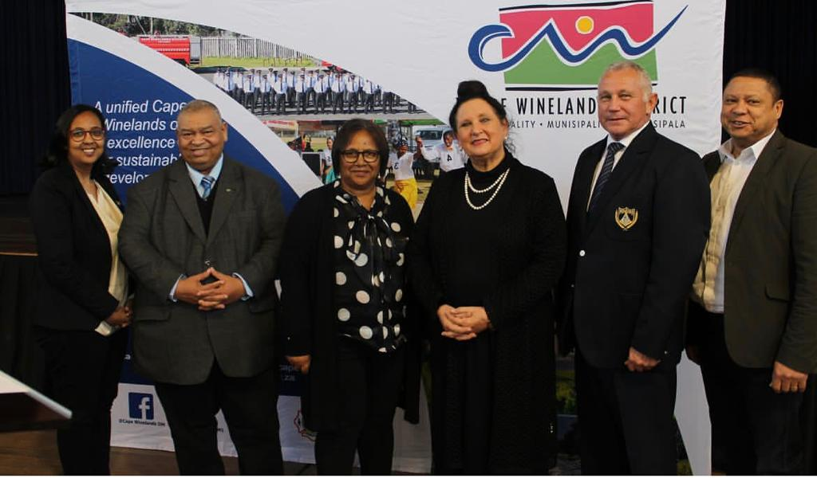

- Highlights and Accolades

We conducted an oversight visit to roads in the CWDM with the Western Cape Minister for Agriculture, Dr. Ivan Meyer. This was to see the progress made in repairing of the roads that were heavily impacted by the June 2023 floods. The current repairs to Slanghoek, Skilpadvlei and the Dekkersvlei roads have cost around R1.5 million so far. The repairs to the roads visited are interim repairs. The CWD roads, and especially the rural roads are vital, not only to the agricultural sector, but also for tourism, and for the access to education and health services for the residents that live in the area. Our dedication to enhance these vital arteries remains unwavering.

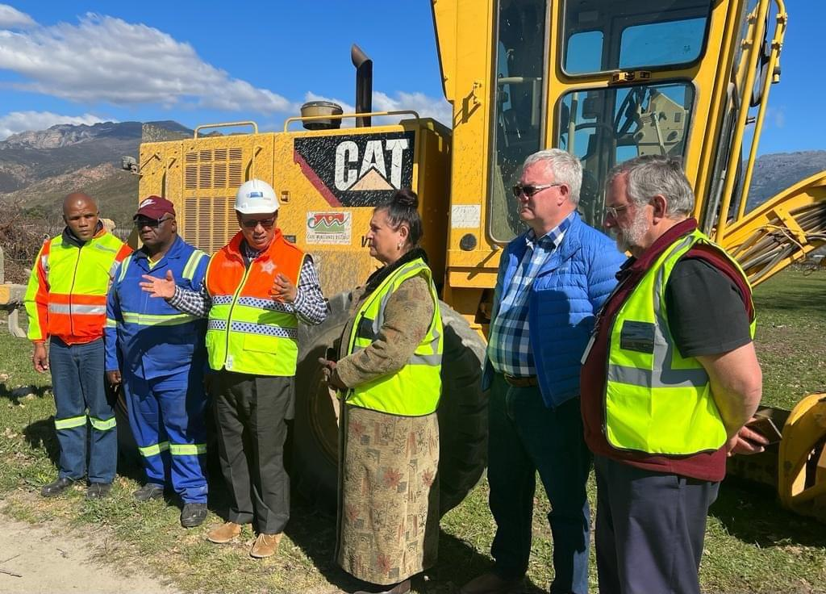

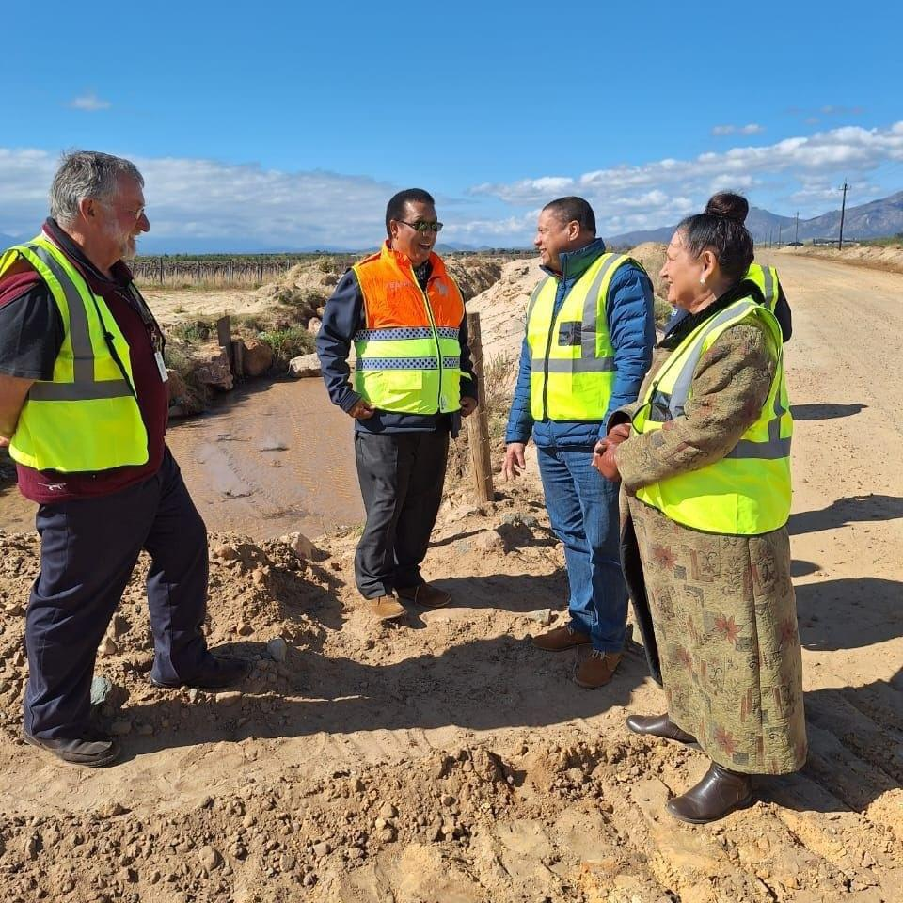

In closing, while I acknowledge the challenges that we also face, let us not lose sight of the resilience, triumphs, and potential that characterize our district. As we move forward, let us remain steadfast in our dedication to creating a brighter future for all those we serve.

As politicians, we are entrusted with a profound duty to elevate our communities, and it is evident that we must strive for a better tomorrow. As the political head of this Municipality, it is my duty to ensure that our actions match our words. We must strive for results that are bold and positively influence the lives of those we serve. Our constituents deserve more than just promises; they deserve efficient governance that translates into real, measurable progress.

Together, we have the power to transform challenges into opportunities, and obstacles into steppingstones toward a better future. Let us continue working together, not only to meet expectations but to exceed them. Through collaboration, dedication, and a unified vision of excellence for sustainable development, we can create a community that thrives.

I thank you, Speaker

C.7 CONSIDERATION OF NOTICES OF MOTION
_______________________________________________________________

None.

C.8 CONSIDERATION OF NOTICES OF QUESTIONS (3/2/1/5)
_______________________________________________________________

None.

C.9 CONSIDERATION OF MOTIONS OF EXIGENCY (3/2/1/4)
_______________________________________________________________

None.

C.10 MINUTES

C.10.1 CONFIRMATION OF THE MINUTES OF THE COUNCIL MEETING HELD ON MONDAY, 24 JULY 2023 (3/2/1/6)
_______________________________________________________________

COUNCIL MEETING: 21 AUGUST 2023: ITEM C.10.1

RESOLVED Unanimously:

That the minutes of the Council meeting held on Monday, 24 July 2023 be taken as read and duly confirmed.

C.10.2 REPORT BY THE MUNICIPAL MANAGER: ACTION MINUTES OF THE COUNCIL MEETING HELD ON MONDAY, 24 JULY 2023
______________________________________________________________

RESOLVED:

That cognisance be taken of the communication by the Municipal Manager that all matters pertaining to the action minutes of the Council meeting held on Monday, 24 July 2023 had been attended to.

C.11 INTERVIEWS WITH OR PRESENTATIONS BY DEPUTATIONS
_______________________________________________________________

None.

C.12 URGENT MATTERS SUBMITTED BY THE MUNICIPAL MANAGER
_______________________________________________________________

None.

C.13 REPORT BY THE EXECUTIVE MAYOR: MAYORAL COMMITTEE MEETING HELD ON TUESDAY, 4 JULY 2023 (3/2/2/1)
_______________________________________________________________

The following report outlines the issues and decisions taken by the Mayoral Committee.

The relevant minutes of matters that served before the Executive Mayor and Mayoral Committee on the date indicated has been distributed to all Councillors -

1 MEETING HELD ON 4 JULY 2023

MATTERS OF WHICH COGNISANCE WERE TAKEN:

MC.7.2 NOTIFICATION TO THE MAYORAL COMMITTEE: RESOLUTIONS BY THE EXECUTIVE MAYOR IN CONSULTATION WITH THE EXECUTIVE DEPUTY MAYOR AND THE EXECUTIVE MAYOR IN TERMS OF THE SYSTEM OF DELEGATIONS RECONFIRMED BY COUNCIL AT ITEM C.4.8 ON 2 DECEMBER 2021 FOR THE INTERIM (2/4/2)
______________________________________________________

RESOLVED:

That cognisance be taken of the item that served before the Mayoral Committee.

MC.7.3 NOTICE TO MAYORAL COMMITTEE: MINUTES OF THE MEETING OF THE TRAINING COMMITTEE HELD ON TUESDAY, 28 FEBRUARY 2023 (3/2/5/1)
______________________________________________________

RESOLVED:

That cognisance be taken of the item that served before the Mayoral Committee.

MC.7.4 SOUTH AFRICAN LOCAL GOVERNMENT BARGAINING COUNCIL (SALGBC) SALARY AND WAGE INCREASE FOR THE PERIOD 01 JULY 2023 TO 30 JUNE 2024 (4/5/1)
______________________________________________________

RESOLVED:

That cognisance be taken of the item that served before the Mayoral Committee.

MATTERS OF WHICH RESOLUTIONS WERE TAKEN:

MC.8.2.1 MONTHLY PROGRESS REPORT ON MUNICIPAL MINIMUM COMPETENCY LEVELS: JUNE 2023 (4/12/5, 1/1/1 & 3/2/5/13)
______________________________________________________

RESOLVED:

That cognisance be taken of the decision taken by the Executive Mayor together with the Mayoral Committee.

MC.8.3.1 EARLY CHILDHOOD DEVELOPMENT (ECD) (4/4/2/3)
______________________________________________________

RESOLVED:

That cognisance be taken of the decision taken by the Executive Mayor together with the Mayoral Committee.

MC.8.3.2 INTERNATIONAL RELATIONS: OFFICIAL VISIT TO LANDESVERBAND KINDER- UND JUGENDERHOLUNGS-ZENTRUM (KiEZ) IN GERMANY FROM SUNDAY, 20 AUGUST 2023 TO WEDNESDAY, 30 AUGUST 2023 TO GIVE EFFECT TO THE SIGNED AGREEMENT OF COOPERATION BETWEEN THE LANDESVERBAND KINDER- UND JUGENDERHOLUNGSZENTRUM (KIEZ), SACHSEN-ANHALT e.V, DEUTSCHLAND AND THE CAPE WINELANDS DISTRICT MUNICIPALITY IN THE REPUBLIC OF SOUTH AFRICA (10/3/8)
______________________________________________________

RESOLVED:

That cognisance be taken of the decision taken by the Executive Mayor together with the Mayoral Committee.

MC.8.3.3 INTERNATIONAL RELATIONS: OFFICIAL VISIT TO LANDESVERBAND KINDER-UND JUNGERHOLUNGSZENTREN (KiEZ) IN GERMANY FROM SUNDAY, 20 AUGUST 2023 TO THURSDAY, 31 AUGUST 2023 BY SKILLED FIREFIGHTERS TO GIVE EFFECT TO THE SIGNED AGREEMENT OF COOPERATION BETWEEN THE LANDESVERBAND KINDER-UND JUNGERHOLUNGSZENTREN (KIEZ), SACHEN-ANHAULT e.V, DEUTSCHLAND AND THE CAPE WINELANDS DISTRICT MUNICIPALITY IN THE REPUBLIC OF SOUTH AFRICA (10/3/8)
______________________________________________________

RESOLVED:

That cognisance be taken of the decision taken by the Executive Mayor together with the Mayoral Committee.

C.14 MATTERS FOR NOTIFICATION
_______________________________________________________________

C.14.1 UNAUDITED DRAFT ANNUAL REPORT OF THE CAPE WINELANDS DISTRICT MUNICIPALITY FOR THE 2022/2023 FINANCIAL YEAR
(5/1/1/18 & 9/1/1)
_______________________________________________________________

PURPOSE OF SUBMISSION

That Council take cognisance of the unaudited draft Annual Report for the 2022/2023 financial year.

BACKGROUND

*** Included under separate cover as Annexure “A” is a copy of the unaudited draft Annual Report for 2022/2023.

The draft Annual Report for 2022/2023 is tabled in terms of sections 121 and 127 of the Municipal Finance Management Act, 2003 (MFMA), (Act No. 56 of 2003) as well as guidance provided in MFMA Circulars 11 and 63.

COMMENT

The Annual Report will assist municipal councillors, municipalities, municipal entities, residents, oversight institutions and other users of Annual Reports with information and progress made on service delivery.

It must align with the Integrated Development Plan (IDP), Budget, Service Delivery and Budget Implementation Plan (SDBIP), and in year reports. The contents will also assist with the annual audits.
B
National Treasury’s Circular 63 provides that due to Annual Reports for the financial year having been produced late in the past, the objective of an Annual Report was lost. However, corrective action was taken by National Treasury and all municipalities are therefore required to prepare and submit their draft Annual Reports to the Auditor-General by 31 August each year.

IMPLICATIONS

PERSONNEL

None.

Comment prepared by: Ms G.C.N. Julie

FINANCIAL

None.

Comment prepared by: Ms FA du Raan-Groenewald

LEGAL

In terms of section 121(2) of the Local Government: Municipal Finance Management Act, 2003 (Act No. 56 of 2003) the purpose of the annual report is –

- to provide a record of the activities of the municipality or municipal entity during the financial year to which the report relates;

- to provide a report on performance against the budget of the municipality or municipal entity for that financial year; and

- to promote accountability to the local community for the decisions made throughout the year by the municipality or municipal entity.

Annual reports must be aligned with the planning documents and municipal budget for the year reported on. This means that the IDP, Budget, SDBIP, In-year reports, annual performance report and annual report should have similar and consistent information to facilitate understanding and to enable the linkage between plans and actual performance.

Annual reports are the key reporting instruments for municipalities to report against the performance targets and budgets outlined in their strategic plans. Annual reports are therefore required to contain information on service delivery and outcomes, in addition to financial statements. It is a backward-looking document, focusing on performance in the financial year that has just ended, and it must demonstrate how the budget was implemented and the results of service delivery operations for that financial year.

The annual report of municipalities is governed by Chapter 12 of the Local Government: Municipal Finance Management Act, 2003 (Act No. 56 of 2003). In terms of section 127(2) of the said Act, the mayor of a municipality must, within seven (7) months after the end of the financial year, table the annual report of the municipality in the municipal council.

Section 127(3)(a) and (b) of the Local Government: Municipal Finance Management Act, 2003 (Act No. 56 of 2003) stipulates that if the mayor, for whatever reason is unable to table in the council the annual report of the municipality, the mayor must promptly submit to the council a written explanation setting out the reasons for the delay, together with any components of the report that are ready and submit to council the outstanding report or the outstanding components of the annual report as soon as possible.

The table below is a short summary of the Chapter 12 process:

ACTION | DEADLINE
The Mayor must within 7 months after the end of the financial year table the draft Annual Report in Council. | 31 January 2024
The Accounting Officer must publish the draft Annual Report. | Immediately after tabling
The Accounting Officer must invite submissions. | Immediately after tabling
The Accounting Officer must submit the draft Annual Report to the Auditor General, Provincial Treasury and the Provincial Department of Local Government. | Immediately after tabling
Council must deal with the draft Annual Report within 9 months after the end of the financial year. Part of this process includes the drafting of an oversight report. | 31 March 2024

In terms of section 121(3) of the Local Government: Municipal Finance Management Act, 2003 (Act No. 56 of 2003) the Annual Report must include-

- the annual financial statements of the municipality, and in addition, if section 122(2) applies, consolidated annual financial statements, as submitted to the Auditor-General for audit in terms of section 126(1);

- the Auditor-General’s audit report in terms of section 126(3) on those financial statements;

- the annual performance report of the Municipality prepared in terms of section 46 of the Municipal Systems Act;

- the Auditor-General’s audit report in terms of section 45(b) of the Municipal Systems Act;

- an assessment by the municipality’s accounting officer of any arrears on municipal taxes and service charges;

- an assessment by the municipality’s accounting officer of the municipality’s performance against the measurable performance objectives referred to in section 17(3)(b) for revenue collection from each revenue source and for each vote in the approved budget for the year;

- particulars of any corrective action taken or to be taken in response to issues raised in the audit reports referred to in paragraphs (b) and (d);

- any explanations that may be necessary to clarify issues in connection with the financial statements;

- any information as determined by the municipality;

- any recommendations of the municipality’s Audit Committee; and

- any other information as may be prescribed.

In terms of section 130(1) of the Local Government: Municipal Finance Management Act, 2003 (Act No. 56 of 2003) the meetings of a municipal council at which an annual report is to be discussed or at which decisions concerning an annual report are to be taken, must be open to the public and any organs of state.

According to MFMA Circular 32 dated 15 March 2006, the Annual Report is submitted to Council by the Accounting Officer and the Mayor and is part of the process for discharging accountability by the executive and administration for their performance in achieving the goals set by Council.

Comment prepared by: Ms. S.S. Sanders

COUNCIL MEETING: 21 AUGUST 2023: ITEM C.14.1

RESOLVED:

That cognisance be taken of the unaudited draft Annual Report for the 2022/2023 financial year, included in the agenda under separate cover.

ACTION | DUE DATE | COMMENT
Noted. | - | -

C.15 MATTERS FOR CONSIDERATION
_______________________________________________________________

C.15.1 DRAFT CAPE WINELANDS DISTRICT MUNICIPALITY 2024/2025 IDP/BUDGET TIME SCHEDULE IN ORDER TO REVIEW THE 2ND REVIEW IDP OF THE 2022/2023 – 2026/2027 CAPE WINELANDS DISTRICT MUNICIPALITY 5TH GENERATION INTEGRATED DEVELOPMENT PLAN (IDP), PERFORMANCE MANAGEMENT SYSTEM (PMS) AND MEDIUM-TERM REVENUE AND EXPENDITURE FRAMEWORK (MTREF) FOR THE 2024/2025, 2025/2026 AND 2026/2027 FINANCIAL YEARS
(2/9/R, 5/1/R & 2/10/R)
_______________________________________________________________

PURPOSE OF SUBMISSION

That Council consider to approve the draft Cape Winelands District Municipality 2024/2025 IDP/Budget Time Schedule in order to review the 2nd Review IDP of the 2022/2023 - 2026/2027 Cape Winelands District Municipality 5th Generation Integrated Development Plan (IDP), Performance Management System (PMS) and Medium-Term Revenue and Expenditure Framework (MTREF) for the 2024/2025, 2025/2026 and 2026/2027 financial years.

BACKGROUND

The annual budget and the IDP are inextricably linked to one another, something that has been formalised through the promulgation of section 21(1) of the Local Government: Municipal Finance Management Act, 2003 (Act No. 56 of 2003) (MFMA) which states that –

The mayor of a municipality must –

- coordinate the processes for preparing the annual budget and for reviewing the municipality’s integrated development plan and budget-related policies to ensure that the tabled budget and any revisions of the integrated development plan and budget-related policies are mutually consistent and credible;

- at least 10 months before the start of the budget year, table in the municipal council a time schedule outlining key deadlines for–

- the preparation, tabling and approval of the annual budget;

- the annual review of –

(aa) the integrated development plan in terms of section 34 of the Municipal Systems Act; and
(bb) the budget related policies.

- the tabling and adoption of any amendments to the integrated development plan and the budget-related policies; and

(iv) the consultative processes forming part of the processes referred to in subparagraphs (i), (ii) and (iii).

It should be noted that the IDP/Budget Time Schedule is guided and informed by the District Framework Plan, and Process Plan which was adopted by Council on 28 April 2022.

COMMENT

*** Attached as Annexure "A" is a copy of the draft Cape Winelands District Municipality 2024/2025 IDP/Budget Time Schedule in order to review the 2nd Review IDP of the 2022/2023 - 2026/2027 Cape Winelands District Municipality 5th Generation Integrated Development Plan (IDP), PMS and MTREF for the 2024/2025, 2025/2026 and 2026/2027 financial years.

*** Attached as Annexure "B" is a copy of the approved Cape Winelands District Framework Plan, Process Plan and Council resolutions.

IMPLICATIONS

PERSONNEL

None.

Comment prepared by: Ms. G.C.N. Julie

FINANCIAL

R132 670 has been appropriated in respect of public participation processes in the 2024/2025 Annual Budget as displayed below:

Cost Code | Item Description | Amount
11512222630000 | Events (Transport) | R45 000
11512223080000 | Hire Charges (Venue) | R500
11512201270000 | Catering Services | R64 170
11512200590000 | Translator, scribes, and editors | R17 000
11512201670000 | Stage and sound crew | R6 000
TOTAL R132 670

Comment prepared by: Ms. F.A. du Raan-Groenewald

LEGAL

Legal Implications have been fully addressed under Background.

Comment prepared by: Ms. S.S. Sanders

RECOMMENDATION BY MUNICIPAL MANAGER:

That the Executive Mayor together with the Mayoral Committee consider to recommend to Council to approve the draft Cape Winelands District Municipality 2024/2025 IDP/Budget Time Schedule in order to review the 2nd Review IDP of the 2022/2023 - 2026/2027 Cape Winelands District Municipality 5th Generation Integrated Development Plan (IDP), Performance Management System (PMS) and Medium-Term Revenue and Expenditure Framework (MTREF) for the 2024/2025, 2025/2026 and 2026/2027 financial years.

MAYORAL COMMITTEE: 1 AUGUST 2023: ITEM MC.8.1.1

RESOLVED:

That it be recommended to Council to approve the draft Cape Winelands District Municipality 2024/2025 IDP/Budget Time Schedule in order to review the 2nd Review IDP of the 2022/2023 - 2026/2027 Cape Winelands District Municipality 5th Generation Integrated Development Plan (IDP), Performance Management System (PMS) and Medium-Term Revenue and Expenditure Framework (MTREF) for the 2024/2025, 2025/2026 and 2026/2027 financial years.

RECOMMENDATION BY MAYORAL COMMITTEE:

That Council consider to approve the draft Cape Winelands District Municipality 2024/2025 IDP/Budget Time Schedule in order to review the 2nd Review IDP of the 2022/2023 - 2026/2027 Cape Winelands District Municipality 5th Generation Integrated Development Plan (IDP), Performance Management System (PMS) and Medium-Term Revenue and Expenditure Framework (MTREF) for the 2024/2025, 2025/2026 and 2026/2027 financial years.

COUNCIL MEETING: 21 AUGUST 2023: ITEM C.15.1

The Executive Mayor proposed that the draft Cape Winelands District Municipality 2024/2025 IDP/Budget Time Schedule in order to review the 2nd Review IDP of the 2022/2023 - 2026/2027 Cape Winelands District Municipality 5th Generation Integrated Development Plan (IDP), Performance Management System (PMS) and Medium-Term Revenue and Expenditure Framework (MTREF) for the 2024/2025, 2025/2026 and 2026/2027 financial years, be approved.

The proposal by the Executive Mayor was seconded by Councillor D. Swart.

The proposal by the Executive Mayor was put to the vote and thirty-four (34) Councillors voted in favour of the proposal.

Councillor C.F. Wilskut abstained from voting.

RESOLVED (35 Councillors) :

That the draft Cape Winelands District Municipality 2024/2025 IDP/Budget Time Schedule in order to review the 2nd Review IDP of the 2022/2023 - 2026/2027 Cape Winelands District Municipality 5th Generation Integrated Development Plan (IDP), Performance Management System (PMS) and Medium-Term Revenue and Expenditure Framework (MTREF) for the 2024/2025, 2025/2026 and 2026/2027 financial years, be approved.

ACTION | DUE DATE | COMMENT
Office of the Municipal Manager (IDP) to attend to the matter. | Continuous | Notice will be displayed in the printed media with effect from 24 August 2023.

C.15.2 MONTHLY PROGRESS REPORT ON MUNICIPAL MINIMUM COMPETENCY LEVELS: JULY 2023 (4/12/5, 1/1/1 & 3/2/5/13)
_______________________________________________________________

PURPOSE OF SUBMISSION

That Council consider the monthly Municipal Minimum Competency Levels Progress Report for July 2023.

MUNICIPAL MINIMUM COMPETENCE COMPLIANCE LEVEL

Number of Municipal Officials that must comply with the MMCL 84
Number of Municipal Officials that comply with MMCL 76
Number of Municipal Officials that are currently in the process 8
to obtain the necessary qualifications

BACKGROUND

The Municipal Regulations on Minimum Competency Levels were first issued on 15 June 2007. This required municipalities and municipal entities to achieve full compliance by 1 January 2013. The Regulations required officials holding key positions and those that are responsible for financial management to comply with the prescribed minimum competencies relevant to their positions.

In April 2012, National Treasury issued MFMA Circular 60 aimed at assisting municipalities who were experiencing difficulties in complying with the legislation for officials already in the employ of the municipality. In accordance with the Circular, municipalities could apply to the National Treasury to consider a delay in enforcement of certain provisions of the regulations as a “Special Merit Case”.

On 14 March 2014, National Treasury issued a MFMA Exemption Notice to delay the enforceability of the Regulations. This Exemption Notice lapsed on 30 September 2015.

After consultation with key stakeholders and correspondence received from municipalities regarding the challenges faced in attracting and retaining key skills as a result of the prescribed minimum competency level requirements, a decision was taken to further exempt municipalities and municipal entities from the application of Regulations 15 and 18 of the Municipal Regulations on Minimum Competency Levels for a period of 18 months from 3 February 2017.

In order to effectively address the above situation, the Cape Winelands District Municipality embarked on a formal tender process to ensure the procurement of an accredited Municipal Finance Management Programme (MFMP) service provider. In March 2016 Kgolo Institute was appointed on a three-year contract as the preferred service provider for the CWDM’s Municipal Finance Management Programme. The Municipal Finance Management Programme were implemented via three intakes over a three-year contract period.

Intake 1 consisted of a combination of CWDM officials, those affected by the MFMA Regulations on Minimum Competency Levels, as well as those middle and junior management officials not affected by the MFMA Regulations on Minimum Competency Levels. Intake 1 concluded in January 2017.

Intake 2 commenced on 19 June 2017 and consisted of officials affected by the MFMA Regulations on Minimum Competency Levels, who have not participated in the previous Municipal Finance Management Programmes (MFMP). Intake 2 concluded in April 2018 and ensured that these officials were in full compliance with the prescribed competency levels on 02 August 2018, as stipulated in the MFMA Exemption Notice 40593.

Intake 3 commenced in July 2018 and consisted of outstanding middle and junior managers within the Cape Winelands District Municipality who are not affected by the Minimum Competency Levels. New appointees (Management Officials appointed after 3 February 2018 in terms of the MFMA Exemption Notice 40593) affected by the MMCL also formed part of Intake 3. Intake 3 concluded in April 2019.

Receipts of Statement of Results are administered by the LGSETA. Currently, the LGSETA has huge backlogs in terms of providing municipalities with these results. A number of affected CWDM officials have completed several Unit Standards and are currently awaiting their LGSETA certification. However, until such time that the CWDM receive these certificates to be issued by the LGSETA, it cannot be reflected in this report.

New Appointees - As from January 2019 (Not part of Intake 3) - All employees appointed after 1 January 2019 affected by the MFMA Exemption Notice 40593 embarked on the Municipal Finance Management Programme to ensure full compliance to the MMCL regulations. On 25 October 2019, the CWDM appointed Stellenbosch University (School of Public Leadership) as the new MFMP service provider. Affected officials commenced with the MFMP on 19 March 2020, however, the Covid-19 Lockdown negatively influenced the course schedules resulting in the postponement of the course, meaning that these affected learners completed their modules in September 2021.

COMMENT

*** On 3 February 2017, MFMA Exemption Notice 40593 was issued in terms of section 177(1)(b) of the MFMA relating to exemption from compliance with Regulations 15 and 18 of the Municipal Regulations on Minimum Competency levels (attached as Annexure “A”).

*** Attached as Annexure “B” is the CWDM Bi-annual Municipal Regulation on Minimum Competency Levels Report submitted to National Treasury for Semester 2 (July 2022 – December 2022).

*** Attached as Annexure “C” is the response received from National Treasury regarding feedback on the CWDM compliance status with regard to the CWDM Bi-annual Municipal Regulation on Minimum Competency Levels Report submitted to National Treasury for Semester 2 (July 2022 – December 2022).

*** Attached as Annexure “D” is the National Treasury (NT) Status Report for the submission of CWDM Bi-annual Municipal Regulation on Minimum Competency Levels Report submitted to National Treasury for Semester 1 (January 2022 – June 2022), showing full compliance of the CWDM in terms of the below MFMA Exemption Notice and regulations.

Paragraphs 2.5 and 2.6 of the MFMA Exemption Notice stipulate as follows:

  - A municipality must –

- Submit a report to the National Treasury on the implementation of the conditions referred to in paragraph 2.1(a), in respect of the municipality and each of its entities in such format and on such dates as the National Treasury determines; and

(b) On a monthly basis, submit to the National Treasury and the relevant Provincial Treasury a report with details of –

- Employment contracts of officials appointed by virtue of this Notice;
(ii) Registration with accredited training providers; and
(iii) Progress made in attaining the minimum competency levels.

2.6 The report envisaged in paragraph 2.5(b) must be tabled at each municipal council meeting to enable the council to –

- Enforce the Regulations and this Notice; and

- Institute corrective action as may be required.

Chapter 2 of the Municipal Minimum Competency Level Regulations stipulates as follows:

(3) An accounting officer and officials involved in supply chain management must note that failure to comply with supply chain management responsibilities, functions and powers may constitute financial misconduct in terms of the Act.

In addition, Chapter 7 of the Municipal Minimum Competency Level Regulations stipulates as follows:

14. Reporting on and monitoring competency levels

(1) The municipal manager of a municipality and the chief executive officer of a municipal entity must monitor, and take any necessary steps to ensure, compliance with the prescribed minimum competency levels for financial officials and supply chain management officials within the timeframes set out in regulation 15.

(2) A municipality must report the consolidated information in respect of the municipality and each of its entities set out in sub-regulation (4) —

- to the National Treasury and to the relevant provincial treasury by 30 January and 30 July of each year, until 30 July 2015; and

- in its annual report, reflecting the information as at the end of the financial year to which the report relates.

(3) A municipal entity must report to its parent municipality by 20 January and 20 July of each year, and in its annual report, the information set out in sub regulation (4). The annual report of the municipal entity must reflect the information as at the end of the financial year to which the report relates.

(4) A report on the compliance with prescribed competency levels must be in the format set out in the Annexure hereto and include the following minimum information as of 30 June and 31 December of each year, as may be appropriate –

- the total number of financial officials employed;
- the total number of financial officials whose competency assessments have been completed;
- the total number of supply chain management officials employed;
- the total number of supply chain management officials whose competency assessments have been completed;
- the total number of financial officials and supply chain management officials that meet the prescribed competency levels; and
- the total number of financial officials and supply chain management officials whose performance agreements comply with regulation 16.

16. Attainment of competency levels within prescribed timeframes to be included in performance agreements

(1) If a financial official or supply chain management official is employed by a municipality or municipal entity subject to a performance agreement and that official does not meet the minimum competency levels, attainment of such competency levels within the timeframes set out in regulation 15 must be included as a performance target in that official’s performance agreement.

The CWDM, fully complies with all the above regulatory requirements, by submitting the required bi-annual reports to National Treasury and the inclusion of Municipal Minimum Competency Levels Progress Report as part of the CWDM Annual Report.

In terms of compliance with the Municipal Regulations on Minimum Competency Levels of officials at the Cape Winelands District Municipality, they are grouped as follows:

Category | Number of officials who comply
Municipal Manager | 1
Chief Financial Officer | 1
Senior Managers | 2
Supply Chain Management Head | 1
Supply Chain Management Manager | 1
Financial Officials at Middle Management Level | 22

Officials involved in Implementation of Supply Chain Management Policy: Officials with Financial Delegations | 29
Officials involved in Implementation of Supply Chain Management Policy: Officials serving on Supply Chain Management Bid Committees | 18

OUTSTANDING: OFFICIALS CURRENTLY ON MFMP TRAINING
Job Title | Date of appointment | Category
Director: Roads | 01/04/2022 | Financial Officials at Middle Management Level - "middle management level" means a management level associated with persons in middle management positions for supervising staff and includes- (a) an official directly accountable to a manager in the senior management level; or (b) a person that occupied a position in a management level, outside the local government sphere.
Deputy Director: Roads | 01/11/2021 | Officials involved in Implementation of Supply Chain Management Policy: Officials with Financial Delegations
Deputy Director: Resealing & Maintenance | 01/07/2021 | Officials involved in Implementation of Supply Chain Management Policy: Officials with Financial Delegations
Deputy Director: Construction & Maintenance | 01/05/2020 | Officials involved in Implementation of Supply Chain Management Policy: Officials with Financial Delegations
Manager: Office of Executive Mayor | 10/02/2022 | Officials involved in Implementation of Supply Chain Management Policy: Officials with Financial Delegations
Occupational Health & Safety Officer | 01/04/2022 | Officials involved in Implementation of Supply Chain Management Policy: Officials with Financial Delegations
Chief Audit Executive | 01/05/2022 | Officials involved in Implementation of Supply Chain Management Policy: Officials with Financial Delegations
Deputy Director:  Legal Services | 01/12/2022 | Officials involved in Implementation of Supply Chain Management Policy: Officials with Financial Delegations

This graph illustrates the CWDM officials that were required to comply with the Municipal Minimum Competency Levels (as stipulated in the MFMA Exemption Notice 40593), by 02 August 2018. As evident on this graph, all affected sixty-seven (67) x officials complied by 02 August 2018.

This graph illustrates the newly appointed CWDM officials, appointed after 02 August 2018 (as stipulated in the MFMA Exemption Notice 40593), that should comply within the required 18-month period. Within the CWDM a total of fifteen (16) x officials (affected by the MMCL) were appointed after 02 August 2018, of which eight (8) x officials complied within the prescribed period. Currently, eight (8) x officials are registered on the Municipal Finance Management Programme (MFMP), for completion by October 2023.

Eight (8) new appointments were made respectively in 2020 and 2021, all falling under the category: Officials involved in the implementation of Supply Chain Management policy: officials with financial delegations. The latter together with three (3) new appointed Financial Interns, embarked on the Municipal Finance Management Programme with Next Step Academy (Pty) Ltd, who was appointed as the accredited service provider, for the implementation of the Municipal Finance Management Programme. This MFMP commenced on 19 April 2022 and will run until 30 October 2023.

IMPLICATIONS

PERSONNEL

Officials who were already in the employment of municipalities prior to 3 February 2017 were given until 2 August 2018 to complete all outstanding prescribed Unit Standards, in order to ensure full compliance with the Regulation.

To give effect to Exemption Notice 40593, all affected officials (already in the employ of the Cape Winelands District Municipality), who are involved in the implementation of the Supply Chain Management policy of the Municipality, must meet the prescribed financial management competency levels. In addition, it is required of them to sign a Memorandum of Agreement which, inter alia, stipulated the consequences to officials should they refuse to either complete their outstanding Unit Standards and/or refuse to participate in the Municipal Finance Management Programme (MFMP).

REMEDIAL ACTIONS TAKEN:

None – All participants are progressing as per training schedule.

Comment prepared by: Ms. G.C.N. Julie

FINANCIAL

Sufficient provision has been made in the 2023/2024 financial year for MMCL training of newly appointed employees.

Comment prepared by: Ms. F.A. du Raan-Groenewald

LEGAL

Section 119(1) of the Local Government: Municipal Finance Management Act, 2003 (Act No. 56 of 2003) (MFMA) stipulates that the accounting officer and all other officials of a municipality or a municipal entity involved in the implementation of the supply chain management policy of the municipality must meet the prescribed financial management competency levels, whilst section 119(2) stipulates that a municipality and a municipal entity must for the purposes of subsection 119(1) provide resources or opportunities for the training of officials referred to in that subsection to meet the prescribed competency levels.

In terms of regulation 13 of the Municipal Regulations on Minimum Competency Levels, 2007 the municipal manager of a municipality and the chief executive officer of a municipal entity must ensure that competencies of all financial officials and supply chain management officials are assessed in order to identify and address gaps in competency levels of those officials.

In terms of regulation 14(1) of the Municipal Regulations on Minimum Competency Levels, 2007 the municipal manager of a municipality and the chief executive officer of a municipal entity must monitor and take any necessary steps to ensure compliance with the prescribed minimum competency levels for Financial officials and supply chain management officials within the time frames set out in regulation 15.

Comment prepared by: Ms. S.S. Sanders

RECOMMENDATION BY MUNICIPAL MANAGER: That –

- The Executive Mayor and Mayoral Committee take cognisance of the monthly Municipal Minimum Competency Levels Progress Report for July 2023;

- The Executive Mayor together with the Mayoral Committee consider to recommend to Council to consider the monthly Municipal Minimum Competency Levels Progress Report for July 2023.

MAYORAL COMMITTEE: 1 AUGUST 2023: ITEM MC.8.2.1

RESOLVED: That –

- Cognisance be taken of the monthly Municipal Minimum Competency Levels Progress Report for July 2023;

- It be recommended to Council to consider the monthly Municipal Minimum Competency Levels Progress Report for July 2023;

- That the report in (b) above be amended to indicate individual progress of current learners as well as the relevant context.

ADDITIONAL COMMENT

At Item MC 8.2.1(c) of the Mayoral Committee held on 01 August 2023, it was inter alia resolved that the monthly MMCL Progress Report be amended to indicate individual progress of current learners as well as the relevant context.

*** At Item C.15.1 of the Council meeting held on 24 July 2023, questions were raised regarding the MMCL Report, and it was resolved that a report be submitted to the Speaker pertaining to members of staff that did not complete their MMCL training within the allocated 18 months from date of their appointment. Attached as Annexure “E” is the report that was submitted to the Speaker on Friday, 4 August 2023. The response included the background to the current MMCL training programme from its inception, current progress made by affected staff, as well as corrective measures taken to address the identified challenges.

With effect from September 2023 the monthly MMCL Progress Report will be amended to focus on the information as contained in the report to the Speaker, with subsequent regular updates.

RECOMMENDATION BY MAYORAL COMMITTEE:

That Council –

- Consider to approve the monthly Municipal Minimum Competency Levels Progress Report for July 2023;

- Take cognisance that in future, the report in (a) above will be amended to indicate individual progress of current learners as well as the relevant context.

COUNCIL MEETING: 21 AUGUST 2023: ITEM C.15.2

Councillor S.E. Korabie proposed that –

- The monthly Municipal Minimum Competency Levels Progress Report for July 2023 be approved;

- Cognisance be taken that in future, the report in (a) above will be amended to indicate individual progress of current learners as well as the relevant context.

The proposal by Councillor S.E. Korabie was seconded by Councillor F. Jacobs.

The matter was put to the vote and twenty-two (22) Councillors voted in favour of the proposal by Councillor S.E. Korabie.

The following Councillors abstained from voting:

Cllr. N.M. Bushwana
Cllr D. Carolissen
Cllr. V. Hani
Cllr. J.J.S. Januarie
Cllr. J. Maliti
Cllr. T.R. Nalumango
Cllr. M.H. Yabo
Cllr. M. van Stade
Cllr. M.S. Liebenberg
Cllr. TR. Mpulanyana
Cllr. A.M. Richards
Cllr. A.J. Pedro
Cllr. C.F. Wilskut

RESOLVED (35 Councillors) : That –

- The monthly Municipal Minimum Competency Levels Progress Report for July 2023 be approved;

- Cognisance be taken that in future, the report in (a) above will be amended to indicate individual progress of current learners as well as the relevant context.

ACTION | DUE DATE | COMMENT
Noted. | - | -

C.15.3 REPORT ON ACTIVITIES OF THE MUNICIPAL PUBLIC ACCOUNTS COMMITTEE IN QUARTER 4 OF THE 2022/2023 FINANCIAL YEAR (3/2/5/17)
_______________________________________________________________

PURPOSE OF SUBMISSION

That Council consider the activities of the Municipal Public Accounts Committee (MPAC) during the period from 01 April 2023 to 30 June 2023.

BACKGROUND

Each municipal council must establish a committee called the Municipal Public Accounts Committee. The municipal council must establish the functions of the above-mentioned MPAC; this has been done by means of a Council approved Terms of Reference.

COMMENT

*** Attached as Annexure “A” is a copy of the “Report on activities emanating from the MPAC meeting for quarter 4 of 2022/2023, held on Friday, 21 July 2023”.

This quarterly MPAC report was submitted to the Speaker of Council and is subsequently tabled to Council in terms of section 79A(4) of the Local Government: Municipal Structures Amendment Act, 2021.

IMPLICATIONS

PERSONNEL

None.

Comment prepared by: Ms. G.C.N. Julie

FINANCIAL

None.

Comment prepared by: Ms. F.A. du Raan-Groenewald

LEGAL

MPAC’s Terms of Reference, at 8.1, stipulates that The MPAC will report directly to Council on the activities of the Committee, and at 8.2, Reports of the MPAC must be submitted by the Chairperson to the Speaker who must table such reports at the next meeting of the Council.

Comment prepared by: Ms. S.S. Sanders

RECOMMENDATION BY MUNICIPAL PUBLIC ACCOUNTS COMMITTEE:

That Council consider the activities of the Municipal Public Accounts Committee (MPAC) during the period from 01 April 2023 to 30 June 2023.

COUNCIL MEETING: 21 AUGUST 2023: ITEM C.15.3

Councillor F. Jacobs proposed that Council take cognisance of the activities of the Municipal Public Accounts Committee (MPAC) during the period from 01 April 2023 to 30 June 2023.

The proposal by Councillor F. Jacobs was seconded by Councillor J. Kriel.

Councillor M.H. Yabo submitted a counter proposal that the item be withdrawn.

The counter proposal by Councillor M.H. Yabo was seconded by Councillor A.M. Richards.

The proposal was put to the vote and twenty-one (21) Councillors voted in favour of the proposal, and ten (10) Councillors voted against the proposal by Councillor F. Jacobs.

The following Councillors abstained from voting:

Cllr. D. Carolissen
Cllr. A.J. Pedro
Cllr. M. van Stade
Cllr. C.F. Wilskut

The counter proposal by Councillor M.H. Yabo was put to the vote and fifteen (15) Councillors voted in favour of the proposal, and twenty-two (22) Councillors voted against the proposal by Councillor M.H. Yabo.

RESOLVED with a majority of votes that cognisance be taken of the activities of the Municipal Public Accounts Committee (MPAC) during the period from 01 April 2023 to 30 June 2023.

ACTION | DUE DATE | COMMENT
Noted. | - | -

C.15.4 APPROVAL OF THE SPENDING OF FUNDS THAT WERE UNSPENT AS AT 30 JUNE 2023 IN TERMS OF SECTION 28(2)(e) OF THE LOCAL GOVERNMENT: MUNICIPAL FINANCE MANAGEMENT ACT, 2003 (ACT NO. 56 OF 2003) (MFMA) AND REGULATION 23(5) OF THE MUNICIPAL BUDGET AND REPORTING REGULATIONS, 2008
(5/1/1/6 & 3/2/5/15)
_______________________________________________________________

PURPOSE OF SUBMISSION

That Council consider to approve an adjustments budget as contemplated in section 28(2)(e) of the Local Government: Municipal Finance Management Act, 2003 (Act No. 56 of 2003) (MFMA) and regulation 23(5) of the Municipal Budget and Reporting Regulations, 2008 to authorise the spending of funds that were unspent as at 30 June 2023.

BACKGROUND

The Cape Winelands District Municipality received an Emergency Municipal Load-Shedding Relief Grant as per Provincial Gazette Extraordinary 8719 dated 13 February 2003 in the amount of R950 000. The Disaster Management Division commenced with a procurement process to acquire two back-up generators. However, due to a material irregularity in the bid specifications the Bid Adjudication Committee recommended to the Accounting Officer to cancel the tender for purchasing the said generators.

The irregularity was addressed, and the tender was readvertised on 14 July 2023.

The CWDM submitted a Roll-Over application to the Provincial Treasury for the unspent funds. If available, this approval will be distributed at the Council meeting.

COMMENTS

An adjustments budget, contemplated in section 28(2)(e) of the Local Government: Municipal Finance Management Act, 2003 (Act No. 56 of 2003) (MFMA), may authorise the spending of funds that were unspent at the end of the past financial year where the under-spending could not reasonably have been foreseen at the time to include projected roll-overs when the annual budget for the current year was approved by the council.

In addition, regulation 23(5) of the Municipal Budget and Reporting Regulations, 2008 (published in Government Gazette No. 32141 on 17 April 2009), determines the timeframes for the tabling of the said special adjustments budget as follows:

“An adjustments budget referred to in section 28(2)(e) of the Act may only be tabled after the end of the financial year to which the roll-overs relate, and must be approved by the municipal council by 25 August of the financial year following the financial year to which the roll-overs relate.”

*** Due to the proposed roll over Capital Adjustments Budget, an additional capital item must be added to the Capital Budget as reflected below. Adjustments to the budget are reflected in Annexures “A” (Revised Schedule B Budget Document), “D” (Revised Capital Budget) and “E” (Revised Schedule B supporting documents) included in the Agenda under separate cover. Annexure “E” is still in a development phase by the service provider and will be distributed at the Council meeting.

Capital Expenditure

Expenditure:

Description | Original budget  2023/2024 | Adjustment | Adjustment Budget  August 2023
2 x Back-up Generators | R0 | R950 000 | R950 000

Capital Funding:

Description | Original budget | Adjustment | Adjustment Budget
Load Shedding Relief Grant | R0 | R950 000 | R950 000

*** Annexure “B” reflects a summary of the Total Operating Budget before the requested adjustments and Annexure “C” reflects a summary of the Total Operating Budget should the requested adjustments be approved.

IMPLICATIONS

PERSONNEL

None.

Comment prepared by: Ms. G.C.N. Julie

FINANCIAL

The financial implications have been addressed under “BACKGROUND” and “COMMENT” above.

Comment prepared by: Ms. F.A. du Raan-Groenewald

LEGAL

Section 28 of the MFMA prescribes that:

(1) A municipality may revise an approved annual budget through an adjustments budget.

(2) An adjustments budget—

- must adjust the revenue and expenditure estimates downwards if there is material under-collection of revenue during the current year;

- may appropriate additional revenues that have become available over and above those anticipated in the annual budget, but only to revise or accelerate spending programmes already budgeted for;

- may, within a prescribed framework, authorise unforeseeable and unavoidable expenditure recommended by the mayor of the municipality;

- may authorise the utilisation of projected savings in one vote towards spending under another vote;

- may authorise the spending of funds that were unspent at the end of the past financial year where the under-spending could not reasonably have been foreseen at the time to include projected roll-overs when the annual budget for the current year was approved by the council;

- may correct any errors in the annual budget; and

- may provide for any other expenditure within a prescribed framework.

(3) An adjustments budget must be in a prescribed form.

(4) Only the mayor may table an adjustments budget in the municipal council, but an adjustments budget in terms of subsection (2)(b) to (g) may only be tabled within any prescribed limitations as to timing or frequency.

(5) When an adjustments budget is tabled, it must be accompanied by—

- an explanation how the adjustments budget affects the annual budget;

- a motivation of any material changes to the annual budget;

- an explanation of the impact of any increased spending on the annual budget and the annual budgets for the next two financial years; and

- any other supporting documentation that may be prescribed.

Section 69(1) and (2) of the MFMA, Budget implementation, states that:

- The accounting officer of a municipality is responsible for implementing the municipality’s approved budget, including taking all reasonable steps to ensure –

- that the spending of funds is in accordance with the budget and is reduced as necessary when revenue is anticipated to be less than projected in the budget or in the service delivery and budget implementation plan; and

- that revenue and expenditure are properly monitored.

- When necessary, the accounting officer must prepare an adjustments budget and submit it to the mayor for consideration and tabling in the municipal council.

Comment prepared by: Ms. S.S. Sanders

RECOMMENDATION BY EXECUTIVE MAYOR:

That Council consider to approve the spending of funds that were unspent as at 30 June 2023, as reflected in Annexures “A”, “B”, “C”, “D”, and “E” in terms of section 28(2)(e) of the Local Government: Municipal Finance Management Act, 2003 (Act No. 56 of 2003) (MFMA) and regulation 23(5) of the Municipal Budget and Reporting Regulations, 2008.

COUNCIL MEETING: 21 AUGUST 2023: ITEM C.15.4

Councillor M.H. Yabo requested for a caucus which was granted.

(Council adjourned at 11:22 and resumed its business at 11:27)

The Executive Mayor proposed that Council approve the spending of funds that were unspent as at 30 June 2023, as reflected in Annexures “A”, “B”, “C”, “D”, and “E” in terms of section 28(2)(e) of the Local Government: Municipal Finance Management Act, 2003 (Act No. 56 of 2003) (MFMA) and regulation 23(5) of the Municipal Budget and Reporting Regulations, 2008.

The proposal by the Executive Mayor was seconded by Councillor M.H. Yabo.

RESOLVED (32 Councillors) (Unanimously) :

That the spending of funds that were unspent as at 30 June 2023, as reflected in Annexures “A”, “B”, “C”, “D”, “E” and “F” in terms of section 28(2)(e) of the Local Government: Municipal Finance Management Act, 2003 (Act No. 56 of 2003) (MFMA) and regulation 23(5) of the Municipal Budget and Reporting Regulations, 2008, be approved.

ACTION | DUE DATE | COMMENT
Noted. | - | -

C.15.5 DETERMINATION OF UPPER LIMITS OF SALARIES, ALLOWANCES AND BENEFITS OF COUNCILLORS OF THE CAPE WINELANDS DISTRICT MUNICIPALITY (5/11/1 & 12/1/1/9)
_______________________________________________________________

PURPOSE OF SUBMISSION

That Council considers Government Notice No. 3807 on the Determination of the Upper Limits of Salaries, Allowances and Benefits of Different Members of Municipal Councils, published in Government Gazette No. 49142 of 18 August 2023.

BACKGROUND

*** Attached as Annexure “A” is a copy of Government Notice No. 3807 on the Determination of the Upper Limits of Salaries, Allowances and Benefits of Different Members of Municipal Councils, published in Government Gazette No. 49142 dated 18 August 2023.

IMPLICATIONS

PERSONNEL

None.

Comment prepared by: Ms. G.C.N. Julie

FINANCIAL

Adequate appropriation has been made in the 2023/2024 Annual Budget for the retrospective implementation from 1 July 2022 of the upper limits of salaries, allowances and benefits of a Grade 5 municipal council as set out in the Notice No. 3807 published in Government Gazette No. 49142 of 18 August 2023.

Notwithstanding the paragraph above, the financial implication of the cell phone and data allowances of R3 600 per month and R317 per month for proportional councillors reflect as follows:

COUNCILLORS | AMOUNT | NUMBER
Executive Mayor (Proportional) | 47 004 | 1
Deputy Executive Mayor  (Representative of Grade 4 Authority) | N/A | 1
Speaker (Proportional) | 47 004 | 1
Mayoral Committee  (Proportional) | 141 012 | 3
Mayoral Committee  (Representative of Grade 4 Authority) | N/A | 6
Chairperson MPAC (Proportional) | 47 004 | 1
Part Time (Proportional) | 517 044 | 11
Part Time (Representative of Grade 5 Authority) | N/A | 8
Part Time (Representative of Grade 4 Authority) | N/A | 9
Total | 799 068 | 41

SASRIA and insurance cover for life or disability are provided for over and above the total remuneration package. The limits of the said insurance are in line with the above-mentioned Government Gazette.

The application of the tools of the trade as included in the notice under discussion, is subject to concurrence by the MEC for local government in the province.

Capacity building for full-time and proportional representative councillors is subject to the determinations of paragraph 16 of the upper limits of salaries and allowances. Appropriation for capacity building programmes may be accommodated on the 2023/2024 Annual Budget.

Any overpayment made to a councillor, including any bonus, bursary, loan, advance or other benefit, might be viewed as irregular expenditure and must be dealt with as prescribed in terms of the relevant legislation.

Comment prepared by: Ms. F.A. du Raan-Groenewald

LEGAL

In terms of section 7 of the Remuneration of Public Office Bearers Act, 1998 (Act No. 20 of 1998):

(1) The upper limits of salaries and allowances of members of municipal councils are determined by notice in the Government Gazette by the Minister of Cooperative Governance and Traditional Affairs, after consultation with the MEC for Local Government in each province and after taking the factors as listed in section 7(1) into consideration;

(2) The salary and allowances of a member of a municipal council is determined by that municipal council by resolution of a supporting vote of a majority of its members, in consultation with the MEC responsible for local government in the province concerned, having regard to, inter alia the upper limits as set out in the notice referred to in subsection 7(1);

- The approval of the salaries and allowances of members of a municipal council may not be delegated by a municipal council.

Councillor remuneration must be dealt with strictly in accordance with the prescriptions of the Act and specific note should be taken that any remuneration paid to a political office bearer in contravention of the Act and/or section 219(4) of the Constitution of the RSA, 1996, shall be regarded as irregular expenditure as defined in the Local Government: Municipal Finance Management Act, 2003 (Act No. 56 of 2003) (MFMA).

Comment prepared by: Ms. S.S. Sanders

RECOMMENDATION BY MUNICIPAL MANAGER: That –

(a) Council take cognisance of –

- Government Notice No. 3807 on the Determination of the Upper Limits of Salaries, Allowances and Benefits of Different Members of Municipal Councils, published in Government Gazette No. 49142 dated 18 August 2023, attached as Annexure “A” to the agenda item;

(ii) The fact that adequate provision has been made in the 2023/2024 Annual Budget for the increased remuneration as set out in the Government Notice and that it is affordable for the Cape Winelands District Municipality;

(b) Council consider to approve the retrospective implementation from 1 July 2022 of the Upper Limits of the Salaries, Allowances and Benefits of a Grade 5 municipal council, as set out in Government Notice No. 3807 published in Government Gazette No. 49142 of 18 August 2023, subject to the outcome of consultation in this regard with the Minister of Local Government, Environmental Affairs and Development Planning of the Western Cape Province.

COUNCIL MEETING: 21 AUGUST 2023: ITEM C.15.5

Councillors A.J. Pedro and C.F. Wilskut objected against the submission of the item to Council.

The Executive Mayor proposed that the item pertaining to the Determination of the Upper Limits of Salaries, Allowances and Benefits of Different Members of Municipal Councils, published in Government Gazette No. 49142 of 18 August 2023 be deferred.

The proposal by the Executive Mayor was seconded by Councillor C.F. Wilskut.

Councillor M.H. Yabo requested a caucus which was granted.

The meeting adjourned at 11:36 and resumed its business at 12:10.

The proposal by the Executive Mayor was put the vote and twenty-two (22) Councillors voted in favour of the proposal and no Councillor voted against the proposal.

RESOLVED (35 Councillors)

With a majority of votes that the item be deferred.

ACTION | DUE DATE | COMMENT
Ms. F.A. du Raan-Groenewald (Admin Support) to attend to the matter. | To be determined | Special virtual Council meeting has been scheduled for 23 August 2023.

All officials except the following are excused from the meeting at 12:15 before the consideration of confidential matters:

Mr. H.F. Prins (Municipal Manager)
Ms. F.A. du Raan-Groenewald
Mr. F. van Eck
Mr. P.A. Williams
Ms. K. Smit
Ms. G.C.N. Julie
Mr. R. Hollenbach
Mr. D.A. Heath
Ms. I. Willemse

CAPE WINELANDS DISTRICT MUNICIPALITY

COUNCIL MEETING

MONDAY, 21 AUGUST 2023 AT 10:00

M I N U T E S

ITEM |  | PAGE
C.1 | OPENING
C.2 | ELECTION OF ACTING SPEAKER, IF NECESSARY
C.3 | DISCLOSURE OF ANY DIRECT OR INDIRECT INTERESTS BY COUNCILLORS AND/OR OFFICIALS
C.4 | APPLICATIONS FOR LEAVE OF ABSENCE
C.5 | STATEMENTS AND COMMUNICATIONS BY THE SPEAKER
C.6 | STATEMENTS AND COMMUNICATIONS BY THE EXECUTIVE MAYOR
C.7 | CONSIDERATION OF NOTICES OF MOTION
C.8 | CONSIDERATION OF NOTICES OF QUESTIONS
C.9 | CONSIDERATION OF MOTIONS OF EXIGENCY
C.10 | MINUTES
C.10.1 | CONFIRMATION OF THE MINUTES OF THE COUNCIL MEETING HELD ON MONDAY, 24 JULY 2023  (ATTACHED)
C.10.2 | REPORT BY THE MUNICIPAL MANAGER: ACTION MINUTES OF THE COUNCIL MEETING HELD ON MONDAY, 24 JULY 2023
C.11 | INTERVIEWS WITH OR PRESENTATIONS BY DEPUTATIONS
 | NONE
C.12 | URGENT MATTERS SUBMITTED BY THE MUNICIPAL MANAGER
C.13 | REPORT BY THE EXECUTIVE MAYOR: MAYORAL COMMITTEE MEETING HELD ON TUESDAY, 4 JULY 2023 (3/2/2/1) | 1

2

ITEM |  | PAGE
C.14 | MATTERS FOR NOTIFICATION
C.14.1 | UNAUDITED DRAFT ANNUAL REPORT OF THE CAPE WINELANDS DISTRICT MUNICIPALITY FOR THE 2022/2023 FINANCIAL YEAR  (5/1/1/18 & 9/1/1) | 3
C.15 | MATTERS FOR CONSIDERATION
C.15.1 | DRAFT CAPE WINELANDS DISTRICT MUNICIPALITY 2024/2025 IDP/BUDGET TIME SCHEDULE IN ORDER TO REVIEW THE 2ND REVIEW IDP OF THE 2022/2023 – 2026/2027 CAPE WINELANDS DISTRICT MUNICIPALITY 5TH GENERATION INTEGRATED DEVELOPMENT PLAN (IDP), PERFORMANCE MANAGEMENT SYSTEM (PMS) AND MEDIUM-TERM REVENUE AND EXPENDITURE FRAMEWORK (MTREF) FOR THE 2024/2025, 2025/2026 AND 2026/2027 FINANCIAL YEARS (2/9/R, 5/1/R & 2/10/R) | 7
C.15.2 | MONTHLY PROGRESS REPORT ON MUNICIPAL MINIMUM COMPETENCY LEVELS: JULY 2023 (4/12/5, 1/1/1 & 3/2/5/13) | 87
C.15.3 | REPORT ON ACTIVITIES OF THE MUNICIPAL PUBLIC ACCOUNTS COMMITTEE IN QUARTER 4 OF THE 2022/2023 FINANCIAL YEAR (3/2/5/17) | 111
C.15.4 | APPROVAL OF THE SPENDING OF FUNDS THAT WERE UNSPENT AS AT 30 JUNE 2023 IN TERMS OF SECTION 28(2)(e) OF THE LOCAL GOVERNMENT: MUNICIPAL FINANCE MANAGEMENT ACT, 2003 (ACT NO. 56 OF 2003) (MFMA) AND REGULATION 23(5) OF THE MUNICIPAL BUDGET AND REPORTING REGULATIONS, 2008  (5/1/1/6 & 3/2/5/15) | 116
C.15.5 | DETERMINATION OF UPPER LIMITS OF SALARIES, ALLOWANCES AND BENEFITS OF COUNCILLORS OF THE CAPE WINELANDS DISTRICT MUNICIPALITY (5/11/1 & 12/1/1/9)

