CAPE WINELANDS DISTRICT MUNICIPALITY

MINUTES OF THE COUNCIL MEETING OF THE CAPE WINELANDS DISTRICT MUNICIPALITY HELD ON THURSDAY, 24 MARCH 2022 AT 10:00 IN THE COUNCIL CHAMBER, CAPE WINELANDS DISTRICT MUNICIPALITY, TRAPPES STREET, WORCESTER

PRESENT (3/2/1/2)

COUNCILLORS

Cllr. D.D. Joubert (Speaker)
Ald. (Dr.) H. von Schlicht (Executive Mayor)
Ald. M. Sampson (Executive Deputy Mayor)
Ald. K. Adams
Cllr. E.G. Arendse
Cllr. W.M. Blom (Virtual)
Cllr. M.N. Bushwana
Cllr. G.J. Carinus
Cllr. A.J. du Plessis
Cllr. R. Farao
Cllr. G.J. Fredericks
Cllr. S. Goedeman
Cllr. E. Groenewald
Cllr. V. Hani
Cllr. J.J.S. Januarie
Cllr. F. Jacobs
Cllr. D.B. Janse
Cllr. C.O. Klaaste
Cllr. J. Kriel
Cllr. M.S. Liebenberg
Cllr. J. Maliti
Cllr. C. Manuel
Cllr. X.L. Mdemka
Ald. C. Meyer
Cllr. T.R. Mphulanyana
Cllr. R.S. Nalumango
Cllr. D.W. Nel
Cllr. L. Ngwane
Cllr. A.J. Pedro
Cllr. W.C. Petersen
Cllr. N. Phatsoane
Cllr. A.M. Richards
Cllr. N.D. Sauerman
Cllr. M. Smit
Ald. R. Smuts
Cllr. J.H.P. Steyn

Cllr. D. Swart
Cllr. M. van Stade
Cllr. M.H. Yabo

OFFICIALS

Mr. H.F. Prins (Municipal Manager)
Ms. F.A. du Raan-Groenewald
Mr. P.A. Williams
Ms. K. Smit
Ms. W.M. Neethling
Ms. B.T. Daries
Ms. E.J. Otto
Mr. M.J. Lesch
Mr. C.J.M. Arangie
Ms. J. Swanepoel
Ms. N. Sigwela (Virtual)
Mr. A.M. Gabier (Virtual)
Ms. N.J. Fortuin (Virtual)
Ms. R.A. Leo (Virtual)
Mr. R. Hollenbach (Virtual)
Ms. M.R. Matthyse
Ms. C. Michael
Mr. D.A. Heath
Ms. I. Willemse

C.1 OPENING (3/2/1/2)
_______________________________________________________________

The Speaker welcomed all present and requested a moment of reflection.

C.1.1 ROBING CEREMONY
_______________________________________________________________

I am honoured to address you today. When Karina let me know that our Councillor robes had arrived and that we would be doing this ceremony, it got me thinking about the purpose of robes and ceremonial dress in general.

I thought back to my own experience, and I realized that throughout life, there are occasions that call for specific forms of dress. Through the ages, all leaders, from chiefs and generals to presidents and judges have announced their authority and office through the wearing of specific items.

In religion, we expect the spiritual leader to wear attire that indicates affiliation, belief and in some cases, seniority and designation of office. In sport, the man of the match is often indicated through a special piece of clothing or a trophy, (like the pink shorts in Varsity Cup Rugby). Even at school, leadership and/or achievement is indicated though the wearing of a badge or special blazer. And of course, when we graduate, we are adorned in a gown showing the level of the qualification attained.

Essentially, the wearing of certain clothing communicates to us, the jurisdiction and sphere of influence as well as what we can expect of the wearer. In our organisation, the fire, roads and cleaning staff all wear uniforms that show us what they do. We know that the employee is qualified to wear that uniform, and that we can trust them to accomplish their task.

Today, we celebrate the robing of our Speaker, Executive Deputy Mayor and the Executive Mayor. To celebrate this auspicious occasion, we have asked a staff member from each department to assist with the hanging of the robes. In line with protocol, we will start the ceremony with the Speaker.

By wearing these robes, you are declaring your commitment to this Council in matters of leadership, authority, and accountability. You are also promising to uphold the highest level of service to our public.

Madame Mayor, Executive Deputy Mayor and Speaker, we trust in your leadership. We wish you well in this term, may wisdom guide and passion drive you to succeed at your tasks so that the citizens of the Cape Winelands District may thrive.

Thank you, Speaker.

C.2 ELECTION OF ACTING SPEAKER, IF NECESSARY (3/2/1/2)
_______________________________________________________________

Not applicable.

C.3 DISCLOSURE OF ANY DIRECT OR INDIRECT INTERESTS BY COUNCILLORS AND/OR OFFICIALS (3/4/1 & 4/8/4)
_______________________________________________________________

None.

C.4 APPLICATION FOR LEAVE OF ABSENCE (3/2/1/2)
_______________________________________________________________

COUNCILLORS

Cllr. J. Smit [subject to submission and approval of prescribed leave form]
Cllr. C.F. Wilskut [subject to submission and approval of prescribed leave form]

OFFICIALS

None.

C.5 STATEMENTS AND COMMUNICATIONS BY THE SPEAKER (Verbatim)
(3/2/1/3)
_______________________________________________________________

I want to confirm that I will address the training of all Councillors regarding the Rules of Order by SALGA Western Cape with the Provincial Director of Operations of SALGA Western Cape as a matter of urgency.

Councillor Birthdays: March 2022

I would like to congratulate the following Councillors who have celebrated their birthdays during March 2022:

02 March : Cllr. G.J. Carinus
14 March : Cllr. A.J. du Plessis
15 March : Cllr. M. Smit
15 March : Cllr. M. van Stade

I wish that you will be blessed with happiness, good luck and success in your life.

Functions of Speaker

Councillors, I would like to remind you of the functions of the speaker as contained in section 37 of the Local Government: Municipal Structures Act, 1998 (Act No. 117 of 1998), namely that the speaker of a municipal council, inter alia –

(a) presides at meetings of the council;
(b) may have certain delegated powers and functions;
(c) must ensure that the council meets at least quarterly;
(d) must maintain order during council meetings;
(e) must ensure compliance in the council and council committees with the Code of Conduct for Councillors; and
(f) must ensure that council meetings are conducted in accordance with the rules and orders of the council.

Rules of Order

For the purpose of today’s Council meeting where Council will consider to adopt the draft 2022/2023, 2023/2024 and 2024/2025 Medium Term Revenue and Expenditure Framework (MTREF) for the Cape Winelands District Municipality for inspection, public representations, inputs and comment, it is important to note the following Rules of Order:

Rule 9 Attendance at meetings and signing of attendance registers
Rule 10 Leave of absence
Rule 23 Conduct of non-members and members of the public
Rule 24 Maintenance of order at Council
Rule 25 Offence
Rule 26 Member to address chair
Rule 27 Order of priority
Rule 28 Precedence of Speaker
Rule 30 Right to speak
Rule 31 Length of speeches
Rule 41 Points of order
Rule 42 Points of explanation

C.6 STATEMENTS AND COMMUNICATIONS BY THE EXECUTIVE MAYOR (Verbatim) (3/2/1/3)
_______________________________________________________________

RAMADAN/ EASTER/ EID GREETINGS

To all religious groups, Councillors and the Administration; on behalf of the Cape Winelands District Municipality I want to wish you all well during your respective celebrations and rituals over the next month. May you and your family during these times only experience blessings and may your paths be enlightened with peace and generosity. I wish you well, and please lend a helping hand to your neighbour. Stay safe.

100 DAYS IN OFFICE REPORT

I will give short feedback of what was achieved in the last three months since Council was reconstituted on 2 December 2021.

INTRODUCTION

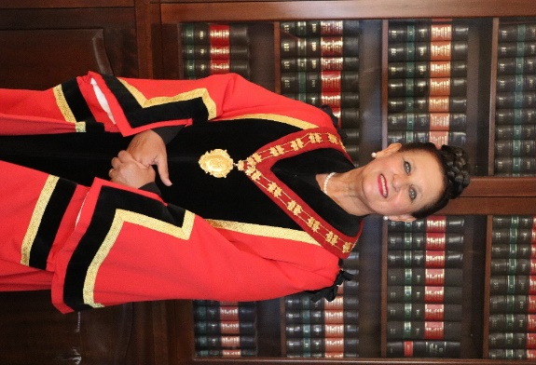
It is an honour and privilege to be able to share my first 100 days in office since Council was reconstituted on 2 December 2021. I am committed to serving the Cape Winelands District Municipality for a second term and am honoured to take on this responsibility as the Executive Mayor, alongside the very efficient and competent official team under the Leadership of the Municipal Manager, Mr Henry Prins.

The community of Cape Winelands can be proud of this Municipality. We serve the district as effective and effectively as possible, and all of this within the legislative mandate and responsibilities of the district.

Herewith follows CWDM continued successes:

- 8 Clean audits;
- Continued successful management of the Covid-19 pandemic;
- World class firefighting services;
- Outstanding environmental health services;
- Committed services to pertaining maintenance of rural roads;
- Significant contributions towards the support of tourism, sport, arts, culture, job creation, safety and humanitarian relief.

It is paramount that this Municipality always leads in creativity and aspire to even greater heights in portraying a pocket of excellence within Local Government.

The credo of Cape Winelands says: “A unified Cape Winelands of Excellence for Sustainable Development”. With this, I have a personal vision in mind for the Municipality that includes –

- Economic revival;
- Job creation;
- Rebuilding our tourism sector;
- Re-imagining our infrastructure;
- Forging relationships with partners to take Local Government forward.

A capable management team was appointed including an Ambassador for persons living with disabilities. I am excited to add that a measurement system was developed for Councillors to keep them accountable in their various portfolios. I wish them all well in serving their various portfolios.

I gladly share a few highlights of the first three months in office:

- Strategic planning session with management tea;
- Prestigious award ceremony for Grade 12 top achievers;
- Approval of the 2021/2022 Adjustments Budget;
- Regional landfill sites for the Witzenberg, Breede Valley and Langeberg municipalities;
- Training of Councillors;
- Successful firefighting;
- Interactive IDP sessions;
- Preparation of the 2022/2023 Budget;
- Mayoral break away focused on improving service delivery.

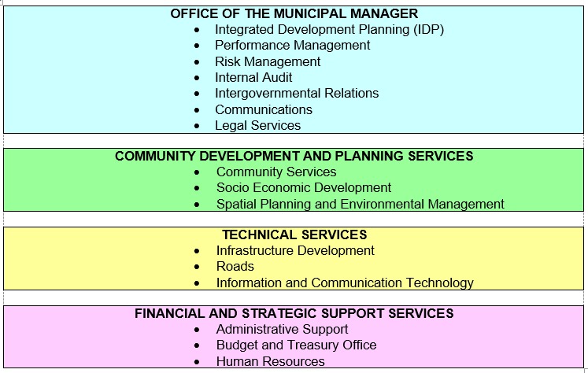

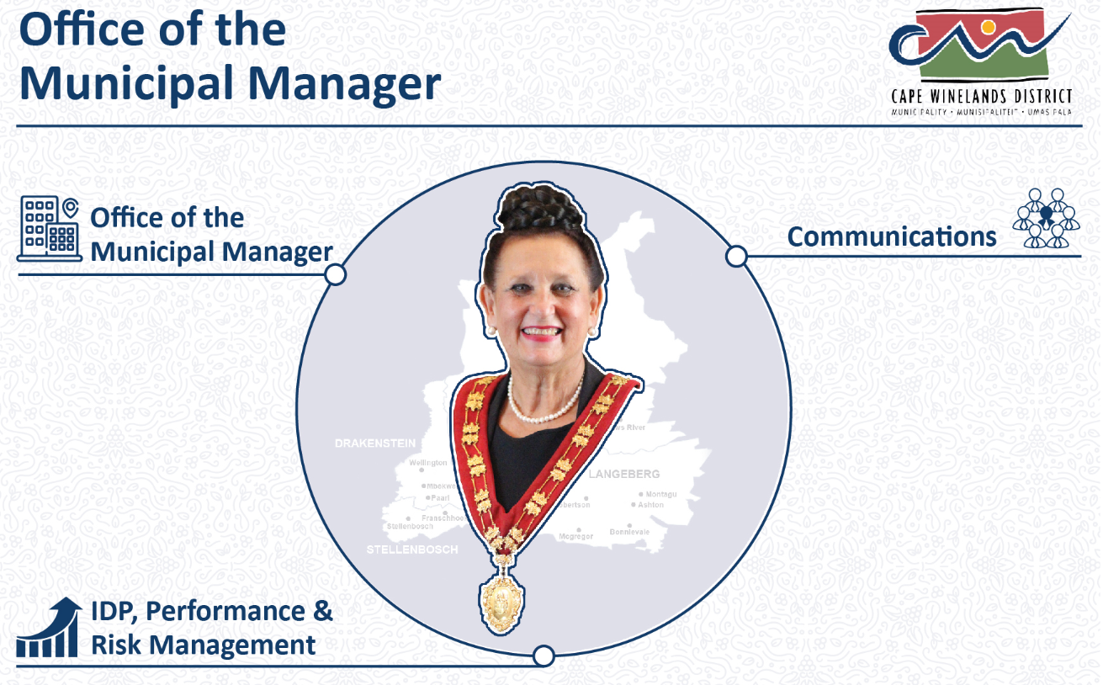

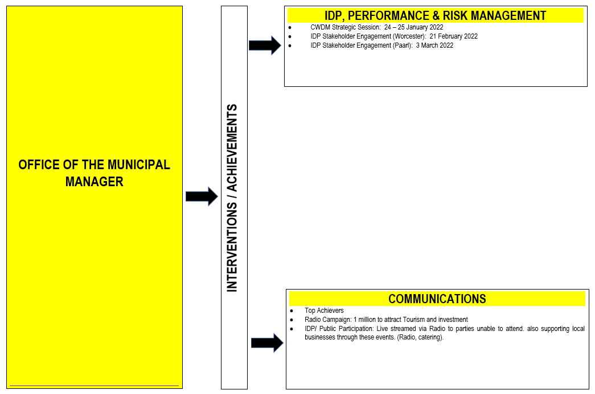

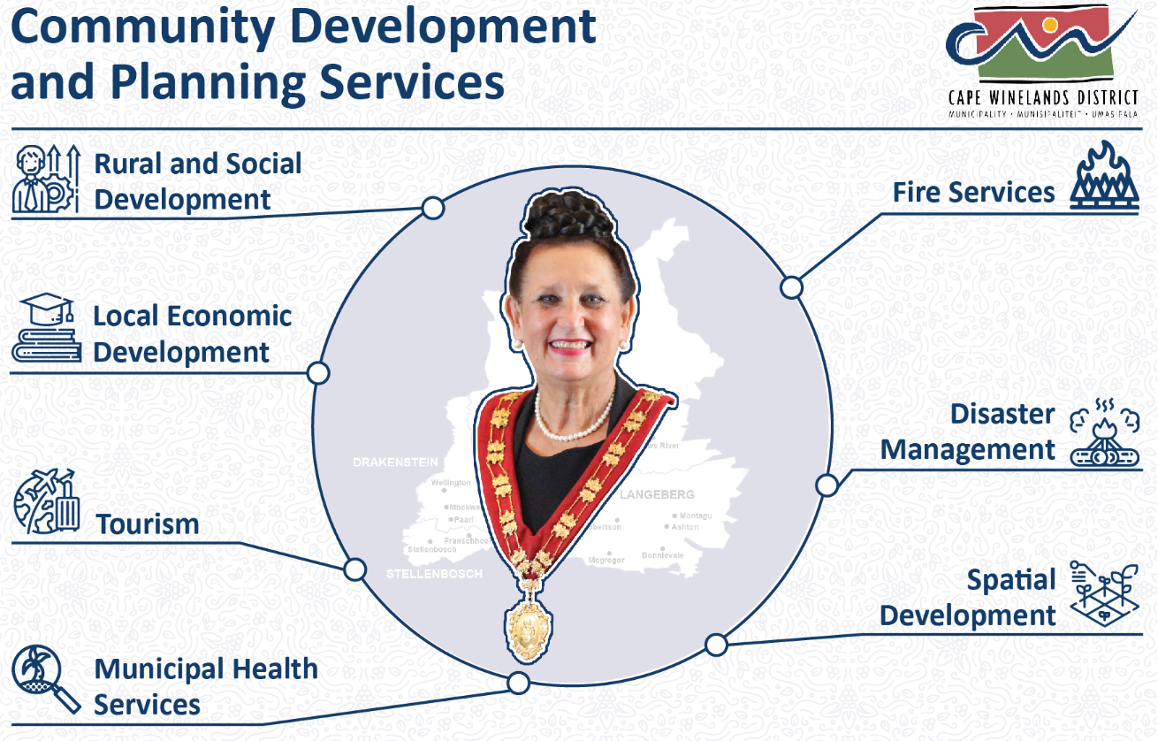

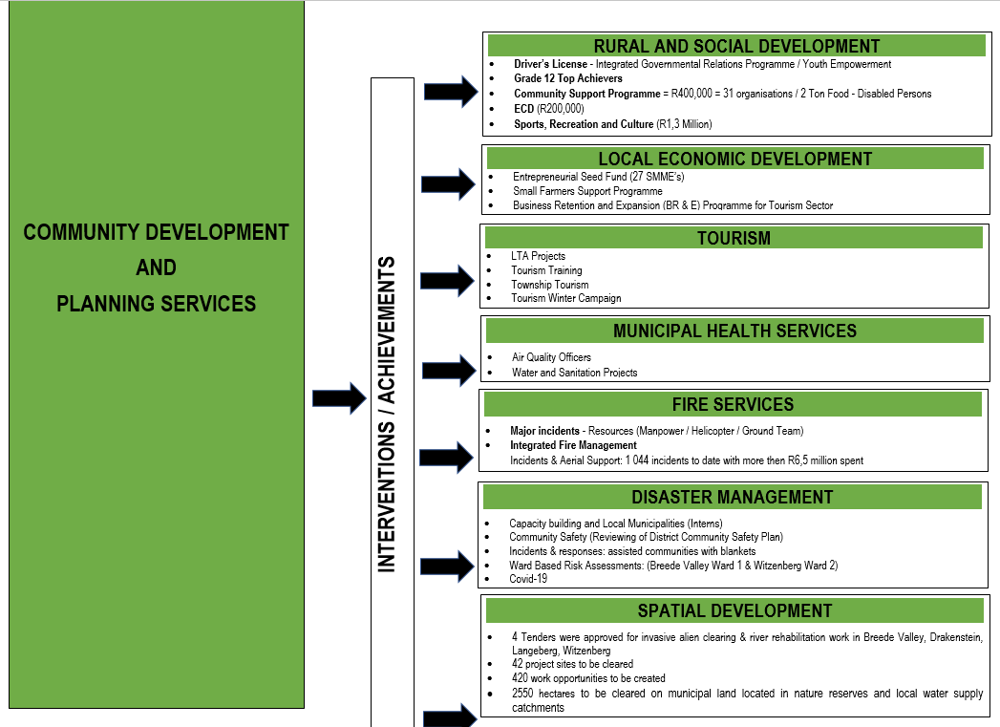

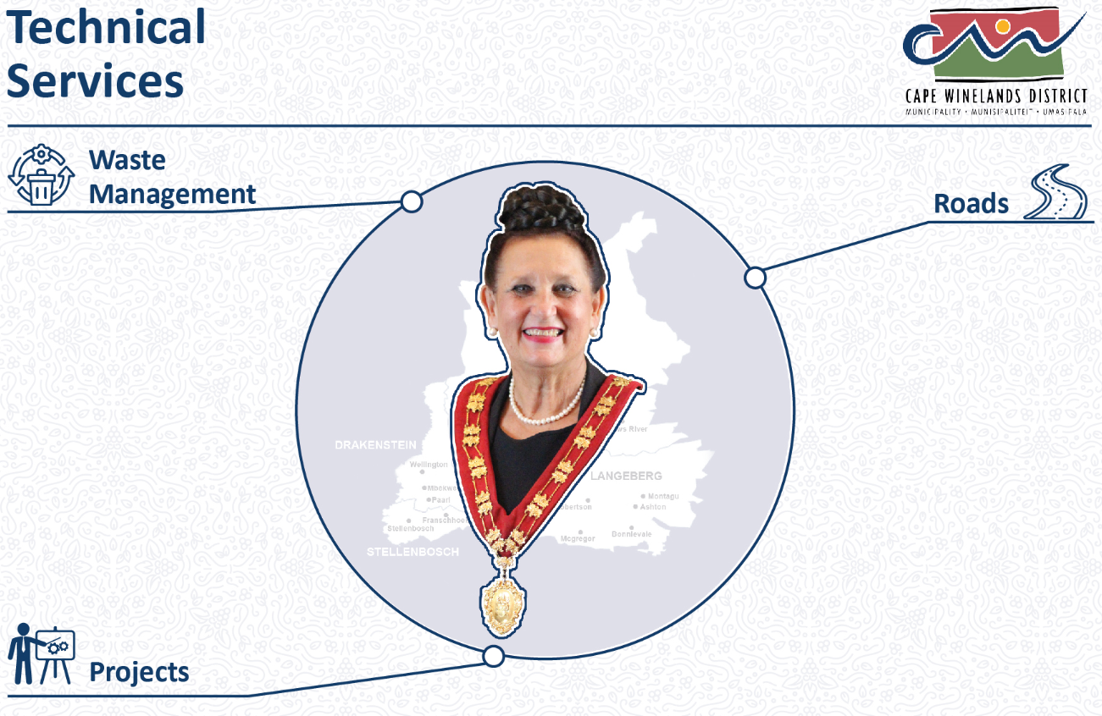

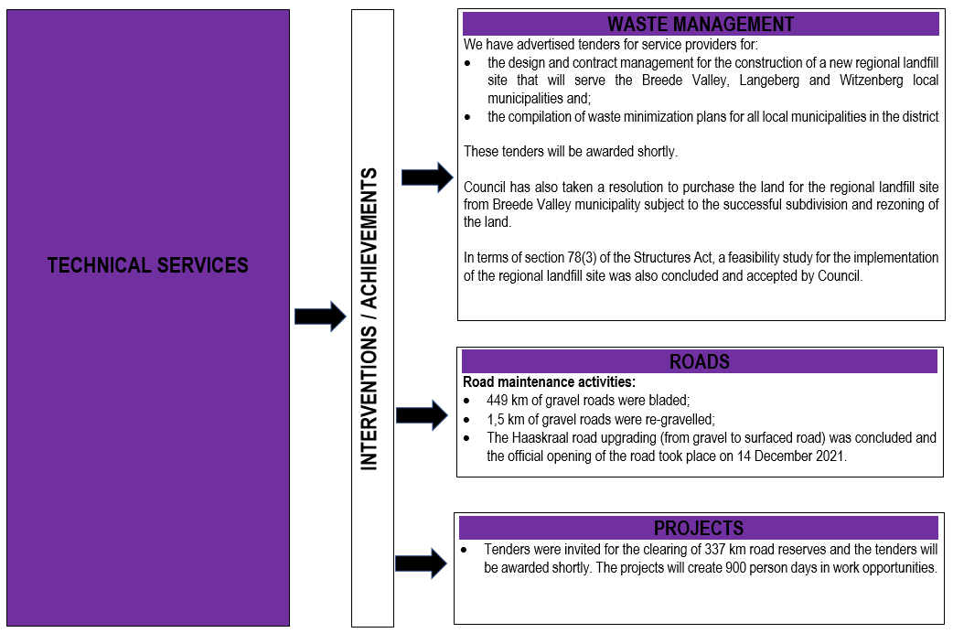

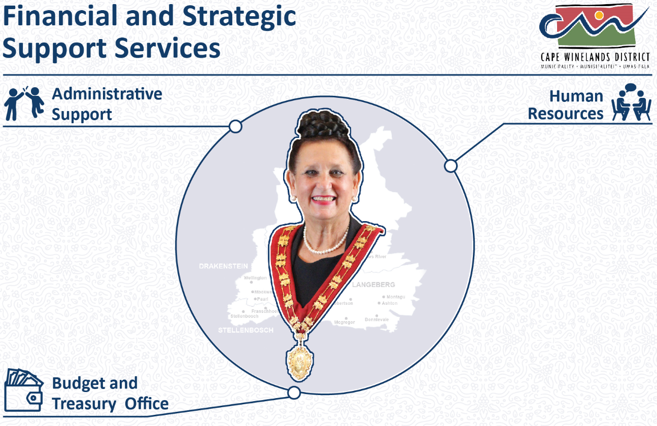

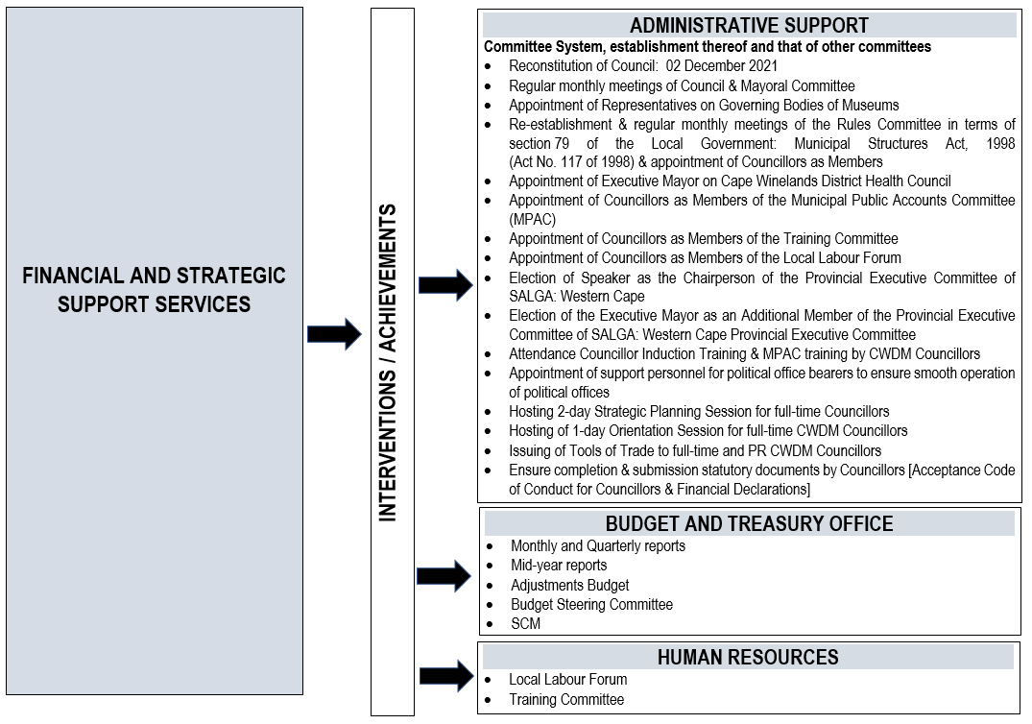

In conclusion, I salute all officials of this Municipality for giving meaning to the credo of the Cape Winelands District Municipality and building a true pocket of excellence within local government.

Councillors D.W. Nel, A.J. Pedro, M.S. Liebenberg, V. Hani, L. Ngwane, C. Manuel, J.J.S. Januarie and J. Maliti congratulated the Executive Mayor on her achievements during the first 100 days of office.

COUNCIL MEETING: 24 MARCH 2022: ITEM C.6

RESOLVED: That –

- Cognisance be taken of the concerns expressed by Councillor J.J.S. Januarie regarding the violence in the Langeberg area;

- Preventative actions to assist local municipalities to address unrest in their respective areas, be investigated.

ACTION | DUE DATE | COMMENT
The Executive Director: Community Development and Planning Services, Mr. P.A. Williams in collaboration with the Office of the MM to attend to (b) | 29 April 2022

C.7 CONSIDERATION OF NOTICES OF MOTION (3/2/1/4)
_______________________________________________________________

None.

C.8 CONSIDERATION OF NOTICES OF QUESTIONS (3/2/1/5)
_______________________________________________________________

None.

C.9 CONSIDERATION OF MOTIONS OF EXIGENCY (3/2/1/4)
_______________________________________________________________

None.

C.10 MINUTES

C.10.1 CONFIRMATION OF THE MINUTES OF THE COUNCIL MEETING HELD ON MONDAY, 28 FEBRUARY 2022 (3/2/1/6)
_______________________________________________________________

RESOLVED:

That the minutes of the Council meeting held on Monday, 28 February 2022 be taken as read and duly confirmed.

C.10.2 REPORT BY THE MUNICIPAL MANAGER: ACTION MINUTES OF THE COUNCIL MEETING HELD ON MONDAY, 28 FEBRUARY 2022
______________________________________________________________

RESOLVED: That –

- Cognisance be taken of the communication by the Municipal Manager that all matters pertaining to the action minutes of the Council meeting held on Monday, 28 February 2022 had been attended to;

(b) Councillor J. Maliti engage with the Municipal Manager in order to obtain clarity regarding her concern of the absence of a completion date for newly appointed officials that must comply with the Municipal Minimum Competence Levels within 18 months and feedback be provided at the next Council meeting.

ACTION | DUE DATE | COMMENT
The MM to attend to (b) | 19 April 2022

C.11 INTERVIEWS WITH OR PRESENTATIONS BY DEPUTATIONS
_______________________________________________________________

C.11.1 PRESENTATION: POWERS AND FUNCTIONS AND 5TH GENERATION IDP OF THE CAPE WINELANDS DISTRICT MUNICIPALITY: MS. B.T. DARIES, DIRECTOR: IDP, PERFORMANCE AND RISK MANAGEMENT
_______________________________________________________________

(The meeting adjourned for a caucus at 11:22 and resumed its business at 12:55)

Councillor M.H. Yabo reported back on the caucus with a request that a workshop be arranged to be facilitated by SALGA as a matter of urgency to discuss the Rules of Order.

COUNCIL MEETING: 24 MARCH 2022: ITEM C.11.1

RESOLVED: That –

*** (a) Cognisance be taken of the presentation by the Director: IDP, Performance and Risk Management, Ms. B.T. Daries, regarding the powers and functions and 5th generation IDP of the Cape Winelands District Municipality, attached as Annexure “A” to the minutes;

(b) All questions of clarity pertaining to the presentation in (a) above be directed to the Director: IDP, Performance and Risk Management, Ms. B.T. Daries.

ACTION | DUE DATE | COMMENT
Noted | - | -

C.11.2 PRESENTATION: OVERVIEW OF THE 2022/2023 TO 2024/2025 MTREF: MS. F.A. DU RAAN-GROENEWALD, CHIEF FINANCIAL OFFICER
_______________________________________________________________

COUNCIL MEETING: 24 MARCH 2022: ITEM C.11.2

RESOLVED:

*** That cognisance be taken of the presentation by the Chief Financial Officer, Ms. F.A. du Raan-Groenewald, regarding an overview of the 2022/2023 to 2024/2025 MTREF of the Cape Winelands District Municipality, attached as Annexure “B” to the minutes.

ACTION | DUE DATE | COMMENT
Noted | - | -

C.12 URGENT MATTERS SUBMITTED BY THE MUNICIPAL MANAGER
_______________________________________________________________

None.

C.13 REPORT BY THE EXECUTIVE MAYOR: MAYORAL COMMITTEE MEETING HELD ON TUESDAY, 8 FEBRUARY 2022 (3/2/2/1)
_______________________________________________________________

The following report outlines the issues and decisions taken by the Mayoral Committee.

The relevant minutes of matters that served before the Executive Mayor and Mayoral Committee on the date indicated has been distributed to all Councillors –

1 MEETING HELD ON 8 FEBRUARY 2022

MATTERS OF WHICH COGNISANCE WERE TAKEN:

MC.7.2 NOTIFICATION TO THE MAYORAL COMMITTEE: RESOLUTIONS BY THE EXECUTIVE MAYOR IN CONSULTATION WITH THE EXECUTIVE DEPUTY MAYOR IN TERMS OF THE SYSTEM OF DELEGATIONS RECONFIRMED BY COUNCIL AT ITEM C.4.8 ON 2 DECEMBER 2021 FOR THE INTERIM (2/4/2)
______________________________________________________

RESOLVED:

That cognisance be taken of the item that served before the Mayoral Committee.

MC.7.3 DEPARTMENT: TECHNICAL SERVICES: INFORMATION AND COMMUNICATION TECHNOLOGY REPORTS FOR THE PERIODS FROM JULY 2021 TO SEPTEMBER 2021 AND OCTOBER 2021 TO DECEMBER 2021 (6/2/1/5)
______________________________________________________

RESOLVED:

That cognisance be taken of the item that served before the Mayoral Committee.

MC.7.4 DEPARTMENT: TECHNICAL SERVICES: QUARTERLY REPORTS: JULY 2021 TO SEPTEMBER 2021 AND OCTOBER 2021 TO DECEMBER 2021 (2/10/1/5)
______________________________________________________

RESOLVED:

That cognisance be taken of the item that served before the Mayoral Committee.

MC.7.5 DEPARTMENT: COMMUNITY DEVELOPMENT AND PLANNING SERVICES: QUARTERLY REPORTS FOR THE PERIODS JULY 2021 TO SEPTEMBER 2021 AND OCTOBER 2021 TO DECEMBER 2021 (6/23/1 & 17/15/5)
______________________________________________________

RESOLVED:

That cognisance be taken of the item that served before the Mayoral Committee.

MC.7.6 DEPARTMENT: COMMUNITY DEVELOPMENT AND PLANNING SERVICES: REPORT ON THE TOURISM MONTH PROJECT FOR THE 2021/2022 FINANCIAL YEAR (17/7/R)
______________________________________________________

RESOLVED:

That cognisance be taken of the item that served before the Mayoral Committee.

MC.7.7 DEPARTMENT: COMMUNITY DEVELOPMENT AND PLANNING SERVICES: REPORT ON WATER QUALITY FOR THE PERIOD JULY 2021 TO OCTOBER 2021 IN THE AREA OF THE CAPE WINELANDS DISTRICT MUNICIPALITY (16/3/R & 17/1/R)
______________________________________________________

RESOLVED:

That cognisance be taken of the item that served before the Mayoral Committee.

MATTERS OF WHICH RESOLUTIONS WERE TAKEN:

MC.7.1 SALGA NOTIFICATION OF THE NEXT SITTING OF THE SALGA NATIONAL CONFERENCE: 22 FEBRUARY 2022 TO 24 FEBRUARY 2022 IN CAPE TOWN (12/1/1/10)
______________________________________________________

RESOLVED:

That cognisance be taken of the decision taken by the Executive Mayor together with the Mayoral Committee.

MC.8.2.1 MONTHLY PROGRESS REPORT ON MUNICIPAL MINIMUM COMPETENCY LEVELS: OCTOBER 2021
(4/12/5, 1/1/1 & 3/2/5/13)
______________________________________________________

RESOLVED:

That cognisance be taken of the decision taken by the Executive Mayor together with the Mayoral Committee.

MC.8.2.2 MONTHLY PROGRESS REPORT ON MUNICIPAL MINIMUM COMPETENCY LEVELS: NOVEMBER 2021
(4/12/5, 1/1/1 & 3/2/5/13)
______________________________________________________

RESOLVED:

That cognisance be taken of the decision taken by the Executive Mayor together with the Mayoral Committee.

MC.8.2.3 MONTHLY PROGRESS REPORT ON MUNICIPAL MINIMUM COMPETENCY LEVELS: DECEMBER 2021
(4/12/5, 1/1/1 & 3/2/5/13)
______________________________________________________

RESOLVED:

That cognisance be taken of the decision taken by the Executive Mayor together with the Mayoral Committee.

MC.8.2.4 MONTHLY PROGRESS REPORT ON MUNICIPAL MINIMUM COMPETENCY LEVELS: JANUARY 2022
(4/12/5, 1/1/1 & 3/2/5/13)
______________________________________________________

RESOLVED:

That cognisance be taken of the decision taken by the Executive Mayor together with the Mayoral Committee.

MC.8.2.5 REVISION OF BUDGET ESTIMATES: MUNICIPAL ADJUSTMENTS BUDGET FOR THE 2021/2022 FINANCIAL YEAR
(5/1/1/9)
______________________________________________________

RESOLVED:

That cognisance be taken of the decision taken by the Executive Mayor together with the Mayoral Committee.

MC.8.4.1 PURCHASE AND TRANSFER OF LAND FOR THE CONSTRUCTION AND OPERATION OF A REGIONAL LANDFILL SITE (16/8/R & 15/2/6/2)
______________________________________________________

RESOLVED:

That cognisance be taken of the decision taken by the Executive Mayor together with the Mayoral Committee.

MC.8.4.2 REPORT IN TERMS OF SECTION 78(3) OF THE LOCAL GOVERNMENT: MUNICIPAL SYSTEMS ACT, 2000 (ACT NO. 32 OF 2000) – FEASIBILITY STUDY IN RESPECT OF AN EXTERNAL SERVICE DELIVERY OPTION FOR THE CONSTRUCTION AND OPERATION OF A REGIONAL LANDFILL SITE (16/8/B)
______________________________________________________

RESOLVED:

That cognisance be taken of the decision taken by the Executive Mayor together with the Mayoral Committee.

MC.8.4.3 INTEGRATED WASTE MANAGEMENT PLAN FOR THE CAPE WINELANDS DISTRICT MUNICIPALITY (16/8/B & 2/9/3/8)
______________________________________________________

RESOLVED:

That cognisance be taken of the decision taken by the Executive Mayor together with the Mayoral Committee.

C.14 MATTER FOR NOTIFICATION
_______________________________________________________________

C.14.1 MONTHLY PROGRESS REPORT ON MUNICIPAL MINIMUM COMPETENCY LEVELS: FEBRUARY 2022 (4/12/5, 1/1/1 & 3/2/5/13)
_______________________________________________________________

PURPOSE OF SUBMISSION

That Council take cognisance of the monthly Municipal Minimum Competency Levels Progress Report for February 2022.

MUNICIPAL MINIMUM COMPETENCE COMPLIANCE LEVEL

Number of Municipal Officials that must comply with the MMCL 78
Number of Municipal Officials that comply with MMCL 75
Number of Municipal Officials that are currently in the process 3
to obtain the necessary qualifications

BACKGROUND

The Municipal Regulations on Minimum Competency Levels were first issued on 15 June 2007. This required municipalities and municipal entities to achieve full compliance by 1 January 2013. The Regulations required officials holding key positions and those that are responsible for financial management to comply with the prescribed minimum competencies relevant to their positions.

In April 2012 the National Treasury issued MFMA Circular 60 aimed at assisting municipalities who were experiencing difficulties in complying with the legislation for officials already in the employ of the municipality. In accordance with the Circular, municipalities could apply to the National Treasury to consider a delay in enforcement of certain provisions of the regulations as a “Special Merit Case”.

On 14 March 2014 the National Treasury issued a MFMA Exemption Notice to delay the enforceability of the Regulations. This Exemption Notice lapsed on 30 September 2015.

After consultation with key stakeholders and correspondence received from municipalities regarding the challenges faced in attracting and retaining key skills as a result of the prescribed minimum competency level requirements, a decision was taken to further exempt municipalities and municipal entities from the application of Regulations 15 and 18 of the Municipal Regulations on Minimum Competency Levels for a period of 18 months from 3 February 2017.

COMMENT

*** On 3 February 2017, MFMA Exemption Notice 40593 was issued in terms of section 177(1) (b) of the MFMA relating to exemption from compliance with Regulations 15 and 18 of the Municipal Regulations on Minimum Competency levels (attached as Annexure “A”).

Paragraphs 2.5 and 2.6 of the MFMA Exemption Notice stipulate as follows:

  - A municipality must –

- Submit a report to the National Treasury on the implementation of the conditions referred to in paragraph 2.1(a), in respect of the municipality and each of its entities in such format and on such dates as the National Treasury determines; and

(b) On a monthly basis, submit to the National Treasury and the relevant Provincial Treasury a report with details of –

- Employment contracts of officials appointed by virtue of this Notice;
(ii) Registration with accredited training providers; and
(iii) Progress made in attaining the minimum competency levels.

2.6 The report envisaged in paragraph 2.5(b) must be tabled at each municipal council meeting to enable the council to –

- Enforce the Regulations and this Notice; and

- Institute corrective action as may be required.

In terms of compliance with the Municipal Regulations on Minimum Competency Levels of officials at the Cape Winelands District Municipality, they are grouped as follows:

Municipal Manager:

- 1 x official complies with the prescribed Unit Standards

Chief Financial Officer:

- 1 x official complies with the prescribed Unit Standards

Senior Managers:

- 2 x officials comply with the prescribed Unit Standards

Supply Chain Management Head:

- 1 x official complies with the prescribed Unit Standards

Supply Chain Management Manager - "supply chain management manager", in relation to a municipality or municipal entity, means an official of the municipality or entity involved in the implementation of the supply chain management policy of the municipality or entity and who is directly accountable to the head of the supply chain management unit of the municipality or entity.

- 1 x official complies with the prescribed Unit Standards

Financial Officials at Middle Management Level - "middle management level" means a management level associated with persons in middle management positions for supervising staff, and includes- (a) an official directly accountable to a manager in the senior management level; or (b) a person that occupied a position in a management level, outside the local government sphere.

- 19 x officials comply with the prescribed Unit Standards

- 3 x new appointees complied by April 2019

Officials involved in Implementation of Supply Chain Management Policy: Officials with Financial Delegations

- 28 x officials comply with the prescribed Unit Standards

- 1 x new appointee complied by September 2021

- 3 x new appointees to comply within 18 months from the commencement of contract with the newly appointed accredited service provider, Next Step Academy (Pty) Ltd

Officials involved in Implementation of Supply Chain Management Policy: Officials serving on Supply Chain Management Bid Committees

- 16 x officials comply with the prescribed Unit Standards

- 2 x new appointees complied by July 2021

In order to effectively address the above situation, the Cape Winelands District Municipality embarked on a formal tender process to ensure the procurement of an accredited Municipal Finance Management Programme (MFMP) service provider. In March 2016 Kgolo Institute was appointed on a three-year contract as the preferred service provider for the CWDM’s Municipal Finance Management Programme. The Municipal Finance Management Programme were implemented via three intakes over the three-year contract period.

Intake 1 consisted of a combination of CWDM officials, those affected by the MFMA Regulations on Minimum Competency Levels, as well as those middle and junior management officials not affected by the MFMA Regulations on Minimum Competency Levels. Intake 1 concluded in January 2017.

Intake 2 commenced on 19 June 2017 and consisted of officials affected by the MFMA Regulations on Minimum Competency Levels, who have not participated in the previous Municipal Finance Management Programmes (MFMP). Intake 2 concluded in April 2018 and ensured that these officials were in full compliance with the prescribed competency levels on 02 August 2018, as stipulated in the MFMA Exemption Notice 40593.

Intake 3 commenced in July 2018 and consisted of outstanding middle and junior managers within the Cape Winelands District Municipality who are not affected by the Minimum Competency Levels. New appointees (Management Officials appointed after 3 February 2017 in terms of the MFMA Exemption Notice 40593) affected by the MMCL also formed part of Intake 3. Intake 3 concluded in April 2019.

Receipts of Statement of Results are administered by the LGSETA. Currently, the LGSETA has huge backlogs in terms of providing municipalities with these results. A number of affected CWDM officials have completed several Unit Standards and are currently awaiting their Statement of Results. However, until such time that the CWDM receive these Statement of Results issued by the LGSETA, it cannot be reflected in this report.

New Appointees - As from January 2019 (Not part of Intake 3) - All new employees appointed after 1 January 2019 affected by the MFMA Exemption Notice 40593 will embark on a Municipal Finance Management Programme in order to ensure full compliance to the MMCL regulations. On 25 October 2019 the CWDM appointed Stellenbosch University (School of Public Leadership) as the new MFMP service provider. Affected officials commenced with the MFMP on 19 March 2020, however, the Covid-19 Lockdown negatively influenced the course schedules resulting in the postponement of the course, meaning that these affected learners completed their modules in September 2021.

Three (3) new appointments made respectively in 2020 and 2021 (officials involved in the implementation of Supply Chain Management policy: officials with financial delegations), together with three (3) new Financial Interns will embark on the Municipal Finance Management Programme with Next Step Academy (Pty) Ltd, who has been appointed as the accredited service provider, for the implementation of the mentioned programme. Upon conclusion of the Programme Initiation Meeting (scheduled for 8 March 2022), the training schedule will be communicated to all affected officials.

Newly appointed officials (those appointed after the 3rd of February 2017) affected by the Municipal Minimum Competency Levels, are also required to sign Memorandums of Agreement stipulating the consequences to officials should the refuse to partake in the MFMP and complete the relevant Unit Standards, within the prescribed 18 months of their appointment dates.

IMPLICATIONS

PERSONNEL

The Exemption Notice is applicable to existing officials who are in the employ of municipalities and municipal entities and new appointments. With regard to officials who were already in the employment of municipalities and municipal entities prior to 3 February 2017, these officials were given until 2 August 2018 to complete the outstanding prescribed Unit Standards to ensure full compliance with the Regulation.

To give effect to Exemption Notice 40593, all affected officials already in the employ of the Cape Winelands District Municipality involved in the implementation of the Supply Chain Management policy of the Municipality who must meet the prescribed financial management competency levels, signed Memorandums of Agreement which, inter alia, stipulated the consequences to officials should they refuse to either complete their outstanding Unit Standards and/or refuse to participate in the Municipal Finance Management Programme (MFMP).

Newly appointed officials (those appointed after 3 February 2017) affected by the Municipal Minimum Competency Levels, are also required to sign Memorandums of Agreement stipulating the consequences to officials should they refuse to partake in the MFMP and complete the relevant Unit Standards, within the prescribed 18 months of their appointment dates.

Comment prepared by: Ms. G.C.N. Gilbert

FINANCIAL

Sufficient provision has been made in the 2021/2022 financial year for MMCL training of newly appointed employees.

Comment prepared by: Ms. F.A. du Raan-Groenewald

LEGAL

Section 119(1) of the Local Government: Municipal Finance Management Act, 2003 (Act No. 56 of 2003) (MFMA) stipulates that the accounting officer and all other officials of a municipality or a municipal entity involved in the implementation of the supply chain management policy of the municipality must meet the prescribed financial management competency levels, whilst section 119(2) stipulates that a municipality and a municipal entity must for the purposes of subsection 119(1) provide resources or opportunities for the training of officials referred to in that subsection to meet the prescribed competency levels.

In terms of regulation 13 of the Municipal Regulations on Minimum Competency Levels, 2007 the municipal manager of a municipality and the chief executive officer of a municipal entity must ensure that competencies of all financial officials and supply chain management officials are assessed in order to identify and address gaps in competency levels of those officials.

In terms of regulation 14(1) of the Municipal Regulations on Minimum Competency Levels, 2007 the municipal manager of a municipality and the chief executive officer of a municipal entity must monitor, and take any necessary steps to ensure compliance with the prescribed minimum competency levels for Financial officials and supply chain management officials within the time frames set out in regulation 15.

Comment prepared by: Ms. W.M. Neethling

RECOMMENDATION BY MUNICIPAL MANAGER: That –

- The Executive Mayor and Mayoral Committee take cognisance of the monthly Municipal Minimum Competency Levels Progress Report for February 2022;

- The Executive Mayor together with the Mayoral Committee consider to recommend to Council to take cognisance of the monthly Municipal Minimum Competency Levels Progress Report for February 2022.

MAYORAL COMMITTEE: 8 MARCH 2022: ITEM MC.8.2.1

RESOLVED: That –

- Cognisance be taken of the monthly Municipal Minimum Competency Levels Progress Report for February 2022;

- It be recommended to Council to take cognisance of the monthly Municipal Minimum Competency Levels Progress Report for February 2022.

RECOMMENDATION BY MAYORAL COMMITTEE:

That Council take cognisance of the monthly Municipal Minimum Competency Levels Progress Report for February 2022.

COUNCIL MEETING : 24 MARCH 2022: ITEM C.14.1

RESOLVED:

That cognisance be taken of the monthly Municipal Minimum Competency Levels Progress Report for February 2022.

ACTION | DUE DATE | COMMENT
Noted | - | -

C.15 MATTERS FOR CONSIDERATION
_______________________________________________________________

C.15.1 DRAFT 2022/2023, 2023/2024 AND 2024/2025 MEDIUM TERM REVENUE AND EXPENDITURE FRAMEWORK (MTREF) FOR THE CAPE WINELANDS DISTRICT MUNICIPALITY (5/1/1/10)
_______________________________________________________________

PURPOSE OF SUBMISSION

That Council consider to adopt the draft 2022/2023, 2023/2024 and 2024/2025 Medium Term Revenue and Expenditure Framework (MTREF) for the Cape Winelands District Municipality for inspection, public representations, inputs and comment.

BACKGROUND

In terms of section 16 of the Local Government: Municipal Finance Management Act, 2003 (Act No. 56 of 2003) (MFMA) a council of a municipality must for each financial year approve an annual budget for the municipality before the start of the financial year.

In order for a municipality to comply with section 16(1) of the said Act, the mayor must table the annual budget at a council meeting at least 90 days before the start of the budget year.

Section 15 of the MFMA prescribes that a municipality may incur expenditure only:

15 (a) In terms of an approved budget; and

(b) Within the limits of the amounts appropriated for the different votes in an approved budget.

The contents of the annual budget must consist of the following documents as prescribed in terms of section 17 of the MFMA:

1. Realistically anticipated income and expenditure per vote for the budget year and the two financial years following the budget year;

2. Budget related policies of the Council (Tariff, Rates & Credit Control Policies);

3. Details of Council’s investments for the budget year;

4. Details of all proposed service delivery agreements, including material amendments to existing service delivery agreements;

5. Particulars of any proposed allocations or grants by the municipality in terms of sections 67 and 17(3)(j) of the MFMA;

6. The proposed cost to the municipality for the budget year of the salary, allowances and benefits of political office bearers and senior managers;

7. Capital expenditure and projects envisioned within the budget year.

COMMENT

*** Attached as Annexures “A” to “R” are copies of the draft 2022/2023, 2023/2024 and 2024/2025 Medium Term Revenue and Expenditure Framework (MTREF) for the Cape Winelands District Municipality as well as related documents as prescribed by the Local Government: Municipal Finance Management Act, 2003 (Act No. 56 of 2003) (MFMA).

The IDP/Budget process for the 2022/2023 financial year was a consultative process – including the Budget Steering Committee, Executive Directors, Senior Managers, Councillors and other stakeholders.

The MTREF (2022 – 2025) has been compiled in accordance with the budget growth guidelines determined by National Treasury. Personnel expenditure (Salaries, Wages and Allowances) increased by 4.5% for 2022/2023, 2023/2024 and 2024/2025. The Budget Steering Committee, established in terms of the Budget and Reporting Regulations, 2008, comprehensively scrutinised the proposed MTREF.

Due to strict budgetary control, management succeeded to compile a balanced budget.

DECLARATION BY MANAGEMENT

Management declare that they followed all guidelines prescribed by the relevant legislation during the budget process.

RECOMMENDATION BY MUNICIPAL MANAGER:

- That the Executive Mayor together with the Mayoral Committee consider to recommend to Council to adopt the draft 2022/2023, 2023/2024 and 2024/2025 Medium Term Revenue and Expenditure Framework (MTREF) for the Cape Winelands District Municipality as outlined in the attached Annexures for inspection, public representations, inputs and comment:

- The draft Medium Term Revenue and Expenditure Framework for the 2022/2023, 2023/2024 and 2024/2025 financial years as set out in Annexure “A”;

(ii) Adjustments to the budget related policies submitted as Annexure “B”;

(iii) Details of Council’s investments as set out in Annexure “C”;

(iv) Details of all proposed service delivery agreements, including material amendments to existing service delivery agreements as set out in Annexure “D”;

(v) Adjustments to the current Integrated Development Plan (IDP) as set out in Annexure “E”;

(vi) Details of employment costs – salaries, allowances and benefits – of all political office-bearers, councillors and senior managers of the Cape Winelands District Municipality as set out in Annexure “F”;

(vii) Capital expenditure within the budget year as set out in Annexure “G”;

(viii) Projects to be undertaken within the budget year as set out in Annexure “H”;

(ix) Particulars of all proposed allocations and grants by the District Municipality in terms of section 67 of the MFMA, as set out in Annexure “I”;

(x) Proposed Tariffs for the 2022/2023 financial year as set out in Annexure “J”;

- Service Delivery Standard as set out in Annexure “K”; and

- Measurable performance objectives for revenue from each source and for each vote in the budget, taking into account the District Municipality’s Integrated Development Plan (IDP) as part of Annexure “L”;

- That cognisance be taken of –

- (a) MFMA Circular No. 88 – Rationalisation Planning and Reporting Requirements for the 2022/2023 MTREF (Performance Indicators), attached as Annexure “M”;

(b) MFMA Circular No. 112: Municipal Budget Circular for the 2022/2023 MTREF – 06 December 2021, attached as Annexure “N”;

- The Cape Winelands District Municipality’s:

- Air Quality Management Plan, attached as Annexure “O”;

- Draft Spatial Development Framework (2021-2025), attached as Annexure “P”;

- Integrated Waste Management Plan, attached as Annexure “Q”;

- Corporate Disaster Management Planning Framework, attached as Annexure “R”.

All the Annexures referred to in subsection (b) above will be distributed via Flash Drive to all Councillors receiving a hard copy of the agenda.

MAYORAL COMMITTEE: 8 MARCH 2022: ITEM MC.8.2.2

RESOLVED: That –

  - It be recommended to Council to adopt the draft 2022/2023, 2023/2024 and 2024/2025 Medium Term Revenue and Expenditure Framework (MTREF) for the Cape Winelands District Municipality as outlined in the attached Annexures for inspection, public representations, inputs and comment:

(i) The draft Medium Term Revenue and Expenditure Framework for the 2022/2023, 2023/2024 and 2024/2025 financial years as set out in Annexure “A”;

(ii) Adjustments to the budget related policies submitted as Annexure “B”;

(iii) Details of Council’s investments as set out in Annexure “C”;

(iv) Details of all proposed service delivery agreements, including material amendments to existing service delivery agreements as set out in Annexure “D”;

(v) Adjustments to the current Integrated Development Plan (IDP) as set out in Annexure “E”;

(vi) Details of employment costs – salaries, allowances and benefits – of all political office-bearers, councillors and senior managers of the Cape Winelands District Municipality as set out in Annexure “F”;

(vii) Capital expenditure within the budget year as set out in Annexure “G”;

(viii) Projects to be undertaken within the budget year as set out in Annexure “H”;

(ix) Particulars of all proposed allocations and grants by the District Municipality in terms of section 67 of the MFMA, as set out in Annexure “I”;

(x) Proposed Tariffs for the 2022/2023 financial year as set out in Annexure “J”;

- Service Delivery Standard as set out in Annexure “K”; and

- Measurable performance objectives for revenue from each source and for each vote in the budget, taking into account the District Municipality’s Integrated Development Plan (IDP) as part of Annexure “L”;

  - Cognisance be taken of –

(i) (a) MFMA Circular No. 88 – Rationalisation Planning and Reporting Requirements for the 2022/2023 MTREF (Performance Indicators), attached as Annexure “M”;

(b) MFMA Circular No. 112: Municipal Budget Circular for the 2022/2023 MTREF – 06 December 2021, attached as Annexure “N”;

(ii) The Cape Winelands District Municipality’s:

- Air Quality Management Plan, attached as Annexure “O”;

- Draft Spatial Development Framework (2021-2025), attached as Annexure “P”;

- Integrated Waste Management Plan, attached as Annexure “Q”;

- Corporate Disaster Management Planning Framework, attached as Annexure “R”.

RECOMMENDATION BY MAYORAL COMMITTEE: That –

- Council consider to adopt the draft 2022/2023, 2023/2024 and 2024/2025 Medium Term Revenue and Expenditure Framework (MTREF) for the Cape Winelands District Municipality as outlined in the attached Annexures for inspection, public representations, inputs and comment:

(i) The draft Medium Term Revenue and Expenditure Framework for the 2022/2023, 2023/2024 and 2024/2025 financial years as set out in Annexure “A”;

(ii) Adjustments to the budget related policies submitted as Annexure “B”;

(iii) Details of Council’s investments as set out in Annexure “C”;

(iv) Details of all proposed service delivery agreements, including material amendments to existing service delivery agreements as set out in Annexure “D”;

(v) Adjustments to the current Integrated Development Plan (IDP) as set out in Annexure “E”;

(vi) Details of employment costs – salaries, allowances and benefits – of all political office-bearers, councillors and senior managers of the Cape Winelands District Municipality as set out in Annexure “F”;

(vii) Capital expenditure within the budget year as set out in Annexure “G”;

(viii) Projects to be undertaken within the budget year as set out in Annexure “H”;

(ix) Particulars of all proposed allocations and grants by the District Municipality in terms of section 67 of the MFMA, as set out in Annexure “I”;

(x) Proposed Tariffs for the 2022/2023 financial year as set out in Annexure “J”;

- Service Delivery Standard as set out in Annexure “K”; and

- Measurable performance objectives for revenue from each source and for each vote in the budget, taking into account the District Municipality’s Integrated Development Plan (IDP) as part of Annexure “L”;

- Cognisance be taken of –

(i) (a) MFMA Circular No. 88 – Rationalisation Planning and Reporting Requirements for the 2022/2023 MTREF (Performance Indicators), attached as Annexure “M”;

(b) MFMA Circular No. 112: Municipal Budget Circular for the 2022/2023 MTREF – 06 December 2021, attached as Annexure “N”;

(ii) The Cape Winelands District Municipality’s:

- Air Quality Management Plan, attached as Annexure “O”;

- Draft Spatial Development Framework (2021-2025), attached as Annexure “P”;

- Integrated Waste Management Plan, attached as Annexure “Q”;

- Corporate Disaster Management Planning Framework, attached as Annexure “R”.

ADDITIONAL RECOMMENDATION BY MUNICIPAL MANAGER

That Council consider to take cognisance of the demand plan, attached as Annexure “S”.

COUNCIL MEETING: 24 MARCH 2022: ITEM C.15.1

(Councillor D.W. Nel left the meeting at 14:08)

*** The Executive Mayor presented her Budget Speech on the draft 2022/2023, 2023/2024 and 2024/2025 Medium Term Revenue and Expenditure Framework (MTREF) for the Cape Winelands District Municipality to Council, a copy of which is attached as Annexure “C“ to the minutes.

The Executive Mayor, Alderman (Dr.) H. von Schlicht seconded by Councillor R. Smuts proposed that the draft 2022/2023, 2023/2024 and 2024/2025 Medium Term Revenue and Expenditure Framework (MTREF) for the Cape Winelands District Municipality be adopted for public representations, inputs and comments.

The matter was put to the vote and twenty four (24) Councillors voted in favour of the proposal by the Executive Mayor, Alderman (Dr) H. von Schlicht.

RESOLVED (38 Councillors) That –

- The draft 2022/2023, 2023/2024 and 2024/2025 Medium Term Revenue and Expenditure Framework (MTREF) for the Cape Winelands District Municipality as outlined in the attached Annexures for inspection, public representations, inputs and comment, be adopted:

(i) The draft Medium Term Revenue and Expenditure Framework for the 2022/2023, 2023/2024 and 2024/2025 financial years as set out in Annexure “A”;

(ii) Adjustments to the budget related policies submitted as Annexure “B”;

(iii) Details of Council’s investments as set out in Annexure “C”;

(iv) Details of all proposed service delivery agreements, including material amendments to existing service delivery agreements as set out in Annexure “D”;

(v) Adjustments to the current Integrated Development Plan (IDP) as set out in Annexure “E”;

(vi) Details of employment costs – salaries, allowances and benefits – of all political office-bearers, councillors and senior managers of the Cape Winelands District Municipality as set out in Annexure “F”;

(vii) Capital expenditure within the budget year as set out in Annexure “G”;

(viii) Projects to be undertaken within the budget year as set out in Annexure “H”;

(ix) Particulars of all proposed allocations and grants by the District Municipality in terms of section 67 of the MFMA, as set out in Annexure “I”;

(x) Proposed Tariffs for the 2022/2023 financial year as set out in Annexure “J”;

- Service Delivery Standard as set out in Annexure “K”; and

- Measurable performance objectives for revenue from each source and for each vote in the budget, taking into account the District Municipality’s Integrated Development Plan (IDP) as part of Annexure “L”;

- Cognisance be taken of –

(i) (a) MFMA Circular No. 88 – Rationalisation Planning and Reporting Requirements for the 2022/2023 MTREF (Performance Indicators), attached as Annexure “M”;

(b) MFMA Circular No. 112: Municipal Budget Circular for the 2022/2023 MTREF – 06 December 2021, attached as Annexure “N”;

(ii) The Cape Winelands District Municipality’s:

- Air Quality Management Plan, attached as Annexure “O”;

- Draft Spatial Development Framework (2021-2025), attached as Annexure “P”;

- Integrated Waste Management Plan, attached as Annexure “Q”;

- Corporate Disaster Management Planning Framework, attached as Annexure “R”;

(e) Demand Plan, attached as Annexure “S”.

The following Councillors left the meeting at 14:30 without permission granted by the Speaker:

Cllr. M.N. Bushwana
Cllr. V. Hani
Cllr. J.J.S. Januarie
Cllr. C.O. Klaaste
Cllr. M.S. Liebenberg
Cllr. J. Maliti
Cllr. T.R. Mphulanyana

Cllr. R.S. Nalumango
Cllr. N. Phatsoane
Cllr. A.M. Richards
Cllr. M.H. Yabo

ACTION | DUE DATE | COMMENT
Ms FA du Raan-Groenewald (BTO) to attend to the matters | 25 March 2022 | Advertisements in the media with effect from Friday, 25 March 2022

C.15.2 DRAFT ANNUAL REPORT FOR 2020/2021 OF THE CAPE WINELANDS DISTRICT MUNICIPALITY AND DRAFT OVERSIGHT REPORT FOR THE 2020/2021 FINANCIAL YEAR (3/2/5/5, 5/1/1/13 & 9/1/1)
_______________________________________________________________

PURPOSE OF SUBMISSION

That Council consider to approve the draft Annual Report for 2020/2021 of the Cape Winelands District Municipality and the draft Oversight Report for the 2020/2021 financial year without reservations.

BACKGROUND

The draft Annual Report 2020/21 is tabled in terms of sections 121 and 127 of the Local Government: Municipal Finance Management Act, 2003 (Act No. 56 of 2003).

The Local Government: Municipal Finance Management Act, 2003 (Act No. 56 of 2003), section 121(2), states that the purpose of the draft Annual Report is to provide a record of activities of Council during the financial year, and to provide a report on the performance against the budget for the financial year and to promote accountability to the local community for the decisions made throughout the year.

At Item C.14.1 of 27 January 2022 Council resolved that cognisance be taken of the draft Annual Report 2020/2021.

COMMENT

*** Included under separate cover in the agenda as Annexure “A” is a copy of the draft Annual Report 2020/2021.

IMPLICATIONS

PERSONNEL

None.

Comment prepared by: Ms. G.C.N. Gilbert

FINANCIAL

The approval of the 2020/2021 Draft Annual Report and concomitant oversight report have no financial impact on the Municipality.

Comment prepared by: Ms. F.A. du Raan-Groenewald

LEGAL

In terms of section 121(2) of the Local Government: Municipal Finance Management Act, 2003 (Act No. 56 of 2003) the purpose of the annual report is –

- to provide a record of the activities of the municipality or municipal entity during the financial year to which the report relates;

- to provide a report on performance against the budget of the municipality or municipal entity for that financial year; and

- to promote accountability to the local community for the decisions made throughout the year by the municipality or municipal entity.

Annual reports must be aligned with the planning documents and municipal budget for the year reported on. This means that the IDP, Budget, SDBIP, In-year reports, annual performance report and annual report should have similar and consistent information to facilitate understanding and to enable the linkage between plans and actual performance.

Annual reports are the key reporting instruments for municipalities to report against the performance targets and budgets outlined in their strategic plans. Annual reports are therefore required to contain information on service delivery and outcomes, in addition to financial statements. It is a backward-looking document, focusing on performance in the financial year that has just ended, and it must demonstrate how the budget was implemented and the results of service delivery operations for that financial year.

The annual report of municipalities is governed by Chapter 12 of the Local Government: Municipal Finance Management Act, 2003 (Act No. 56 of 2003). In terms of section 127(2) of the said Act, the mayor of a municipality must, within seven (7) months after the end of the financial year, table the annual report of the municipality in the municipal council.

Section 127(3)(a) and (b) of the Local Government: Municipal Finance Management Act, 2003 (Act No. 56 of 2003) stipulates that if the mayor, for whatever reason is unable to table in the council the annual report of the municipality, the mayor must promptly submit to the council a written explanation setting out the reasons for the delay, together with any components of the report that are ready and submit to council the outstanding report or the outstanding components of the annual report as soon as possible.

The table below is a short summary of the Chapter 12 process:

ACTION | DEADLINE
The Mayor must within 7 months after the end of the financial year table the draft Annual Report in Council. | 31 January 2022
The Accounting Officer must publish the draft Annual Report. | Immediately after tabling
The Accounting Officer must invite submissions. | Immediately after tabling
The Accounting Officer must submit the draft Annual Report to the Auditor General, Provincial Treasury and the Provincial Department of Local Government. | Immediately after tabling
Council must deal with the draft Annual Report within 9 months after the end of the financial year. Part of this process includes the drafting of an oversight report. | 31 March 2022

In terms of section 121(3) of the Local Government: Municipal Finance Management Act, 2003 (Act No. 56 of 2003) the Annual Report must include-

- the annual financial statements of the municipality, and in addition, if section 122(2) applies, consolidated annual financial statements, as submitted to the Auditor-General for audit in terms of section 126(1);

- the Auditor-General’s audit report in terms of section 126(3) on those financial statements;

- the annual performance report of the Municipality prepared in terms of section 46 of the Municipal Systems Act;

- the Auditor-General’s audit report in terms of section 45(b) of the Municipal Systems Act;

- an assessment by the municipality’s accounting officer of any arrears on municipal taxes and service charges;

- an assessment by the municipality’s accounting officer of the municipality’s performance against the measurable performance objectives referred to in section 17(3)(b) for revenue collection from each revenue source and for each vote in the approved budget for the year;

- particulars of any corrective action taken or to be taken in response to issues raised in the audit reports referred to in paragraphs (b) and (d);

- any explanations that may be necessary to clarify issues in connection with the financial statements;

- any information as determined by the municipality;

- any recommendations of the municipality’s Audit Committee; and

- any other information as may be prescribed.

In terms of section 130(1) of the Local Government: Municipal Finance Management Act, 2003 (Act No. 56 of 2003) the meetings of a municipal council at which an annual report is to be discussed or at which decisions concerning an annual report are to be taken, must be open to the public and any organs of state.

According to MFMA Circular 32 dated 15 March 2006, the Annual Report is submitted to Council by the Accounting Officer and the Mayor and is part of the process for discharging accountability by the executive and administration for their performance in achieving the goals set by Council.

Comment prepared by: Ms. W.M. Neethling

RECOMMENDATION BY MUNICIPAL MANAGER:

That the members of the Municipal Public Accounts Committee (MPAC) consider to recommend to Council to –

- Take cognisance of –

- The report on the draft Annual Report for 2020/2021 by the Chairperson of the Audit Committee as contained in the draft Annual Report;

(ii) The report of the Auditor-General on the financial statements of the Cape Winelands District Municipality for the year ended 30 June 2021 as contained in the draft Annual Report;

- Approve –

- The draft Annual Report for 2020/2021 of the Cape Winelands District Municipality, attached as Annexure “A” to the agenda item;

- The draft Oversight Report for the 2020/2021 financial year without reservations.

MUNICIPAL PUBLIC ACCOUNTS COMMITTEE (MPAC): 15 MARCH 2022: ITEM MPAC.9.3

RESOLVED:

That it be recommended to Council to –

- Take cognisance of –

(i) The report on the draft Annual Report for 2020/2021 by the Chairperson of the Audit Committee as contained in the draft Annual Report;

(ii) The report of the Auditor-General on the financial statements of the Cape Winelands District Municipality for the year ended 30 June 2021 as contained in the draft Annual Report;

- Approve –

(i) The draft Annual Report for 2020/2021 of the Cape Winelands District Municipality included under separate cover as Annexure “A” to the agenda item;

(ii) The draft Oversight Report for the 2020/2021 financial year without reservations.

RECOMMENDATION BY MUNICIPAL PUBLIC ACCOUNTS COMMITTEE (MPAC): That –

- Council take cognisance of the –

(i) Report on the draft Annual Report for 2020/2021 by the Chairperson of the Audit Committee as contained in the draft Annual Report;

(ii) Report of the Auditor-General on the financial statements of the Cape Winelands District Municipality for the year ended 30 June 2021 as contained in the draft Annual Report;

- Council consider to approve the –

(i) Draft Annual Report for 2020/2021 of the Cape Winelands District Municipality included under separate cover as Annexure “A” to the agenda item;

(ii) Draft Oversight Report for the 2020/2021 financial year without reservations.

COUNCIL MEETING: 24 MARCH 2022: ITEM C.15.2

RESOLVED (28 Councillors): That –

- Cognisance be taken of the –

(i) Report on the draft Annual Report for 2020/2021 by the Chairperson of the Audit Committee as contained in the draft Annual Report;

(ii) Report of the Auditor-General on the financial statements of the Cape Winelands District Municipality for the year ended 30 June 2021 as contained in the draft Annual Report;

- The draft Annual Report for 2020/2021 of the Cape Winelands District Municipality included under separate cover as Annexure “A” to the agenda item, be approved;

(c) The draft Oversight Report for the 2020/2021 financial year be approved without reservations.

ACTION | DUE DATE | COMMENT
Office of the Municipal Manager (Director: IDP, Performance and Risk Management) to attend to the matter | 25 March 2022 | Advertisement in the media with effect from Friday, 25 March 2022

C.16 CONCLUSION
_______________________________________________________________

The agenda was concluded at 14:35.

CONFIRMED ON THIS DAY OF 2022.

SPEAKER
DAH/iw
CAPE WINELANDS DISTRICT MUNICIPALITY

COUNCIL MEETING

THURSDAY, 24 MARCH 2022 AT 10:00

M I N U T E S

ITEM |  | PAGE
C.1 | OPENING | 1
C.1.1 | ROBING CEREMONY | 1
C.2 | ELECTION OF ACTING SPEAKER, IF NECESSARY | 1
C.3 | DISCLOSURE OF ANY DIRECT OR INDIRECT INTERESTS BY COUNCILLORS AND/OR OFFICIALS | 1
C.4 | APPLICATIONS FOR LEAVE OF ABSENCE | 1
C.5 | STATEMENTS AND COMMUNICATIONS BY THE SPEAKER | 1
C.6 | STATEMENTS AND COMMUNICATIONS BY THE EXECUTIVE MAYOR | 1
C.7 | CONSIDERATION OF NOTICES OF MOTION | 1
C.8 | CONSIDERATION OF NOTICES OF QUESTIONS | 1
C.9 | CONSIDERATION OF MOTIONS OF EXIGENCY | 1
C.10 | MINUTES
C.10.1 | CONFIRMATION OF THE MINUTES OF THE COUNCIL MEETING HELD ON MONDAY, 28 FEBRUARY 2022  (ATTACHED) | 1
C.10.2 | REPORT BY THE MUNICIPAL MANAGER: ACTION MINUTES OF THE COUNCIL MEETING HELD ON MONDAY, 28 FEBRUARY 2022 | 2
C.11 | INTERVIEWS WITH OR PRESENTATIONS BY DEPUTATIONS
C.11.1 | PRESENTATION: POWERS AND FUNCTIONS AND 5TH GENERATION IDP OF THE CAPE WINELANDS DISTRICT MUNICIPALITY: MS. B.T. DARIES, DIRECTOR: IDP, PERFORMANCE AND RISK MANAGEMENT | 2
C.11.2 | OVERVIEW OF THE 2022/2023 TO 2024/2025 MTREF: MS. F.A. DU RAAN-GROENEWALD, CHIEF FINANCIAL OFFICER
C.12 | URGENT MATTERS SUBMITTED BY THE MUNICIPAL MANAGER | 2
C.13.1 | REPORT BY THE EXECUTIVE MAYOR: MAYORAL COMMITTEE MEETING HELD ON TUESDAY, 8 FEBRUARY 2021 | 3
2

ITEM |  | PAGE
C.14 | MATTERS FOR NOTIFICATION
C.14.1 | MONTHLY PROGRESS REPORT ON MUNICIPAL MINIMUM COMPETENCY LEVELS: FEBRUARY 2022 (4/12/5, 1/1/1 & 3/2/5/13) | 5
C.15 | MATTERS FOR CONSIDERATION
C.15.1 | DRAFT 2022/2023, 2023/2024 AND 2024/2025 MEDIUM TERM REVENUE AND EXPENDITURE FRAMEWORK (MTREF) FOR THE CAPE WINELANDS DISTRICT MUNICIPALITY (5/1/1/10) | 17
C.15.2 | DRAFT ANNUAL REPORT FOR 2020/2021 OF THE CAPE WINELANDS  DISTRICT MUNICIPALITY AND DRAFT OVERSIGHT REPORT FOR THE 2020/2021 FINANCIAL YEAR (3/2/5/5, 5/1/1/13 & 9/1/1) | 19
C.16 | CONCLUSION

